

Celebrating Easter
Celebrate your first Easter with CBeebies - CBeebies Discover the many ways Liberty and her family celebrate, from visiting a farm to decorating eggs.

Click on the QR code to access more fun and affordable activities you can enjoy with your child/children

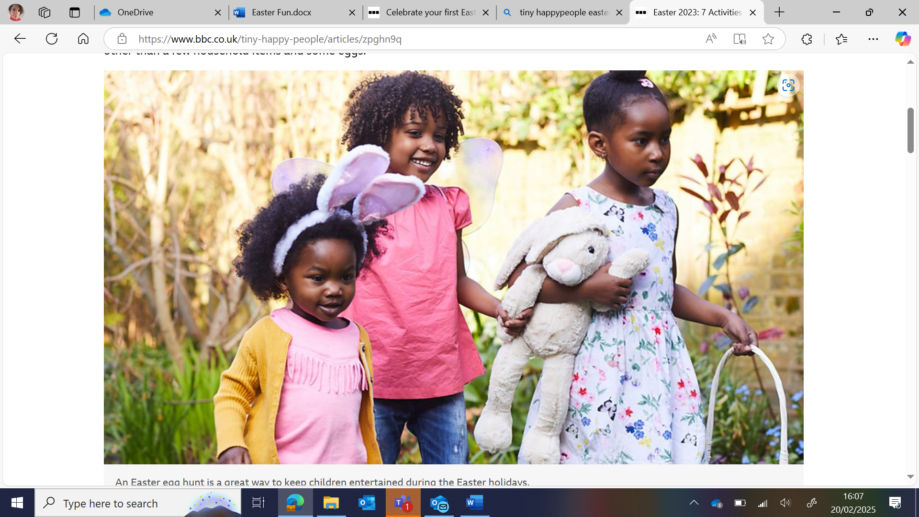
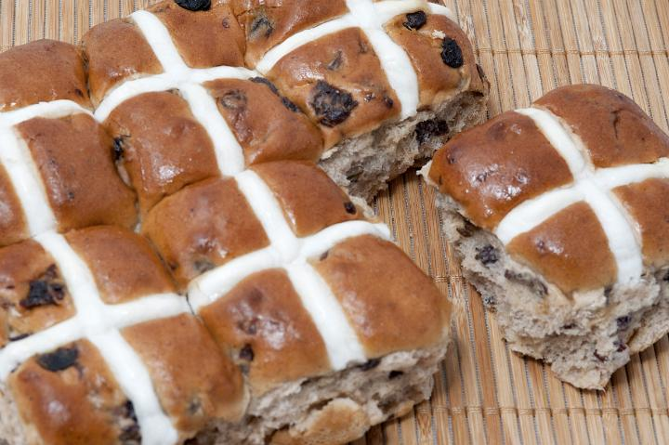

Easter Fun
Easter is the most important celebration in the Christian calendar. It is celebrated in different and unique ways around the world

Rolling
Go outside for a walk with your child and find a grassy slope or small hill.
Lie on your side and enjoy rolling down the hill. When you get to the bottom, jump up and run back to the top and do it again! Enjoy the laughter and fun.

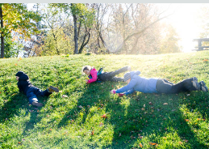

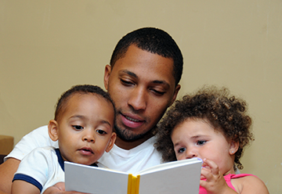



Easter Story Time
There are many books with an Easter theme at your local Library. Why don’t you plan a trip to choose one together? At the library keep a look out for these: Egg by Sue Hendra and Paul Linnet
The First Egg Hunt by Adam & Charlotte Guillain and Pippa Curnick
WANTED – The Chocolate Monster by Pip Jones and Laura Hughes
Every Bunny Dance by Ellie Sandall Booktrust Every Bunny Dance
Read the story together and add actions to the movements. Clap your hands (clap them high, clap them low, loudly and softly), shake your tail (shake your hips from side to side, bend up and down) , twist and twirl (spin around and around), wiggle and whirl (shake your hips and spin around!).

Song Time
Can you move like a hopping Easter bunny in this fun song that helps children follow instructions, use their imagination and get active as they jump, hop or skip to this fun song Sleeping Bunnies song - BBC Tiny Happy People
Use songs and rhymes to help teach numbers and quantity. Can you make some props to use when singing this song Five Currant Buns | Words for Life such as pictures of hot cross buns or large stones or circles cut from an empty box


Information for Parents & Carers

Top Tips
Traditions at Easter around the world represent parts of the Christian Easter story. This is the time that Jesus came back to life. You can listen to the Easter story and find more about how it is celebrated by Christians with your child on
CBeebies - Let's celebrate Easter
Look at a world map (you can use the maps on your phone or computer) and show your child where the different Countries are. Chat about how you would get there and how far away they are. This is the starting point of geography and the realisation of the world around them and that it may be different to where they live.
All around the world The Easter celebration food is chocolate. As you see the shops full of Easter Chocolate Eggs talk to your child about celebrations and that different families celebrate the same and different things, this can be because of their Religion or family culture.
Kite Flying on Good Friday is a tradition in Bermuda.
Rolling down hills and banks is popular in Scotland.
In France certain towns make an enormous omelette out of eggs and church bells ring out.
In Poland celebrations include a Country wide water fight – make sure you have a waterproof coat for that.
Easter bonnet parades are traditional in the UK, Australia and U.S.A – why don’t you choose a hat and have a family parade?
Tip for cooking with Children
Before you start tie back any long hair, put on your aprons and wash your hands. Make sure your child is stable where they are cooking and comfortable with the angle they are cooking at. As you cook explain what the different ingredients are where they come from. Point out the changes to the ingredients as they are mixed with others or beaten. This may be their colour, or texture or size.
Chatting Matters
Vocabulary and increasing the number of new words you child hears every day is very important for future learning. Include words such as weigh, measure, mix, sort, same, different, large, small, celebrate, tradition, world, map, far, near, hard, soft, melting, solid, changing.

Communication and Language
3 and 4 year olds
You might notice that your child can:
Use long sentences of four to six words.
Use words and actions to explain thoughts and ideas.
Give their point of view and disagree.
Have long conversations with you and their friends.
Tell you a long story and talk about their favourite books. Knows lots of nursery rhymes.

Find out more about your child’s development
What to expect in the Early Years: A guide for parents

If you have any concerns about your child’s development the first thing you can do is chat to your Child’s Key Person at their Setting.

Physical Development
3 and 4 year olds
You might notice that your child can:
I can wave flags and streamers using large muscle movements and paint and make marks on a big scale.
I can use one handed tools such as scissors.
When holding pens and pencils I have a comfortable grip and good control.
Show whether left or right-handed.
Run, walk, jump, hop, skip and moving around in lots of different ways.

Find out more
CBeebies – Chocolate Maker

CBeebies Parenting

Health for Under 5s

Parents and families | National Literacy Trust

Learning to talk - Start for Life - nhs.uk

Home - Starting Reception

Homepage | Best Start in Life
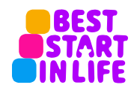

Understanding the World
3 and 4 year olds
You might notice that your child:
Is learning to develop positive attitudes about the differences between people.
Knows that there are different countries in the world. They can talk about differences they have experienced or seen in photos.

