
Lights, Lights Every Where
As the evening comes and it gets dark take your child outside for a walk or a drive around your neighbourhood.
Look at all the different lights and count how many different ones you see. How different the streets look and sound at night, what do you notice? How many sounds and sights are like those in this CBeebies story?
Arthur Darvill - In the Darkness of Night - CBeebies

Nursery Rhyme Time
Before your child’s bedtime have a look through the window to see the dark sky, point out the stars and sing ‘Star Light Star Bright’
Star light, star bright,
First star I see tonight,
I wish I may, I wish I might,
Have this wish, I wish tonight.
Why not make a wish together? I wish …….

Star Light Star Bright
Winter is a time to celebrate across the world. Light is a theme as the nights get longer and darker. December brings the festival of Hanukkah 10th-18th December & Christmas 25th December





Hanukkah ‘The Jewish Festival of Light’ What is Hanukkah? - BBC Bitesize
This is an 8-day festival. Celebrated by Jewish families.
Look at this Menorah – count with your child the candles 1,2,3,4,5,6,7,8,9. Each night of Hanukkah a candle is lit, the ‘helper’ candle in the middle is lit every day and used to light the others. This makes
9 candles in total. Each candle is the sign of a miracle when something amazing happened.
You may not celebrate this in your home but talking about this is a great way to help your child understand differences

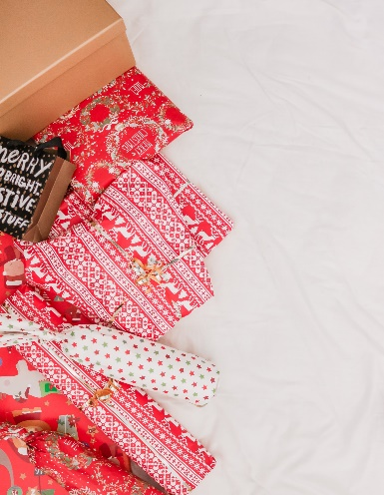
Christmas Wrapping Up
Celebrating Christmas has become a cultural tradition in the UK, and this has developed from the Christian Religion so not everyone around you will be celebrating it. Giving presents is a part of many festivals.
You will need: A selection of boxes, packets and toys, newspaper, old wrapping paper or scrap, safety scissors and some sticking tape.
You could try: Show your child how to wrap up a present. Talk aloud about what you may be thinking ... I wonder how much paper I will need for this? Will it be a small piece or a big piece? Let’s test a piece to see? Oh no that’s the wrong shape my present is round? Chat through the stages and how to fold the paper over and secure with the tape. Show your child how to fold the ends together to seal it up. Who has the biggest present or the smallest? Who has the heaviest or the lightest? Can you now write a label for the parcel? Encourage your child to ‘have a go,’ this will probably be a squiggle but ask them what it says. Talk about using scissors safely. See how Katie, Hannah and their family prepare for Christmas by making cards, wrapping gifts and decorating the tree Celebrating Christmas - CBeebies.

Top Tips
Talking to your child about the different cultures around them and how communities celebrate differently, but together, helps your child to understand that differences are a good thing. Celebrating diversity!

Helping young children to develop an understanding of festivals through family experiences is a great place to start.
Children will learn that members of all families love one another and that they show this in different ways, for example, by caring and sharing, preparing special food and by exchanging gifts. This helps children understand we are all special, despite differences in how we look or dress, or what we eat or celebrate.
Games and activities offer a fun way for young children to learn about differences and similarities among people and to introduce the concept of diversity. All types of differences such as race, religion, language, traditions, and gender can be introduced this way.

Chatting Matters
Vocabulary and increasing the number of new words you child hears every day is very important for future learning. Use bold for suggested words

Communication and Language
3 and 4 year olds:
You might notice that your child:
- Can tell you a long story and talk about their favourite books. They know lots of nursery rhymes.
- Is still learning how to use word endings and might still make mistakes such as ‘runned’ for ‘ran’. Instead of correcting them, please reply and use the right ending, e.g. “Yes, I saw how fast you ran!”
- Likes listening to longer stories and can remember a lot of what happens.

Information for Parents/ Carers

Find out More

CBeebies Celebrating differences

Learning to talk - Start for Life - nhs.uk

Homepage | Best Start in Life

Small Talk | National Literacy Trust

Health for Under 5s

Home - Starting Reception


Understanding the World
3 and 4 year olds:
You might notice that your child:
- Is learning about their own life -story and their family’s history
- Is learning to develop positive attitudes about the differences between people
- Knows that there are different countries in the world. They can talk about differences they have experienced or seen in photos

Find out more about your Child’s development
What to expect in the Early Years: A guide for parents

If you have any concerns about your child’s development the first thing you can do is chat to your child’s Key Person at their setting.
Mathematical Development
3 and 4 year olds:
You might notice that your child:
- Can say numbers in order past five
- Can say one number for each item in order: 1,2,3,4,5.
- Knows that the last number I reach when counting a small set of objects tells me how many there are in total
- Can show ‘finger numbers’ up to 5
- Can talk about and identify patterns that they see around them, e.g. stripes on clothes. They use everyday language like ‘pointy’, ‘spotty’, ‘blobs’ etc

