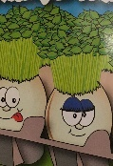
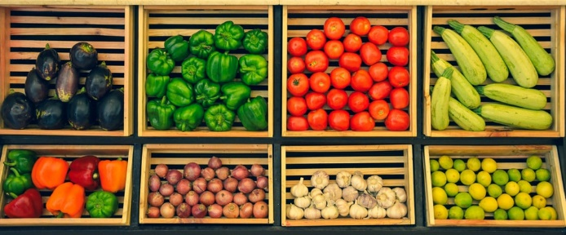
Ideas to play and learn about vegetables

Sowing seeds
Broad beans: can be planted in pots or directly into the soil from February to May.
Runner or French beans: can be planted in pots in March and April but only outside in May, when there is no chance of frost. These will need poles or string to climb up.
Radish: sow in small pots or directly into the soil.
Courgettes: start inside in pots in March then transplant outside in May.
Cress: grow inside on top of moist kitchen towel.
For fun, this can be inside half of an empty
washed eggshell and draw a face on the shell.
Our food journeys
Where does our food come from? – watch these videos with your children and talk about the different fruits they see, where and how they grow, and what transport was used.
. 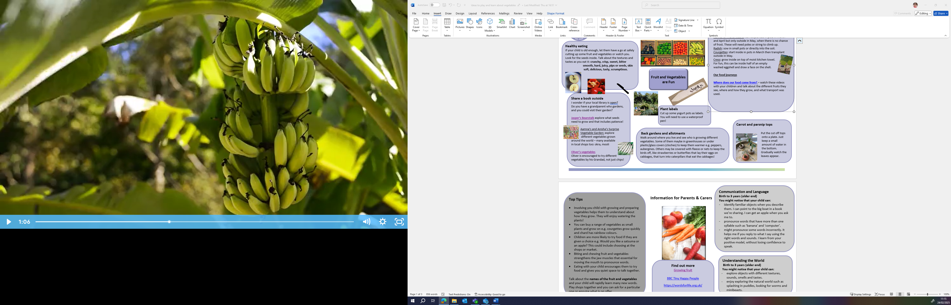

Healthy eating
If your child is old enough, let them have a go at safely cutting up some fruit and vegetables or watch you. Look for the seeds inside. Talk about the textures and tastes as you eat it: crunchy, crisp, sweet, bitter smooth, hard, juicy, pips or seeds, skin soft, delicious, tasty, scrumptious. Click the link for more tips on healthy eating, from suitable snack to weaning and fussy eaters. Feeding & Nutrition | Health for Under 5s

Fruit and Vegetables are Fun
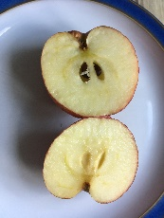


Share a book outside
I wonder if your local library is open.
Do you have a grandparent who enjoys, could you visit their garden?
Jasper's Beanstalk explore what seeds need to grow and that includes patience!
Jo Jo and Gran Gran Harvest Vegetables
Jo Jo and Gran Gran are making special Callaloo soup, but where will they find the rest of the ingredients when the shop is closed? Watch with your child to discover how food is grown and harvested.
Oliver's vegetables
Oliver is encouraged to try different vegetables by his Grandad, not just chips!

Shopping for Fruit and Vegetables
Encourage your child to make their own shopping list and show them how by writing one yourself. This will help show your child that their marks on paper have a meaning. Talk about what is healthy, what is a fruit or a vegetable and how many you will buy
Children’s shopping list activity | Words for Life
When you have your shopping, encourage your child to help unpack, make sure you have time to then talk about what you bought, what they look like – size, shape and quantity
learning as we unpack the shopping - BBC Tiny Happy People

Carrot and parsnip tops

Put the cut off tops
onto a plate. Just
keep a small
amount of water in
the bottom.
Gradually watch the
leaves appear.

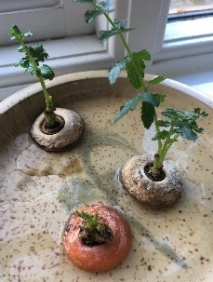

Top Tips

- Involving you child with growing and preparing vegetables helps them to understand about how they grow. They will enjoy watering the plants!
- You can buy a range of vegetables as small plants and grow on e.g. courgettes grow quickly and chard has rainbow colours.
- Children are more likely to try food if they are given a choice e.g. Would you like a satsuma or an apple? This could include choosing at the shops or market.
- Biting and chewing fruit and vegetables strengthens the jaw muscles that essential for moving the mouth to pronounce words.
- Eating with your child encourages them to try food and gives you quiet space to talk together.

Talk about the names of the fruit and vegetables and your child will rapidly learn many new words. Play shops together and you can ask for a particular one or enquire what is on offer.

Chatting Matters
Vocabulary and increasing the number of new words you child hears every day is very important for future learning. Use bold for suggested words

Information for Parents & Carers
Communication and Language
Birth to 3 years (older end)
You might notice that your child can:
- identify familiar objects when you describe them. I can point to the big boat in a book we’re sharing. I can get an apple when you ask me to.
- pronounce words that have more than one syllable such as ‘banana’ and ‘computer’.
- might pronounce some words incorrectly. It helps me if you reply to what I say using the right words and sounds. I learn from your positive model, without losing confidence to speak.

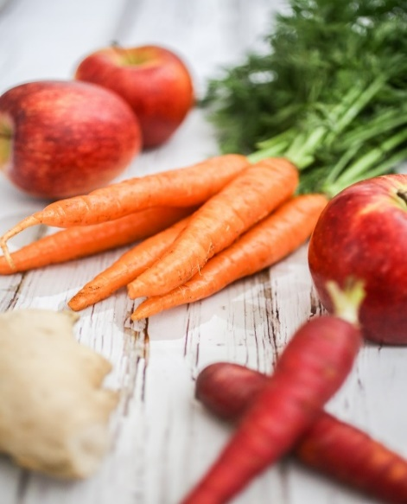

Find out more

Healthy Habits, Happy Hearts Practitioner and Parent Cards

CBeebies Parenting

Health for Under 5s

Small Talk | National Literacy Trust

Learning to talk - Start for Life - nhs.uk

Home - Starting Reception

Homepage | Best Start in Life


Understanding the World
Birth to 3 years (older end)
You might notice that your child can:
- explore objects with different textures, sounds, smells and tastes.
- enjoy exploring the natural world such as splashing in puddles, looking for worms and minibeasts.

Expressive Arts and Design
Personal, Social and Emotional
Birth to 3 years (older end)
You might notice that your child can:
- beginning to understand how to wait for my turn and learning to control my feelings when I want something.
- I am becoming more and more independent. This means I can sometimes get frustrated when I want to do something by myself.

Find out more about your child’s development

What to expect in the Early Years: A guide for parents

If you have any concerns about your child’s development the first thing you can do is chat to your Child’s Key Person at their Setting.

