
A guide for childminders for creating an Admissions and Fees Policy
The information listed below is a useful guide to what needs to be included in an Admissions and Fees Policy for a childminder offering Funded Entitlement places in Buckinghamshire. This provides clear and transparent information so parents can understand how funded hours are applied.
You must start by stating the below information
- As an Ofsted registered early years childminder you are legally bound to meet the requirements of the Ofsted regulations and the Early Years Foundation Stage Framework published by the Department for Education.

- Detail your criteria for admitting children into your setting and managing your waiting list (if applicable) by explaining how places are prioritised. This may be, for example, by:
  - Children in need
  - Children with Special Educational Needs and Disabilities (SEND)
  - Siblings of children you already childmind
  - 2-year-old funded children
  - Children within a certain catchment area
The criteria you choose is entirely your choice, but it must be available for any parent who wishes to see it, and it needs to be adhered to.
Opening hours and hours when funding is available.
- State the hours you will be available for all childminding. These are your opening times - they are not just in reference to Funded children. For example:
  - 8am – 6pm Monday to Friday 38 weeks of the year (term time only)
  - 8am to 6pm Monday to Friday 45 OR 47 weeks of the year

- State the days and times that your setting will make funded hours available to parents. There must be no artificial breaks for the funded hours e.g. 9am-12pm and then 1pm-4pm. A parent can request to use funded hours, without the purchase of private hours, at the funded times that are stated within the policy.
This is an example of a compliant offer, but your offer may vary.
9am – 3pm Monday to Friday 38 weeks of the year (term time only)
8am to 6pm Monday, Wednesday and Friday 45 OR 47 weeks of the year (one of these can be offered alongside term time if you choose)
State the funding streams you offer:
• Disadvantaged (Families in Receipt of Additional Support (FRAS)) 2-year-olds (15 hours per week/570 hours per year)
• Universal entitlement for all 3- & 4-year-olds (15 hours per week/570 hours per year)
• Eligible Working Parent Entitlement for 9 months – 2 years old (30 hours per week/1140 hours per year)
• Eligible Working parent 3- & 4-year-olds (additional 15 hours per week/570 hours per year on top of the Universal entitlement)
Weeks per year – Term time and Stretched
You can offer funding for 38 weeks (term time) or choose to stretch the funding claim over either 45 or 47 weeks of the year. 51 weeks is not available to childminders. You can offer term time alongside one stretched offer only. If you offer stretched, then there will be some residual hours which are not used. Please see the below table as to how these are worked out. You need to state if and how these would be offered, so parents are aware of these. These should be offered as hours only and cannot be shown as a cash value.
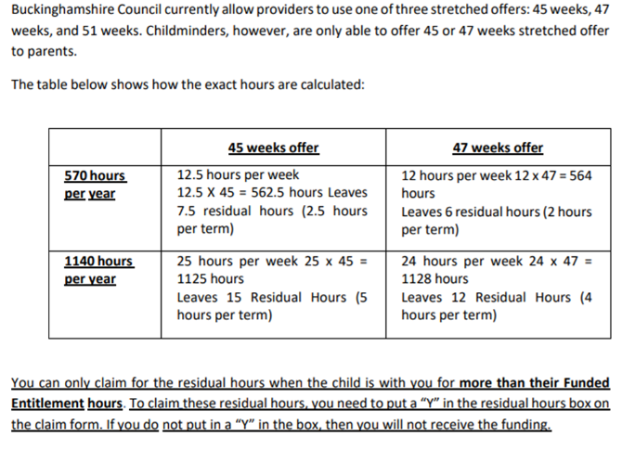
Consumables and Chargeable Extras
These are all additional charges that parents may incur when accessing funded hours. These costs should be clearly detailed within the policy with a breakdown of the individual cost of the following areas, which have been accessed by the child, where these are offered.
- consumables to be used by the child, such as nappies or sun cream.
- meals and snacks consumed by the child.
- extra optional activities such as events, celebrations, specialist tuition (for example music classes or foreign languages) or other activities that are not directly related or necessary for the effective delivery of the Early Years Foundation Stage (EYFS) statutory framework.
- Providers can also charge for any additional, private paid hours according to their usual terms and conditions provided taking up private paid hours is not a condition of accessing a free place.
It should not include items and activities, such as arts and crafts or staffing, which are covered by the EYFS (Early Years Foundation Stage).
- Parents cannot be made to pay for extra services or hours in order to have a funded place. Payment for the consumables and chargeable extras is voluntary. Providers are responsible for setting a clear policy on stating options for alternatives to payment for consumables, such as waiving or reducing the cost of meals and consumables or allowing parents to supply their own. A lunch policy should be in place.
- Please note: You may need to explain to parents that the Funded Entitlement is not intended to cover the cost of meals, other consumables, additional hours, or additional activities. Providers can request a voluntary fee for these additions, but clear alternative options to payment must be offered. You may need to refer them to the “Charging” section on Page 8 of Buckinghamshire Council Guidance on: Local Management of the Funded Entitlement which can be found on the Early Years website. ’Government funding is intended to deliver 15 or 30 hours a week of free, high quality, flexible childcare. The 15 or 30 hours must be able to be accessed free of charge to parents. There must not be any mandatory charges for parents in relation to the free hours. Government funding is not intended to cover the costs of meals, other consumables, additional hours or additional services.’’
- Clearly state your fee payment plan including information about when you will invoice, the amount of any deposits that may be required, and the action you will take around non-payment of fees.
- It should be clear that an invoice has come from the provider. It should be broken down clearly to – free entitlement hours; private hours; food charges; non-food consumables; activities. This invoice should agree with the settings’ published chargeable extras. This takes effect by January 2026 and applies to all providers. An example of a compliant invoice can be found on the Early Years website.
- Deposits for funded only children must be returned within 6 weeks of the place being taken up.
- No registration fee can be applied for funded only children.
- Consumables are not intended to be used as a “top-up.”
- The DfE defines a top up as ‘’any difference between a provider’s normal charge to parents and the funding they receive from the local authority to deliver free places.”
There may be other items you wish to include in your admissions and fees policies, but you must ensure that these points are included so that you are in compliance with Buckinghamshire Council Guidance on providing Funded Entitlement places. Buckinghamshire Council cannot sign off policies which are not DfE (Department for Education) compliant, and this may delay the application process.

Eligible Working Parent Funding
It is not essential to include reference to Eligible Working Parent funding in your policy but is highly recommended in the event that a parent falls out of eligibility and challenges any subsequent fees they may be liable for.
- Eligible Working Parent Funding can be applied for on Homepage | Best Start in Life
- It is eligible parents’ responsibility to apply for the Eligibility code before the fixed deadlines 31st March, 31st August and 31st December and to reconfirm their codes every three months.
- Families remain eligible at a current setting if they fall into their grace period but cannot start with a new setting until their code has been reconfirmed and prior to the cut-off date.
- New or lapsed codes will show as eligible once confirmed but cannot be claimed for until the next cut-off date. A new code confirmed on 2nd January may show the child as eligible, but it has missed the cut off date of 31st December and cannot be used until the Summer term.
- Codes can only be used for the term after a child turns 9 months and cannot be used once the child has started at Reception in school.
- Please note: A new child on a claim form will not be funded if their code is in the grace period BEFORE when the term starts. This is still applicable even if the child was attending the setting prior to eligibility and paying for private hours.

2 Year funding for parents in receipt of certain benefits
Eligibility is applied for with BFIS (Bucks Family Info Service) and the code verified by Early Years. This code does not need to be checked again and remains valid until the term after the child turns three, where they will then qualify for three-year-old funding.

