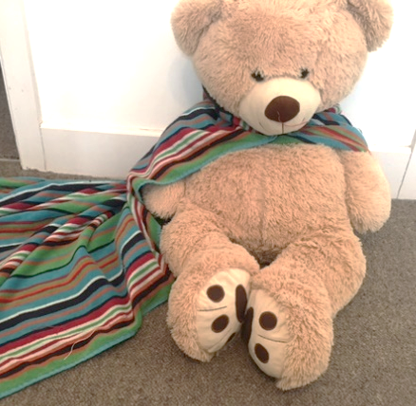
Story time

Sharing stories are a lovely way to learn about daily routines in a relaxed way. Take a trip to the library and borrow one of the many books telling stories of characters getting dressed, or this story about Simon, an odd, stripey sock who wants to find his perfect match so he can go on adventures like the other sock pairs. SIMON SOCK - YouTube

Why not play a matching game and add some maths to your child’s learning too? Can your child match up their socks? Do they have different colours and patterns like the socks in the story? Learn the language of shapes and patterns as you describe the socks as stripey, spotty, big and small.
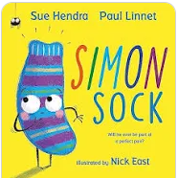

Getting Dressed Races
Getting dressed should be fun and will help your child practise their physical skills. Play the game below:
- Lay four items of clothing, spaced apart in a line across the room, for each player (jumper, scarf, sunglasses, bracelet).
- All start in the same place and say, “ready steady go!”
- The first person to put the clothes and accessories on will be the winner.
- Why not add in a couple of fun actions like spinning round, jumping across pillows, or a chair to crawl under.

Dressing
Fun
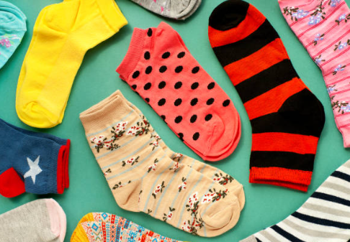

Dressing Up Fun
Children love to dress up! Costumes that are made from old clothes/materials from your house help children to develop their imaginations more than ones that are bought from the shop. Why not dress up together as different people and things? Ask your child, what they would like to be and what they need to dress up? Below are ideas to get you started:
- A night gown and bit of tinsel makes a beautiful princess dress.
- A towel makes a great superhero cape.
- Adult gloves, on your feet, make large monster feet.
- A white sheet makes a scary ghost.
Play with your child and take on the role of your character.
What might they say? What might they do?
“I’m a ghost…. Whoo…. I love to fly around in the dark….
Whoo…. I can move fast…. I can move slowly… where shall we go?”

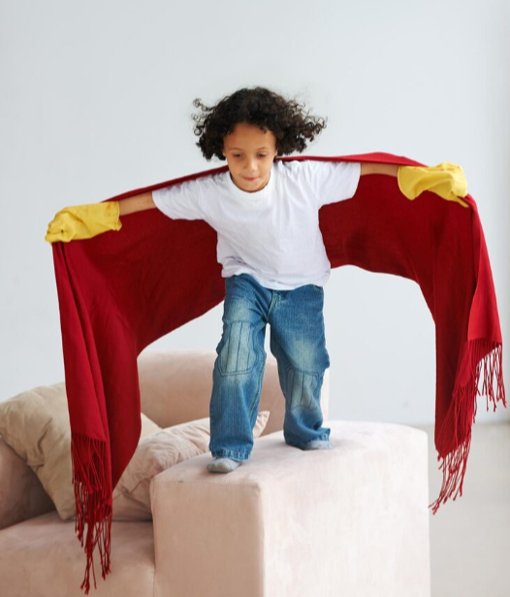
Ideas to Encourage Independent Dressing at Home - BBC Tiny Happy People – getting ready to go out is a great opportunity to talk with your children as they develop life skills. This web page offers top tips on talking through getting ready so it can become a fun activity rather than a stressful event. A video included shows parents trying a variety of techniques to encourage children’s independence and develop their vocabulary.

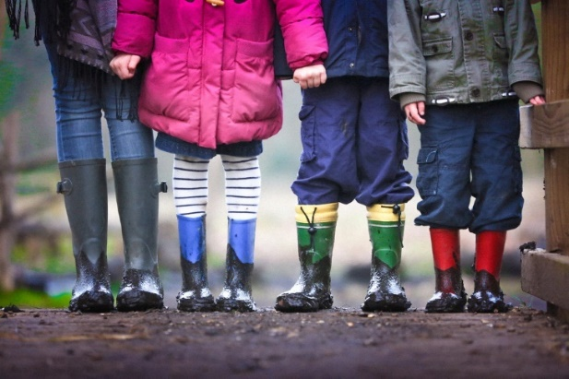
Information for Parents/Carers
Physical Development
3 and 4 year olds
You might notice that your child can:

- explore and move around in spaces, fit into such as large boxes, dens and tunnels.
- spin and roll. I can use ropes independently, like tyre swings

Communication and Language
3 and 4 year olds
You might notice that your child can:

- join in with pretend play like ‘putting the baby to sleep’.
- feel really frustrated when I can’t make myself understood.

Top Tips
- Try to make getting dressed fun!
- Look in the mirror and talk about what you can see in a positive way.
- Have a daily routine to help your child understand when getting dressed will happen; for example, “we get dressed after breakfast”.
- Talk about the order we put clothes on using words such as first, after, next, then, last of all.
- Talk about the different colours and patterns you notice on clothing and different material types: stripes, checks, polka-dots, bright, colourful, dark, cotton, polyester, woollen, etc

Chatting Matters
Vocabulary and increasing the number of new words your child hears every day is very important for future learning. first, after, next, then and last of all, shirt, polo shirt, short sleeves, long sleeved, tank top, cardigan, shorts, skirt, blouse, zip, buttons, cloth, plastic, paper, waterproof, wet, stripes, checks, polka-dots, bright, colourful, dark, cotton, polyester, woollen, soaked, dry.

Find out more

Dressing Up - CBeebies - BBC

CBeebies Parenting

Health for Under 5s

Small Talk | National Literacy Trust

Learning to talk - Start for Life - nhs.uk

Home - Starting Reception

Homepage | Best Start in Life



Expressive Arts and Design
3 and 4 year olds
You might notice that your child can:

- begin to take part in pretend play, pretend one object represents another, e.g. holding a wooden block to my ear and pretending it’s phone.
- enjoy taking part in action songs, such as ‘Twinkle Twinkle Little Star.’

Find out more about your child’s development

What to expect in the Early Years: A guide for parents
If you have any concerns about your child’s development the first thing you can do is chat to your Child’s Key Person at their Setting

