
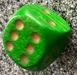
Festival Fun

Wrapping paper
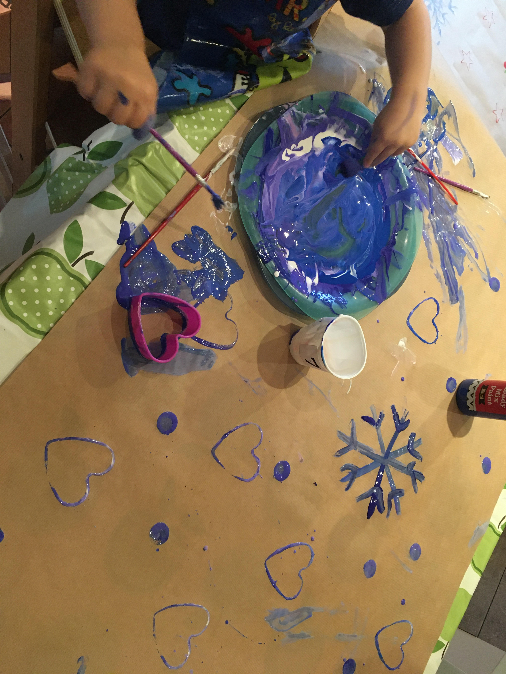

Snowman game
You will need:
A dice or six cards numbered 1 to 6
a sheet of paper and a pencil each.
To play:
Throw the dice in turn and draw the body parts of the snowman to match the number thrown.
You must draw the body before anything else, so you can't start until you throw a six. You must throw a five to draw a head before you can draw the eyes and nose.
Throw a 6 to draw the body,
Throw a 5 to draw the head,
Throw a 4 to draw the arms,
Throw a 3 to draw a nose,
Throw a 2 to draw his eyes,
Throw a 1 to draw a hat.
The first player to draw a complete snowman shouts 'SNOWMAN!'

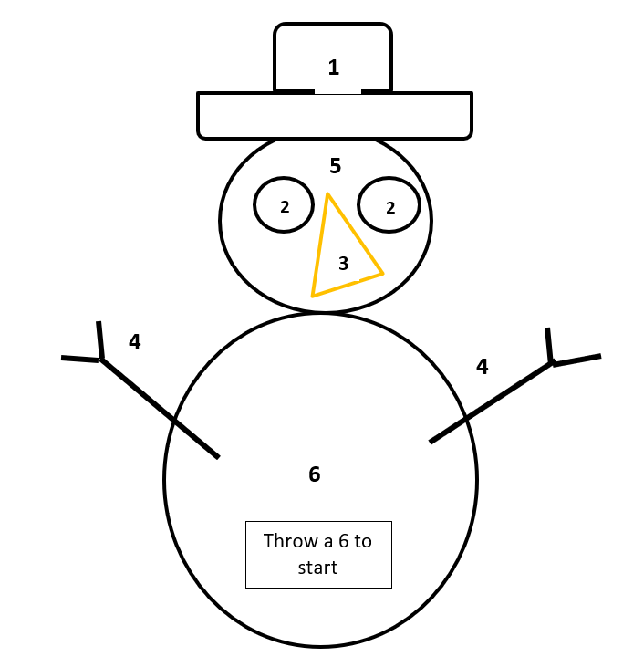

A fun game to help your child recognise numbers. Use a dotted dice or one with numbers.

Making decorations
To make salt dough:
2 cups of flour
1 cup of salt
½ cup water
- Mix the flour and water together
- Slowly add the water until the dough sticks together and is ready to knead.
It is ready when it does not stick to your hands and not too dry it is crumbly.
- Knead for 10 minutes until it feels warm.
Help your children to mix, roll out and cut using cutters, chatting about how it feels or what the shape is.
Remember to add a hole to hang it.
Bake in the oven on a low setting until hard.
Decorate with pens or paint and hang up.



Song Time

Join your child in singing and dancing to their favourite festive sings, there are lots of ideas here - CBeebies Christmas Songs - CBeebies - BBC
What is your favourite? Is it Jingle bells? We wish you a Merry Christmas?
Can you help your child develop their maths knowledge with this fun song about snowmen melting?
five little snowmen melting song

Story Time
Find a cosy place and share festival stories and rhymes together. For example,
Little Fir Tree read by Nadia Hussain

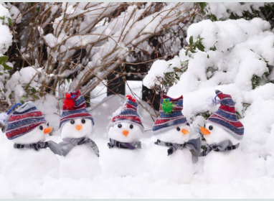



Card Making

Use old cards, magazines, pens and paper and create your own unique cards for friends and family.

Christmas card making for children | Words for Life for more ideas.

Information for Parents/ Carers

Information for Parents
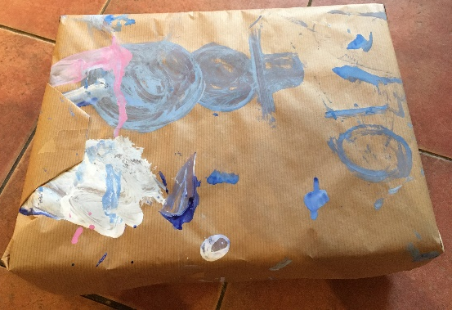
Find out more

CBeebies Parenting

Health for Under 5s

Small Talk | National Literacy Trust

Learning to talk - Start for Life - nhs.uk

Homepage | Best Start in Life

Home - Starting Reception



Top Tips
- Joining your child in making something is a time to try things out and have fun together.
- Let your child play with the resources, be it dough, card, paint before trying to make anything specific.
- Remember to give one instruction at a time.

Chatting Matters
Make suggestions and ask a few questions to extend children’s ideas of what is possible e.g. I wonder what would happen if …
Use words to help children talk about what they are feeling, seeing or doing e.g. warm, sticky, lumpy, messy, join, bake, cook, bauble, decorations.

Chatting Matters
Vocabulary and increasing the number of new words you child hears every day is very important for future learning. Use bold for suggested words
Communication and Language
3 and 4 year olds
You might notice that your child can:
- understand questions and instructions that are more complicated and have two parts, like: “Please get your coat and wait at the door.”
- use words and actions to explain my thoughts and ideas. I can give my point of view and disagree.
- tell you a long story and talk about my favourite books. I know lots of nursery rhymes.

Expressive Arts and Design
3 and 4 year olds
You might notice that your child can:
- enjoy exploring colour and colour mixing.
- explore different materials freely. Is learning to develop ideas about how to use them and what to make.
- join different materials together and explore the textures of different materials.

Maths
3 and 4 year olds
You might notice that your child can:
- show ‘finger numbers’ up to 5.
- match the correct numeral (number symbol) to
the right amount, up to 5, e.g. point to the
number 3 when I count 3 snails.
- Recognise numbers up to 3 objects without
having to count them individually.

Find out more about your Child’s development

What to expect in the Early Years: A guide for parents

If you have any concerns about your child’s development the first thing you can do is chat to your child’s Key Person at their setting.

