A child playing in the mud.

**Words you could use with your child**

**squelchy**

**messy**

**squishy**

**sticky**

**revolting**

**glorious**

**grubby**

**gooey**

**oozing**

**lumpy**

**Mud play ideas**

Mud ice creams – mud, utensils & ice cream cones

Muddy river – mud & aluminium foil

Mud cupcakes – mud & cake cases

Mud wormery – watch the worms dig down into their new home

Mud pies – mud, leaves, petals, and stones

Mud car wash – mud & small toy cars (then wash them clean!)

Mud stew – mud, water & spoons for mixing

Mud paint – mud, sticks, brushes, or fingers & feet!

Mud monsters – mud & children! Let them coat their arms and hands in mud! Wash it off together.

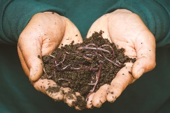

**The natural environment**

**Encourage children to:**

Touch anything, they want (within reason), including dirt, mud, trees, plants, insects, animals but not break flowers, trees, or plants or, trample, destroy or frighten creatures. Most children have an innate desire to get dirty; this should be nurtured as much as possible.

*Remember to wash hands thoroughly after playing with mud.*

**Mud Play**

**What can I use to put the mud in?** Washing up bowl small paddling pool Wheelbarrow Mixing bowls Buckets Saucepans Spoons and scoops

**Add items such as:**

* Kitchen utensils
* Pots and pans
* Watering cans
* Pie tins
* Plastic containers & bottles
* Spoons, spades & trowels
* Sticks and stones
* Planks of wood
* Toy cars and animals
* Flowers, leaves & feathers

**What to wear**

Dress appropriately - decide which of your children’s clothes are “good clothes” and which ones are “play/messy clothes”.

Here are a few ideas to encourage your child to talk about the weather and which clothes are suitable [Dress for the weather - CBeebies Parenting](https://www.bbc.co.uk/tiny-happy-people/articles/zkt992p)

**Information for Parents & Carers**

## Top Tips

* If you don’t like messy play inside – take it outside - create a mud kitchen, or a digging area.
* Always keep family pets away from this area.
* If it helps have a designated area for messy play (indoors or outdoors)
* Your child needs to feel **confident** and **happy** whilst playing and worrying about getting dirty or making a mess will impact on their **playful experiences**.
* Help your child to feel confident whilst playing by ‘allowing’ them to get dirty or to make a mess.
* Explore muddy places locally such as the woods or a trip to the park.

**Chatting Matters**

**Vocabulary** and **increasing** the number of new words you child hears every day is very important for future learning.

**Communication and Language**

**3 and 4 year olds**

**You might notice that your child likes:**

* having long conversations with you and their friends.
* to talk when they are playing and pretend: “Let’s go on a bus... you sit there... I’ll be the driver.

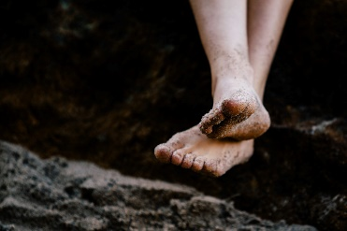

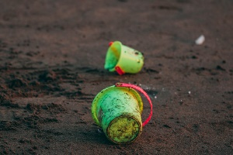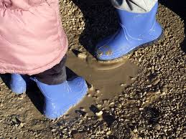

**Find out More**

[20 Top Mud Play ideas to get your kids enjoying the outdoors! (mothernatured.com)](https://mothernatured.com/nature-play/mud-play-for-kids/)

<https://wordsforlife.org.uk/>

[Learning to talk - Start for Life - nhs.uk](https://www.nhs.uk/start4life/baby/learning-to-talk/2-to-3-years/#anchor-tabs)

[Let's get talking - Health for Under 5s](https://healthforunder5s.co.uk/sections/toddler/lets-get-talking/)

[CBeebies Parenting](https://www.bbc.co.uk/cbeebies/parenting)

[Home - Starting Reception](https://startingreception.co.uk/?es_c=308CAA55AD47458C53A7854E8022C490&es_cl=31CAEEFA6CD7BB5DA1A8D907712C1260&es_id=ph7%C2%A322)

**Understanding the World**

**3 and 4 year olds**

**You might notice that your child can:**

* enjoy exploring natural materials using all my senses.
* talk about what I explore and investigate using a wide range of words.
* learning that it is important to respect and care for the natural environment and all living things.

**Find out more about your child’s development**

[What to expect in the Early Years: A guide for parents](https://foundationyears.org.uk/files/2021/09/What-to-expect-in-the-EYFS-complete-FINAL-16.09-compressed.pdf)

If you have any concerns about your child’s development the first thing you can do is chat to your child’s Key Person at their setting.

**Physical Development**

**3 and 4 year olds**

**You might notice that your child can:**

* think carefully about which movement I need to make, for example whether to crawl, walk or run across a plank, depending on its length and width.
* choose the right tools for what they need to do.