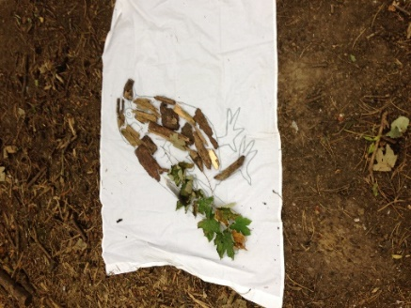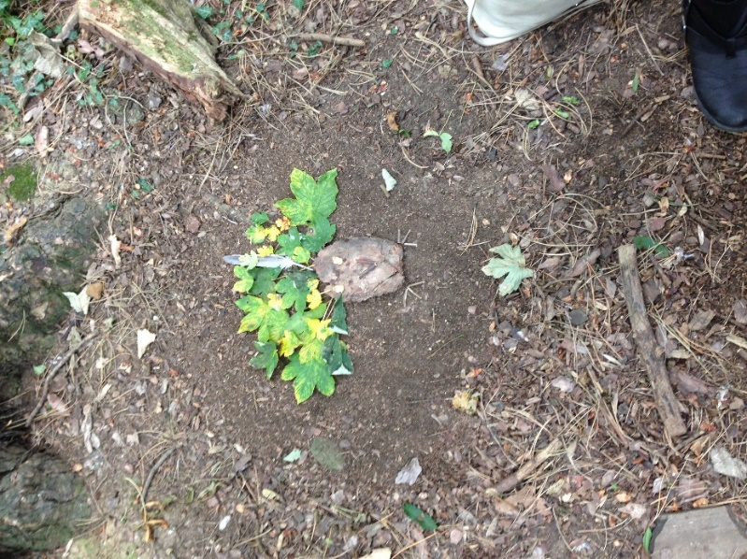

**Autumn walk**

Take a walk and collect natural resources you may find along the way. You could give your child a paper bag and count the items they find. These could include:

Feathers, pinecones [Conkers](https://www.woodlandtrust.org.uk/trees-woods-and-wildlife/british-trees/a-z-of-british-trees/horse-chestnut/), stones, leaves (different shapes and varieties) if you can, twigs and sticks. As you collect them, chat about the colours, sizes, shapes.

**Can you add a variety of new words into your conversation as you walk and look for Autumn treasures?**

**Artwork in the woods**

Collect a large sheet/ towel / piece of paper and display all the items you have found on your walk. **Can you create a self-portrait?**

Take a walk and go foraging (searching for food)–[The Woodland Trust](https://www.woodlandtrust.org.uk/visiting-woods/things-to-do/woods-through-the-seasons/autumn/) highlights local places to visit and things to do inautumn.Be careful what you pick – [foraging responsibility guide](https://www.woodlandtrust.org.uk/visiting-woods/things-to-do/foraging/foraging-guidelines/).

**Autumn Creativity**

**Story time**

**Listen** [**to the Stickman**](https://www.bbc.co.uk/iplayer/episode/b06t09rk/stick-man) **by Julia Donaldson**

Join Stick Man on an incredible adventure across the seasons as he runs from a playful dog, gets thrown in a river, escapes from a swan's nest and even ends up on top of a fire. Will he get back to his family in time for Christmas? Or take a trip to the local [library](https://www.buckinghamshire.gov.uk/libraries/information-about-local-library/) to locate the book.

Create your own stickmen – encourage your child to explore and use their own imagination. Can you make up a story together about going on a walk in the woods and the adventures you may have?

**This is not a stick…..**

It’s a wand

It’s a guitar

It’s a shovel

It’s a baton

It’s a telescope

It’s a sword

It’s a microscope

It’s a ski pole

It’s a spoon

It’s a fishing pole

It’s a treasure finder

It’s a paddle

…And everything else a child could imagine

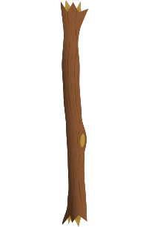

**Make a crown**

Go on a leaf and stick/twig hunt and stick these onto a strip of card (consider recycling a cardboard box such as a cereal box) and make the shape of a crown (to go round your child’s head) and have a woodland tea party!

**Need some inspiration?** Create a [Woodland Fairy Crown](https://www.youtube.com/watch?v=lkDk6s58KNE)

Encourage a teddy / friend to attend a tea party and show off your crowns

**Information for Parents/ Carers**

**Communication and Language**

**3 and 4 year olds**

**You might notice that your child can:**

-use lots of different words. I like to learn new words.

-it helps me if you explain what new words mean

use words and actions to explain my thoughts and ideas. I can give my point of view and disagree.

**Top Tips**

Let children create their own structures and artwork and encourage them to use their own imaginations to create anything.

Encourage children to use a variety of resources and explore the difference and similarities of these natural resources.

You may have some ideas but create alongside your child chatting about what you are doing and why? This will help them with ideas but also enable them to follow their own.

Creating with natural objects can be a perfect place to pretend and make believe. Helping your child to show an understanding of the world they live in.

**Chatting Matters**

**Vocabulary and increasing the number of new words you child hears every day is very important for future learning.** Can you add a variety of new words into your conversation as you walk and look for Autumn treasures?**Use words like crunchy, smooth, hard, bronze, golden, curved, heavy, straight, seed, fruit**

**Chatting Matters**

Vocabulary and increasing the number of new words you child hears every day is very important for future learning. *Use italics for suggested words*

[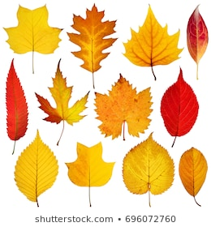](https://www.google.com/url?sa=i&url=https%3A%2F%2Fwww.shutterstock.com%2Fsearch%2Fautumn%2Bleaves&psig=AOvVaw0FpcZzFFPgnxYuS9ysDg7Z&ust=1600162661555000&source=images&cd=vfe&ved=0CAIQjRxqFwoTCJi44M6s6OsCFQAAAAAdAAAAABAV)

**Find out More**

**Find out more**

[Let's get talking - Health for under 5s](https://healthforunder5s.co.uk/sections/toddler/lets-get-talking/)

[CBeebies Parenting](https://www.bbc.co.uk/tiny-happy-people)

<https://wordsforlife.org.uk/>

[The Woodland Trust](https://www.woodlandtrust.org.uk/)

[Learning to talk - Start for Life - nhs.uk](https://www.nhs.uk/start4life/baby/learning-to-talk/2-to-3-years/#anchor-tabs)

[Home - Starting Reception](https://startingreception.co.uk/?es_c=308CAA55AD47458C53A7854E8022C490&es_cl=31CAEEFA6CD7BB5DA1A8D907712C1260&es_id=ph7%C2%A322)

[Talking to your child when you’re out and about | Words for Life](https://wordsforlife.org.uk/activities/talking-to-your-child-when-out-and-about/)

**Physical Development**

**3 and 4 year olds**

**You might notice that your child can:**

**-**wave flags and streamers using large muscle movements and paint and make marks on a big scale

-holding pens and pencils, have a comfortable grip and good control.

**Expressive Arts and Design**

**3 and 4 year olds**

**You might notice that your child can:**

-explore different materials freely. I am learning to develop my ideas about how to use them and what to make.

-enjoy exploring colour and colour mixing

**Find out more about your Child’s development**

[What to expect in the Early Years: A guide for parents](https://foundationyears.org.uk/files/2021/09/What-to-expect-in-the-EYFS-complete-FINAL-16.09-compressed.pdf)

If you have any concerns about your child’s development the first thing you can do is chat to your Child’s Key Person at their Nursery or Pre-school or Childminder.