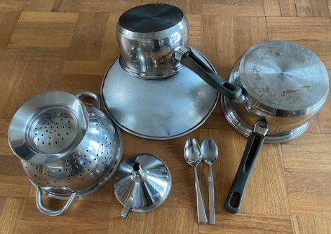
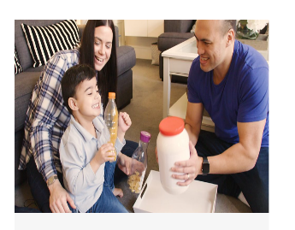


Body Sounds
Ask your child to make as many different sounds as they can with their hands – click, tap, rub, clap, slap etc.
Choose two sounds and make a pattern e.g. clap, clap, click, click.
What other sounds can they discover using their tummies, tongues, cheeks, feet.
If there are a few of you make a sound and pass it on.
Sing: If You're Happy and You Know It
“If you’re Happy and you know it clap your hands,
If you’re happy and you know it stamp your feet,
If you’re happy and you know it
and you really want to show it,
if you’re happy and you know it pat your tummy.”

Listen to the sounds of Winter
Wrap up warm and go for a wintry walk – what can you hear?
Crunching footprints on frosty or snowy ground,
dripping water as it thaws, Strong winds blowing whistling, muffled quiet when snow falls.
Squelching as you walk through mud or splashes as you jump in puddles.


Opposite Sounds
Talk about sound opposites such as quiet and loud -this is called ‘dynamics’, long and short – ‘rhythm’, fast and slow – ‘tempo’, high and low – ‘pitch’. Have fun experimenting using your voices, body percussion (clapping, patting, clicking fingers) and instruments.
If you make a quiet sound, can they make a loud sound?

Making Music
Listen to different types of music with your child and talk about what you like and don’t like. Why not try classical, opera, pop, jazz and choir?
Make your own instruments
Using empty bottles, jars and boxes is an easy way to make your own music at home.
How to make maracas with plastic bottles: Music play with toddler - BBC Tiny Happy People this website offers tips on how to make instruments together and includes a video showing how to make shakers.

Top Tips
-When you hear your child singing to themselves in play, join in by copying and adding on another word or line to the song.
-When your child plays with an instrument, join them by copying and adding on with your own instrument this helps with their understanding of rhythm.
-Join in with their play and start singing a song to go with what they are doing e.g. sing along to the ‘In my ear I hear a drum’ if they are playing with the homemade instruments.
-When singing songs try leaving a gap at the end of a line and wait to see if the child fills in the missing word e.g. ‘Twinkle, twinkle little ……’
-Add silly words at the end of a line in a song and wait to see your child’s reaction e.g. ‘Humpty Dumpty sat on a jelly’.
-Try to put actions with nursery rhymes and songs because it will help your child remember them.
-Don’t worry if your child wants to sing the same song over and over again, it helps them remember.
Chatting Matters
Vocabulary and increasing the number of new words you child hears every day is very important for future learning.
Language: Rhythm, beat, high, low, tones, drum, piano, guitar, xylophone.

Chatting Matters
Vocabulary and increasing the number of new words you child hears every day is very important for future learning. Use bold for suggested words

Did you know?
Supporting children to keep a steady beat through songs, music, rhymes, marching, clapping, drumming will help the understanding of rhythm. It also helps them to learn the tempo and rhythm of speaking which will in turn help with their communication skills, reading and writing.

Information for parents and carers
Find out more
cbeebies music

CBeebies Parenting

Health for Under 5s

Small Talk | National Literacy Trust

Learning to talk - Start for Life - nhs.uk

Home - Starting Reception

Homepage | Best Start in Life



Communication and Language
3 and 4 year olds
You might notice that your child:
- Tell you a long story and talk about my favourite books. Knows lots of nursery rhymes.
- Knows lots of songs and enjoy singing them.
- Can understand questions and instructions that are more complicated and have two parts, like: “Please get your coat and wait at the door.”

Personal, Social and Emotional Development
3 and 4 year olds
You might notice that your child:
- Is keen to be independent. Especially around dressing and feeding themselves.
- Like to be given responsibility and to help with jobs like setting the table or washing up my plate after snack.

puttin
Find out more about your child’s development

What to expect in the Early Years: A guide for parents
If you have any concerns about your child’s development the first thing you can do is chat to your child’s Key Person at their setting.

Expressive Arts and Design
3 and 4 year olds
You might notice that your child can:
- Enjoy creating their own songs, can make up a song around one that they already know.
- Play instruments with increasing control to express my feelings and ideas.
- Can remember and sing entire songs.

