Go for a wintery walk with your child, wrap up warm and see what you can find. Winter walk | Words for Life offers tips and ideas as well as a video showing a mum talking to her baby on their winter walk.
Winter 2 Spotter Sheet
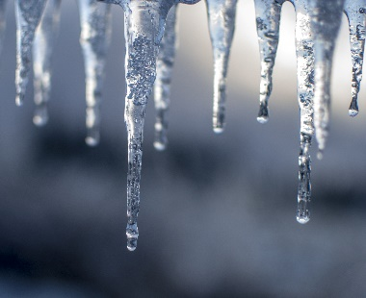

Icicles
An icicle is a spike of ice formed when water dripping or falling from an object freezes. You might see one hanging from the guttering of a building or on plants and trees.

Icicles are hanging from the brown leaves on this bush – have a look in your local area and see if you can find some if the weather is very cold?
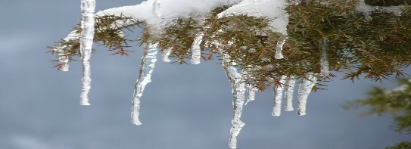
As they melt, icicles can drip very cold water from their tips. You can touch one or try to catch the drops.

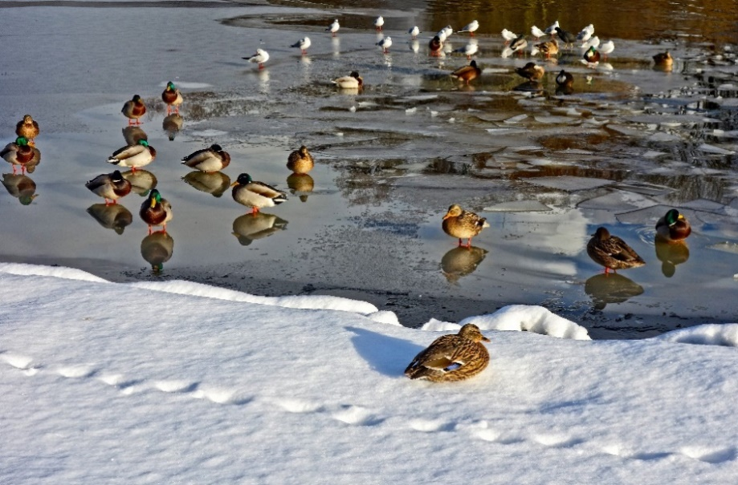
You might see birds standing on frozen ponds when it is very cold and icy. They stand very still to try and keep warm. Sometimes you may see them landing on a frozen pond – do you think they will slip and slide?

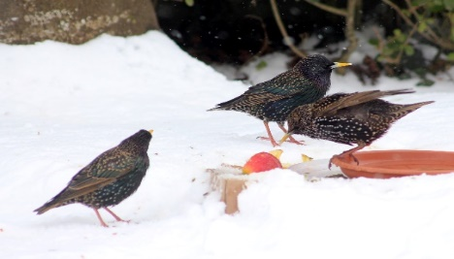
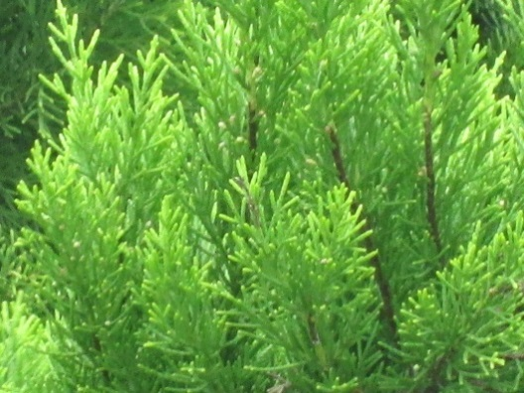

Birds and animals might not find food easily when the ground is hard and cold, if you are very quiet and still you may see some eating apples or other fruits and nuts that have fallen from trees

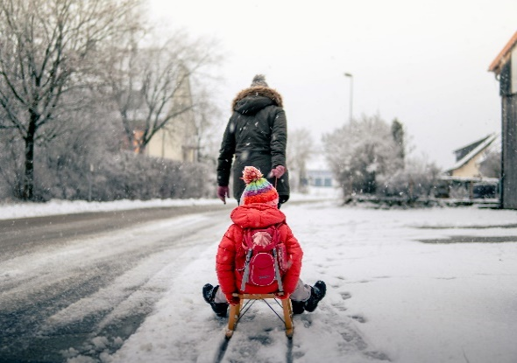
Snow
Snow forms when tiny ice crystals in clouds stick together to become snowflakes. If enough crystals stick together, they'll become heavy enough to fall to the ground.
Snowflakes that fall through moist air that is slightly warmer than 0 °C will melt around the edges and stick together to produce big flakes. Snowflakes that fall through cold, dry air produce powdery snow that does not stick together. (www.metoffice.gov.uk/weather/learn-about/weather/types-of-weather/snow/how-does-snow-form )
Snow is formed when temperatures are low and there is moisture in the atmosphere in the form of tiny ice crystals.

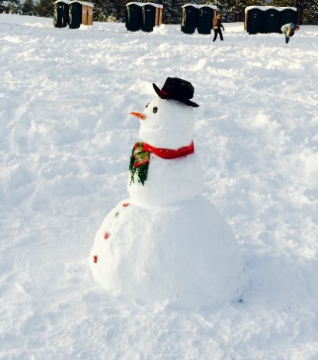
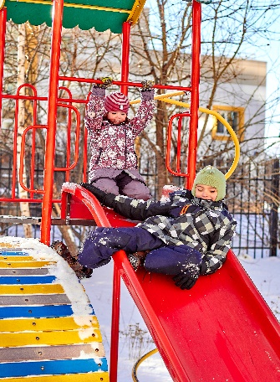
Snow Activities
Can you make a snowman? How many do you see when you are out on your walk – do they all look the same? You can talk about size and shape, colours of their scarves, or how many buttons (pieces of coal or stones) they have on their tummies?

Wrap up warmly and experience playing in the snow – gloves will be needed, especially if playing at the playground – metal can be very cold! Foster your child’s independence by letting them start to put on their own outdoor clothing – with support and encouragement.

Nursery Rhymes
While out in the winter, say or sing nursery rhymes together such as ‘I’m a little snowman’

“I'm a little snowman short and fat,
Here's my scarf and here's my hat.
When I see the snowfall,
Hear me shout
- All you children please come out!”

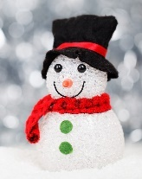

Snow Angels
Can you find any snow angels on the ground? You can make your own by wrapping up in warm clothes and lying flat in thick snow. Move your arms up and down and your legs from side to side. You will make the shape of an angel in the snow.
For other ideas for fun in the snow go to CBBC
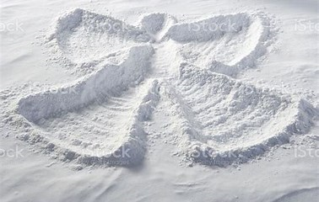

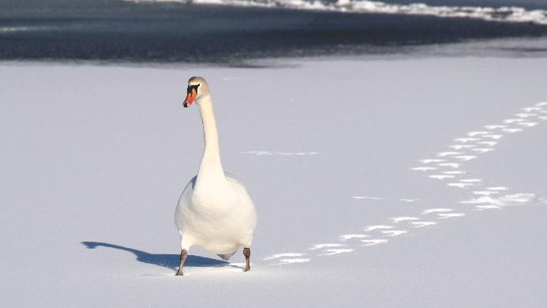
Animal Tracks in the snow
Have you seen any animal or bird markings in the mud, snow or frost? To find out what animal or bird they may be go to The Woodland Trust website for ideas or go to the The Royal Society for the Protection of Birds (RSPB) website.
In your street or park you may find tracks from birds, dogs, cats or even foxes, rabbits or squirrels– look carefully.

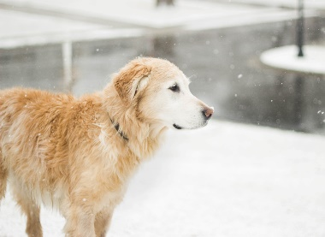
The swan’s prints are flattened because they have webbed feet to help them swim. Many other birds like robins and sparrows have arrow shaped prints like those below.
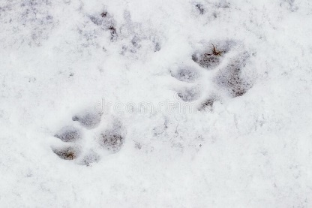
dog paw prints in snow

Thistle prickly
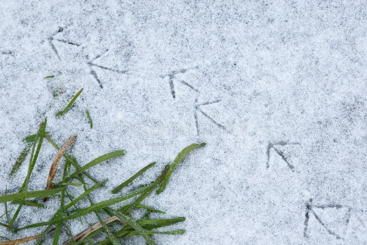
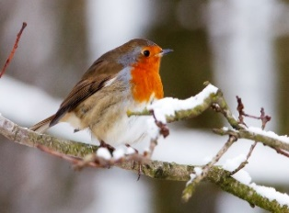
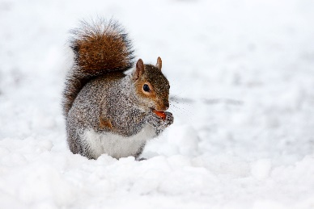
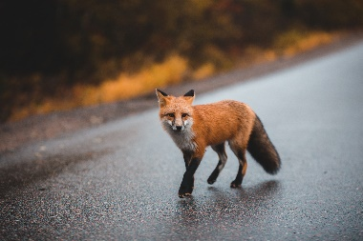
robin
fox
squirrel

