Star Light
Star Bright.
Celebrating with Food
Winter celebrations
At this time of year there are many religious celebrations such as Hanukkah, Christmas, Diwali and Milad un-Nabi. Find out about these winter festivals here: My First Festivals - CBeebies - BBC
Foods are an important part of these celebrations. To help young children understand how special these occasions are you might like to have a little party of your own. You could try making foods from different celebrations:
- People from the Jewish faith sometimes make ‘potato latkes’ to eat at Hanukkah: Potato Latkes
- People from the Hindu faith sometimes eat Indian sweets such as ‘shankarpali’ at Diwali: Shakarpara-recipe-shankarpali

Christmas Polish gingerbread biscuits
During advent, some Polish families bake ‘piernicki biscuits’ these can be different shapes such as hearts and animals. Make some biscuits together using the method below: https://www.thespruceeats.com/polish-gingerbread-cookies-pierniczki-recipe-1136960
Encourage your child to help and mix all the ingredients together.

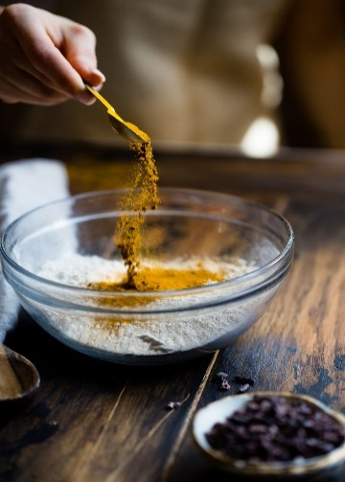

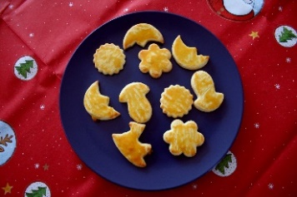
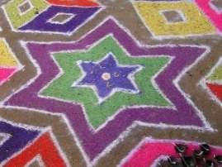
Edible Sparklers
For those celebrating Guy Fawkes Night, also known as Bonfire night, these tasty breadstick sparklers make for a tasty treat.
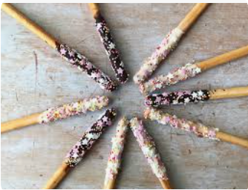
All you will need are breadsticks chocolate for melting and sprinkles for decorating.

Rangoli patterns with coloured rice
Hindi families may decorate their homes during Diwali with Rangoli patterns. Rangoli means ‘colour’ and it represents welcoming people into the home.
You might like to have fun making Rangoli patterns.
Soak rice in a small amount of water with food colouring.
Dry the rice out. Look at Rangoli patterns and talk about the shapes and colours: rangoli-coloring-pages
Put rice onto a plate or tray. Can you make shapes
or patterns using coloured rice?
Diwali 2025: Fun activities to celebrate Diwali - BBC Tiny Happy People

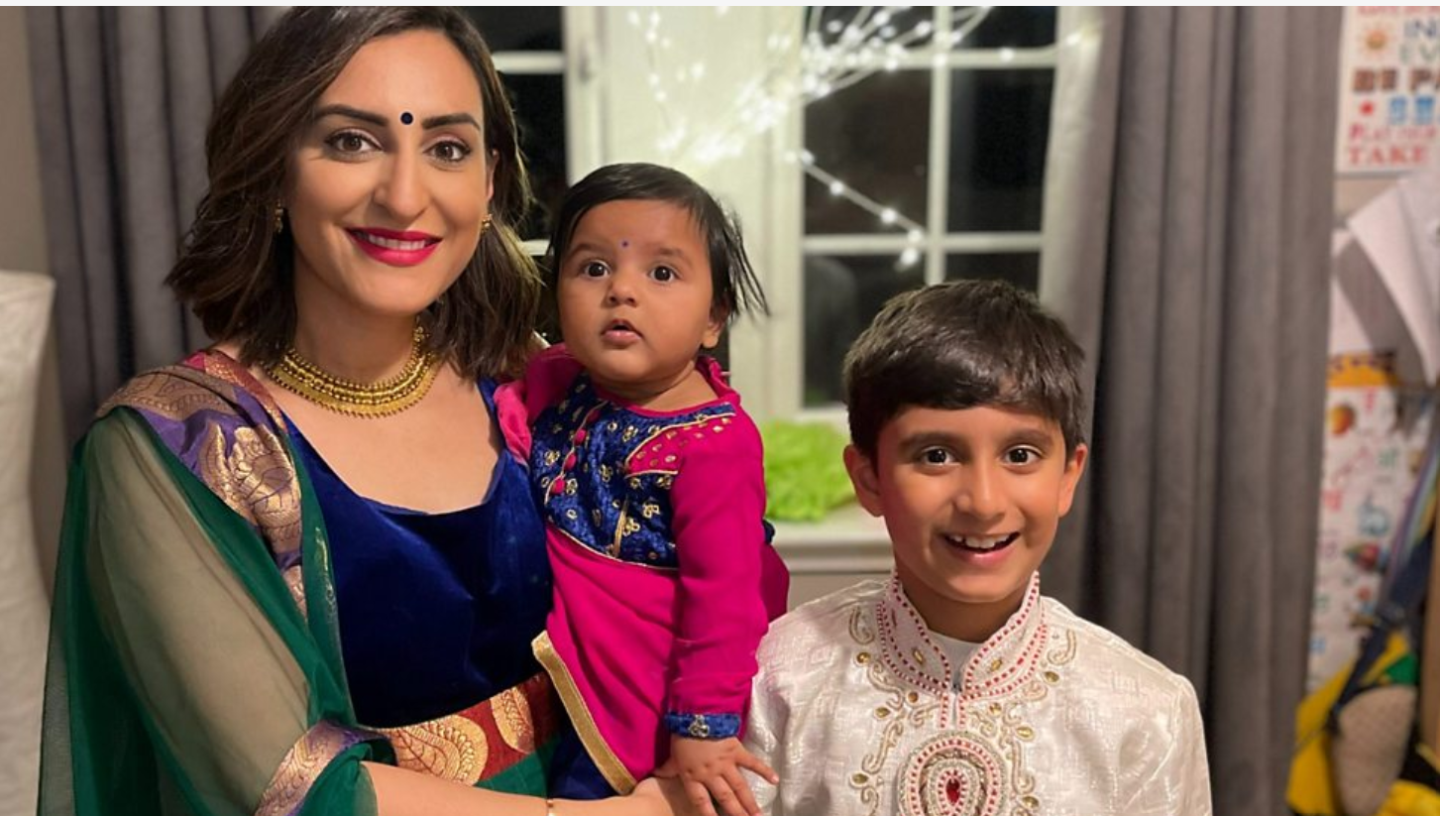

Information for Parents/Carers
Communication and Language
3 and 4 years
You might notice that your child can:
- listen to longer stories and can remember a lot of what happens.
- use lots of different words and likes to learn new words.
- use words and actions to explain their thoughts and ideas. Give their point of view and disagree.

Top Tips
When talking about foods:
- Talk about what things look like, the colours, shapes and sizes. Use words such as little, large, round, curved, lumpy, flat, long, thin, thick, bright, colourful, dark, light
- Talk about what things smell like. Use words such as strong, weak, spicy, cinnamon, ginger, fruity, fragrant
- Talk about what food tastes like and their textures. Use words such as sweet, savoury, dry, crumbly, hard, crunchy, spicy, salty, lumpy, liquid, smooth
- Count the number of biscuits and foods you’ve made and use words such as more and less.

Chatting Matters
Vocabulary and increasing the number of new words you child hears every day is very important for future learning. Use bold for suggested words

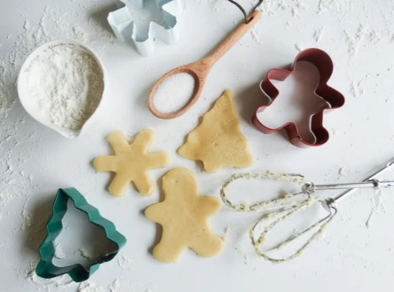

Personal Social and Emotional Development
3 and 4 years
You might notice that your child can:
- is keen to be independent, especially around dressing and feeding themselves.
- begin to eat independently, learning to use a knife and fork.

Understanding the World
3 and 4 years
You might notice that your child can:
- is learning about their own life -story and their family’s history.
- is learning to develop positive attitudes about the differences between people.
- knows that there are different countries in the world. Talks about differences they have experienced or seen in photos.

Find out more about your child’s development
What to expect in the Early Years: A guide for parents

If you have any concerns about your child’s development the first thing you can do is chat to your child’s Key Person at their setting.

Find out more

CBeebies parenting
Health for under 5s

Small Talk | National Literacy Trust

Learning to talk - Start for Life - nhs.uk

Homepage | Best Start in Life

the-lets-go-club-baking-tips

Home - Starting Reception



