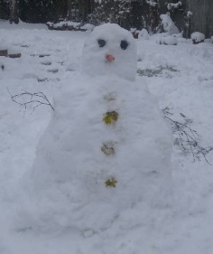
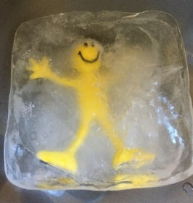

Exploring snow
Go outdoors if you can or bring some snow inside in a bowl. Let your child explore it, feel how cold it is and how they can squeeze it into ball. Talk about it being freezing, icy, tingly cold, squeezed and squashed, crunchy, melting.

Making fake snow
To one cup of bicarbonate of soda (in baking section of the supermarket), gradually add one tablespoon of water at a time. Mix with a fork until correct consistency. Explore with your child how you can mould it or rub it between your thumb and finger. The dry snow will keep for a few days in a sealed plastic bag – try it in the fridge for a cooler feel.

Help the creature escape
Put a small toy, like a plastic figure or toy car into a small container of water and freeze overnight. Can your child help the toy escape? The difficult thing here is to let your child explore ways without telling them- this maybe the first time they have explored that warmth will melt the ice…whether this is their hands or they ask you for water. Some children may drop or try to smash the ice.

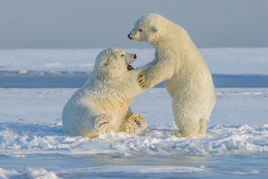
Animals in the cold
Polar bears have thick layers of fur. Look at the birds outside how they fluff up their feathers. The fur and the feathers trap air and this keeps the warmth in. Cuddle up in a duvet- it keeps you warm because of the air trapped inside its filling. Snuggle and share a story together about Cuddly Dudley You can talk about how the penguin made friends – eventually!
Penguin parents carry the egg or baby penguin on top of their feet. I wonder why? Try walking or waddling like a penguin with a ball or cuddly toy on your feet.

Ice Worlds

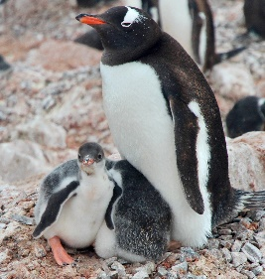

Playing pretend animals
Let’s get moving and play at being different animals.
Playing pretend animals - BBC Tiny Happy People offers tips and ideas on how to pretend successfully with your child and includes videos to support

Create an ice mini world
Use small toy animals, some cake decorations, or
twigs, stones, pine cones to add to your snow, maybe some ice cubes. Talk about what is happening or might happen. Perhaps create a story together.

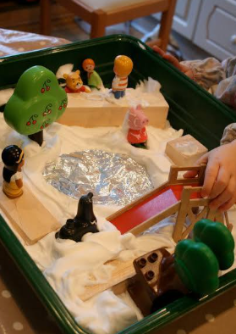
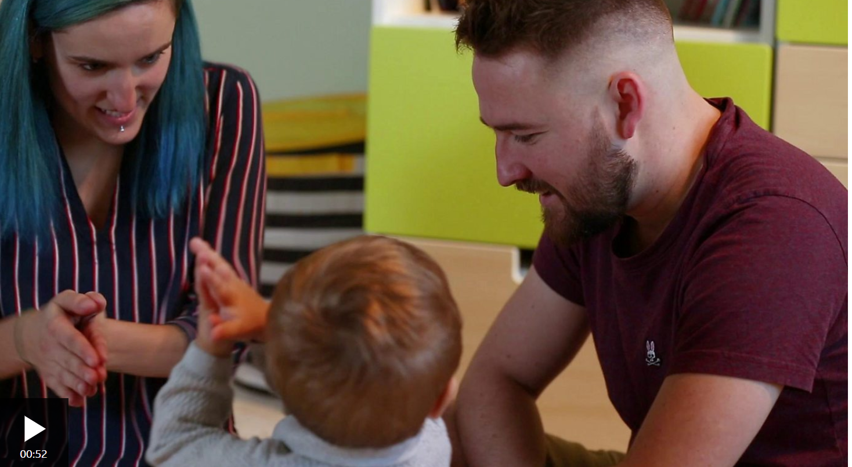

Information for Parents/Carers
Communication and Language
3 and 4 year olds
You might notice that your child can:
- Have conversations but often jumps from topic to topic.
- understand simple questions about ‘who’, ‘what’ and ‘where’ (but generally not ‘why’).
- listen to simple stories. I can understand what is happening, with the help of the pictures.

Top Tips
Children need to explore their world practically to begin to understand it. Let them feel that snow is cold and if they go out in the rain, they will get wet. The words Wet and cold then have some meaning to them – of course support them with drying off and warming up.

Try to let children discover what happens as a result of their actions, rather than tell them. Ice disappears and turns into water when it gets warmer- we know this by years of experiencing it, but children need to see this happening repeatedly to understand it. Use questions like I wonder why that happened? to help them explore their thinking. The Snowman book is fantastic for this – just pictures for you to share and talk about with your child.

It’s fine to say to your child I don’t know and then explore through trial and error, possible answers. Children are natural scientists and need to be encouraged to have a go (safely).

Chatting Matters
Vocabulary and increasing the number of new words you child hears every day is very important for future learning. Use bold for suggested words

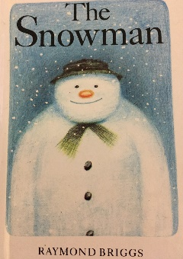

Characteristics of Effective Teaching and Learning: Playing and Exploring
You might notice that your child can:
- understand that their actions have an effect on the world, so wants to keep on exploring.
- make independent choices.
- respond to new experiences that you introduce.

Listen to and see The Snowman book here
Find out more

Move like a penguin

CBeebies Parenting

Health for Under 5s

Small Talk | National Literacy Trust

Learning to talk - Start for Life - nhs.uk

Home - Starting Reception

Homepage | Best Start in Life



Understanding the World
3 and 4 year olds
You might notice that your child can:
- enjoy exploring the natural world such as splashing in puddles, looking for worms and minibeasts.
- notice differences between people.

Find out more about your Child’s development

What to expect in the Early Years: A guide for parents

If you have any concerns about your child’s development the first thing you can do is chat to your Child’s Key Person at their Setting.

