
Rhyme Time ‘The Moon’
Play a game with me, Mr. Moon.
Can you look like a white balloon?
Can you hide half of your face
and move around high up in space?
Can you look like a smile on its side?
I can't see you where do you hide.
Can you look out of your window at night and see the moon? Does it look the same every-day? The moon appearance changes on a cycle. Perhaps use paper or paper plates to re-create the phases of the moon. Find out more - Moon phases
Listen to the story and Watch Hatem as he shows us how he illustrated different parts of the story that highlight different aspects of Ramadan. Join Hatem to give it a go yourself and draw your own very special moon. Celebrate Ramadan Kareem | Words for Life

Space Fun

Story Time 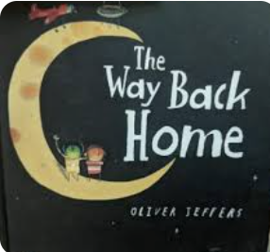
Listen to Dr Who as he tells the story of
The Way Back Home about a boy who finds himself making a friend in space.
Or take a trip to the local library to locate the book.
Create your own space rocket or alien spaceship.
Use an empty kitchen towel holder, decorate your rocket with felt pens, paints or stick coloured paper, wrappers to it.
Can it blast into space? Or use it in your Den?
Or create a telescope? Cover the end with some clingfilm and decorate. Look out your window at night and explore the dark sky, do you see any stars? What else can you see?


Create a Cosy Dark Den
Collect a blanket, towel, or sheet. Hang it over or peg it over a table, chair, or sofa to build a Den.
This will create a small space that
Your child will love. Perhaps use a torch or a mobile phone torch and explore light patterns, shadows and the Dark! To find out more about creating shadows explore here
Use this space to read other stories by torch light.
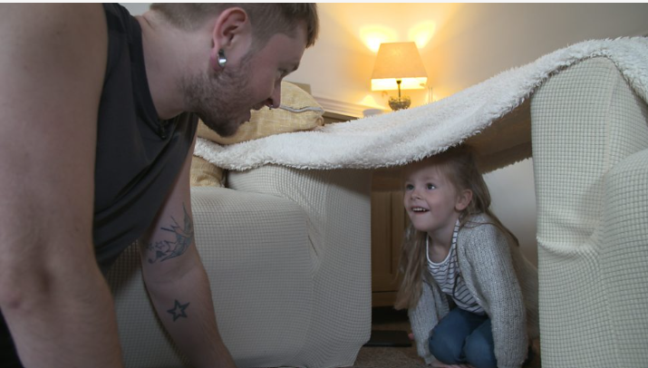 Building Dens With Kids - BBC Tiny Happy People offers lots of ideas on the benefits of den building with your child.

Chatter Together
I wonder where light comes from …….
Ask your child to share their ideas?
Chat about different lights and bring new words into your conversation, stars, moon sunlight, lightbulb, torch, fireworks, fire, light and dark, shadow, silhouette.
When is it dark or light, when is it sunrise and sunset?

Let’s Sing
Join your child in singing some nighttime songs –
Twinkle, Twinkle Little Star | Words for Life – lie on your back and watch your hands as they follow the actions while you sing.

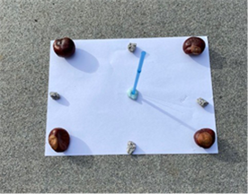
Making a telescope to see the night sky.
Make a Cardboard Telescope: Ideas for Grandparents - BBC Tiny Happy People

All you need is a tube.
Decorate using pens, crayons, stickers
And pretend to look for the moon and
stars.

Information for Parents/ Carers
Communication and Language
3 and 4 year olds
You might notice that your child can:
- When I am playing, I talk to pretend: “Let’s go on a bus... you sit there... I’ll be the driver.”
- I can use long sentences of four to six words.
- Use lots of different words. I like to learn new words.

Top Tips
Allow children to create their own dens and artwork and encourage them to use their own imagination to develop their play, could they visit the moon, can they pretend they are following an adventure in a book?
You may have some ideas and could assist your child on the journey, by asking prompting questions such as ‘what should be take on our journey?’ And ‘where should we go in our rocket?’
Creating a den or quiet space is the perfect place to pretend and make believe. Helping your child to show an understanding of the world they live in.

Chatting Matters
Vocabulary and increasing the number of new words you child hears every day is very important for future learning. Use words like crescent, moon, full or half-moon, candle, sunlight, lightbulb, torch, stars, fireworks, fire, light and dark, silhouette, and shadow.

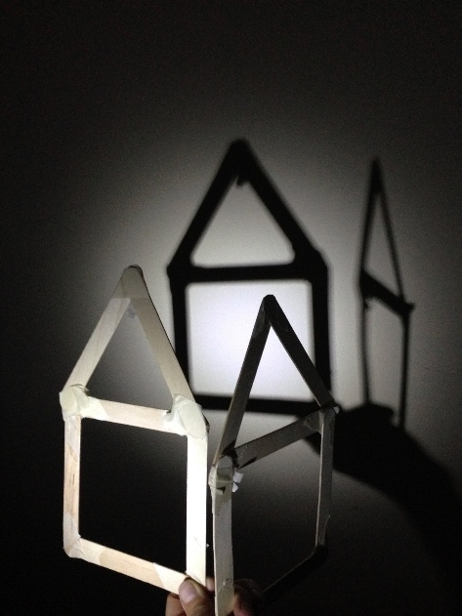

Expressive Arts and Design
3 and 4 year olds
You might notice that your child can:
- Take part in simple pretend play, using an object to represent something else.
- Enjoy exploring different materials freely. Develop my ideas about how to use them and what to make.
- Join different materials together.

Find out more

Space Website – CBeebies

Health for Under 5s

CBeebies Parenting

Learning to talk - Start for Life - nhs.uk

Homepage | Best Start in Life

Small Talk | National Literacy Trust

Home - Starting Reception


Physical Development
3 and 4 year olds
You might notice that your child can:
- Join in with group and team activities. Sometimes I like to make these up with my friends.
- Can think carefully about which movement I need to make, for example whether to crawl, walk or run across a plank, depending on its length and width.

Find out more about your Child’s development

What to expect in the Early Years: A guide for parents

If you have any concerns about your child’s development the first thing you can do is chat to your Child’s Key Person at their Setting

