

NEN Competency Framework Audit
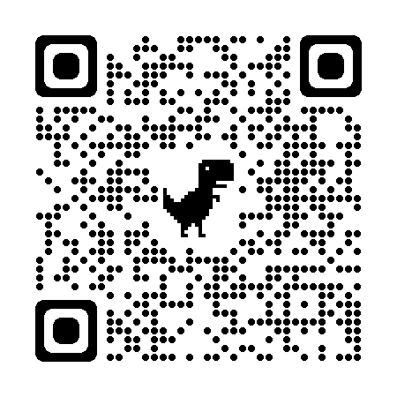

Name:
Setting:

Key: E = Emerging – An area where there is room for development, or we haven’t yet considered
D = Developing – We’re on our way
S = Secure – We know we do this well and can explain and demonstrate how

Early Years Service November 2025
Buckinghamshire – Competency Framework Audit
A Unique Child
Principle One: Understanding the strengths, interests, and needs of each autistic child.
C1. I identify the key strengths and needs of autistic children in the areas of social understanding and communication; flexibility, information processing and understanding, and sensory processing and integration.
C2. I understand that many autistic children have co-occurring conditions and differences. They experience high levels of anxiety and stress, and these can create barriers to learning. I know that a child may display behaviour based on a combination of factors and I work hard to understand the causes and functions of the behaviour
Principle Two: Enabling the autistic child to contribute to and influence decisions.
C3. I include, consult, and support children to communicate their experiences. I understand the importance of observing and listening to the child. I regularly involve children in any decisions being made
C4. I see the child as a partner in their learning and actively involve autistic children in the development of their learning goals.
A Unique Child: | Focus Standard Numbers | Current Status: | Next Steps |  | Review
Positive Relationships:
Principle Three: Collaboration with parents/carers and other professionals and services Relationships
C5. I engage and build up trust with parents/carers to establish and develop ways of communicating and sharing information, ideas, and progress.
C6. I collaborate with health, social care, and other professionals to improve educational experiences and outcomes for autistic children.
Principle Four: Workforce development related to good autism practice.
C7. I engage in professional development that enables me to address the needs of autistic children and to enhance and embed inclusive practice.
C8. I reflect on, note down, and gather data on the implications of my learning and development for my own practice, and ultimately for the autistic child/children I work with.
Positive Relationships | Focus Standard Numbers | Current Status: | Next Steps | Review
Enabling Environments
Principle Five: Leadership and management that promotes and embeds good autism practice.
C9. I create enabling environments based on what I know of the individual child and through making reasonable adjustments accordingly.
C10. I create positive, supportive, and caring relationships, between autistic children and staff, between autistic children and their peers, and between parents/carers and staff.
Principle Six: An ethos and environment that fosters social inclusion for autistic children.
C11. I understand the importance of focusing on identifying and addressing barriers to learning in the three areas of difference, namely social understanding and communication; flexibility, information processing, and understanding; and sensory processing and integration.
C12. I provide a clearly organised learning environment that takes into account the needs of autistic children.
Enabling Environments | Focus Standard Numbers | Current Status: | Next Steps | Review
Learning and Development
Principle Seven: Targeted support and measuring the progress of autistic children.
C13. When assessing progress towards learning goals, I have a holistic approach that builds on strengths and interests, whilst addressing skills and understanding that autistic children may find difficult as a result of their autism.
C14. I am involved in the development and implementation of child-centred support plans in partnership with children, parents and other staff.
Principle Eight: Adapting the curriculum, teaching, and learning to promote wellbeing and success for autistic children.
C15. I strive to understand autistic children and I adapt the learning environment and my teaching approaches to provide high-quality support for autistic children.
C16. I promote positive attitudes towards autism and have high expectations for all the children I work with.
Learning and Development | Focus Standard Numbers | Current Status: | Next Steps | Review

