Go for a walk with your child, and see if you can spot any birds, bugs or animals
Spring Spotter Sheet 2

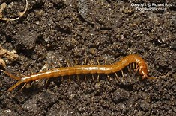
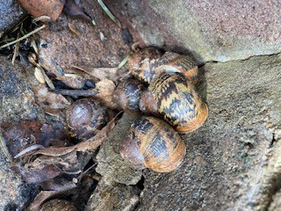
As the weather warms up you may start to see more birds and animals – put on your coats and see what you can find.

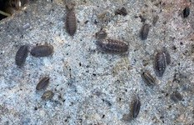
Most centipedes don’t have 100 legs. They have two legs per body segment, and they all grow to different lengths. It is fascinating to watch them move all these legs!

A snail is a gastropod, meaning it has a soft body with a flat base which it uses to move around. They like damp places but are a favourite food of some birds – you may see empty shells!

Woodlouse: These minibeasts love damp, dark places such as piles of dead leaves and rotten logs.

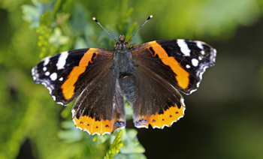
Butterflies: The Red Admiral is a butterfly that is seen in England in spring. They lay their eggs on the tips of nettles, which the emerging caterpillars eat. Adults feed on nectar from flowers.

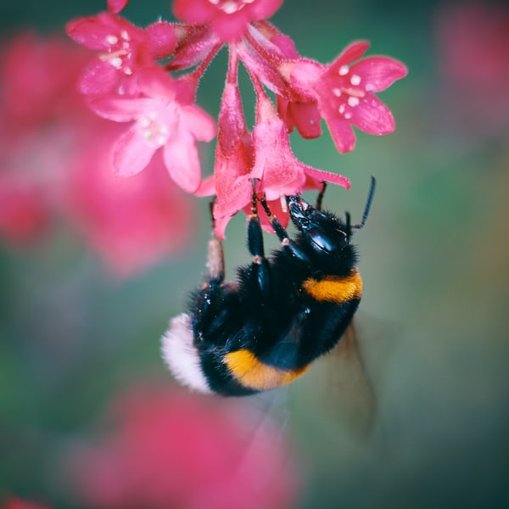
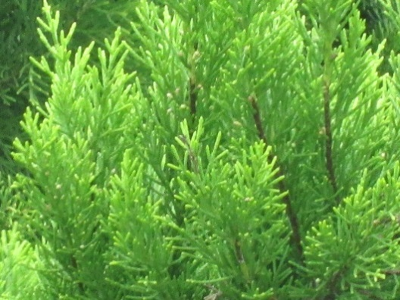
In spring you might see large bumblebee Queens looking for somewhere to nest. Bumblebees seen in late spring and summer are usually female workers or males. Between spring and late summer these buzz from flower to flower, picking up and spreading pollen.

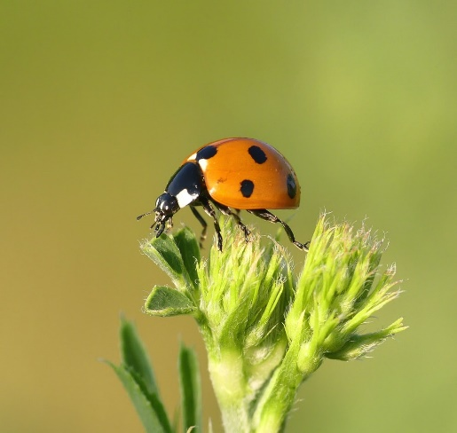

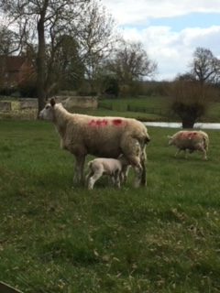

In the Spring you might see lots of baby animals and birds. Baby sheep are called lambs, they can be seen in the fields. Spot the ewes (female sheep) and sometimes the male rams. What other baby animals or birds can you see?

Ladybirds are brightly coloured - maybe count their spots. They feed on very small insects, like greenfly aphids. They can be seen from April onwards.

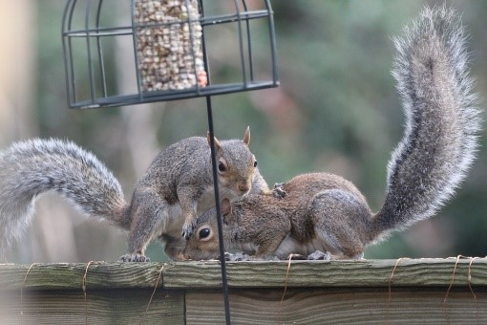
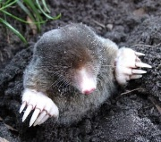
Squirrels are very busy in Spring, collecting food, especially nuts. They can be seen in parks and gardens.

Did you know that moles live under the ground? You are unlikely to see them, but you may be able to tell where they have gone from molehills in the grass. Molehills look like mounds of mud in a row.

A picture of a mole

Foxes can be seen in the town or countryside; they may even look for food in dustbins.
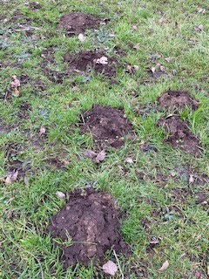

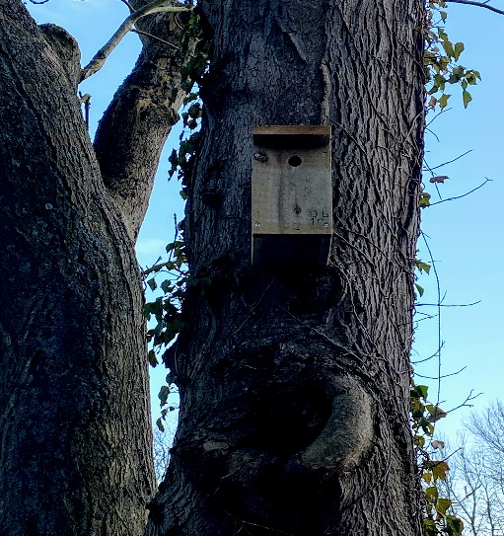
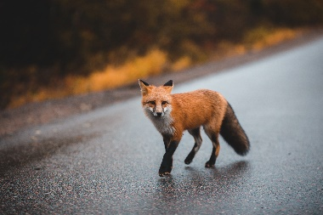

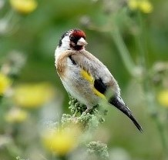
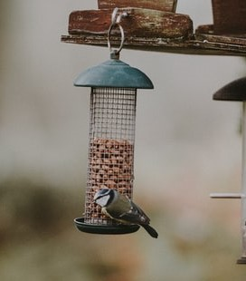
Birdboxes are attached to trees to encourage birds to nest in them. You may spot them in your local park, or you could put one in your garden.

Thistle prickly

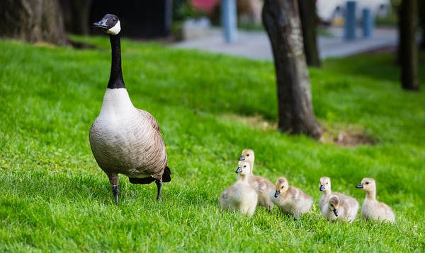
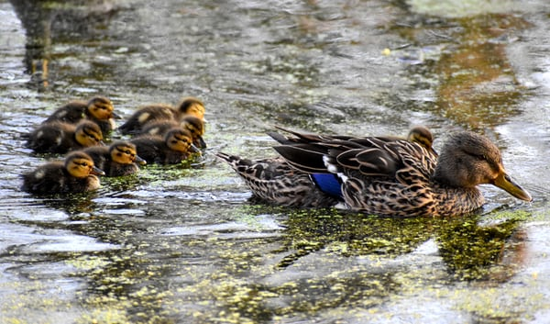
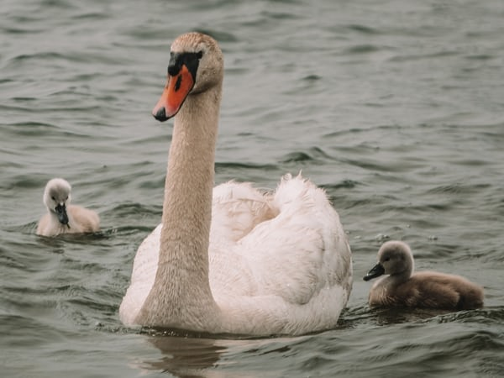
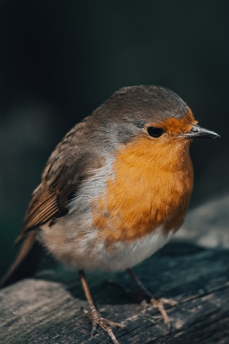
Mute Swan -baby swans are called cygnets – they are the bird in the Ugly Duckling Story Listen together and talk about how the duckling felt.
In spring at your local park, river, canal or even in your own garden or street you will find lots of birds, animals and bugs. Look under stones or logs for minibeasts – let them go back to where you found them, their habitat. Listen to hear the birdsong in daytime or evening and find exciting new creatures.
Canada Goose and goslings.
Did you know that baby geese are called goslings?
Mallard Duck and her babies. Did you know that baby ducks are called ducklings?
Goldfinch use their beaks like tweezers to get seeds out of plants. A group of goldfinches is called a ‘charm’. You can see these in bushes or shrubs

You will see some birds feeding from food that people have put into feeders for them. This one is a blue tit. It is a little bird which has a yellow tummy and blue on its head and wings. Have you seen one?

The robin likes to eat from the ground, or from food trays. They sing very loudly

