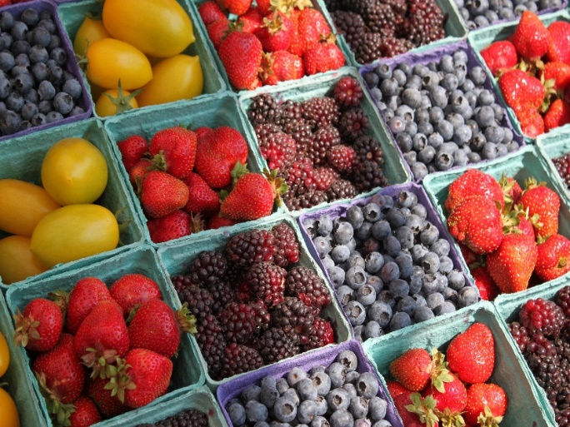****

**Getting to the** **Shops**

Do you normally go by car? Consider using a bus instead. Learn and sing during your journey [Learn The Wheels on the Bus](https://wordsforlife.org.uk/activities/wheels-on-the-bus/). Talk about what you can see out of the windows on the route. [More tips for bus journeys](https://www.bbc.co.uk/tiny-happy-people/articles/zvcbgwx) click here

**Prepare for your visit**

Make sure you have a drink/snack for your child unless you intend to buy them.

Decide what shop you wish to visit and why? Make decisions with your child and give them choices. Is it the fruit and vegetable area of a supermarket or a separate shop selling fruit and vegetables - a ‘greengrocer’ – what do you need to buy? What will interest your child? Chat to your child about the choices and involve them making the decisions.

**A visit to the shops to buy fruit and vegetables**



**Make a shopping list together**

This is the perfect opportunity to model writing with your child. Make sure you both have paper and a pen or pencil. You talk about what you would like to buy and write it on your list. What would your child like to buy? Can they ‘write’ it on their list? Let them practise making marks across the paper to represent letters and words

[Children’s shopping list activity | Words for Life](https://wordsforlife.org.uk/activities/making-shopping-lists-your-child/) for more ideas.

**When you get home**

Allow your children to taste some of the fruit and vegetables you have bought – can they be eaten raw, or do they have to be cooked? What do they smell like or feel like (what texture do they have)?

Ask the children what they taste like, add new words such as ***bitter, tart, sour, sweet*** to put flavours into words.

Use the scales to weigh the vegetables, which is *heavier* or the *heaviest*, *lighter* or *lightest, biggest* or *smallest, shortest* or *longest*? Think together about the shapes, tomatoes are round and curved, grapes are ovals, what other vegetables are the same shape?

**Paying for your Shopping**

Let your child help you put the shopping on the conveyor belt if in a supermarket. Count how many apples, bananas you have chosen.

Can you use cash? – talk to the children about different ways of paying and when you get home talk to them about different coins & notes, pointing out the numbers, sizes and colours of the coins. Use words like *pence, pennies, pounds, coins, notes, more and less*.

At home make pretend greengrocers and act out the trip.

**Top Tips**

Time your visit – do not go when your child is tired or hungry.

Set some ground rules – do not buy treats or snacks every time you go.

Go shopping with a purpose – as a way of helping your child’s learning, rather than an opportunity to do your main weekly shop.

Give yourself plenty of time – it can be exciting for children to be able to see everything.

If you are using a supermarket, children may be able to talk to the supermarket’s assistants as they stock shelves?

**Chatting Matters**

Vocabulary and increasing the number of new words your child hears every day is very important for future learning. ***Taste, texture, bitter, sweet, sour, smooth, fuzzy, hard, bumpy, crunchy, soft, juicy.***

**Communication and Language**

**3 and 4 year olds**

**You might notice that your child can:**

* use lots of different words and likes to learn new words.
* Can understand when you ask them questions about why something happened, I understand, e.g. “Why do you think the pumpkin got so big?”

**Information for Parents and Carers**

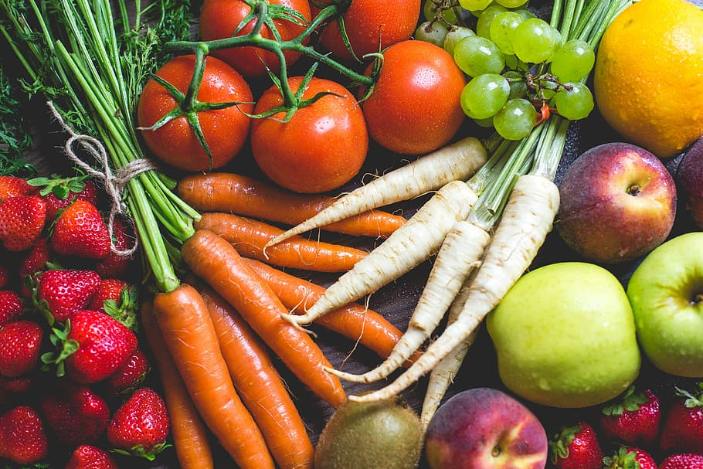

**Find out more**

[Let's get talking - Health for Under 5s](https://healthforunder5s.co.uk/sections/toddler/lets-get-talking/)

<https://wordsforlife.org.uk/>

[CBeebies Parenting](https://www.bbc.co.uk/tiny-happy-people)

[Learning to talk - Start for Life - nhs.uk](https://www.nhs.uk/start4life/baby/learning-to-talk/2-to-3-years/#anchor-tabs)

[Home - Starting Reception](https://startingreception.co.uk/?es_c=308CAA55AD47458C53A7854E8022C490&es_cl=31CAEEFA6CD7BB5DA1A8D907712C1260&es_id=ph7%C2%A322)

**Maths**

**3 and 4 year olds**

**You might notice that your child can:**

* quickly recognise groups of up to 3 objects, without having to count them individually (this is called ‘subitising’).
* say one number for each item in order: 1,2,3,4,5.
* show ‘finger numbers’ up to 5.

**Physical Development**

**3 and 4 year olds**

**You might notice that your child can:**

* choose the right tools for what I need to do.
* work with friends to carry large objects.
* showing whether I am left or right-handed.

**Find out more about your Child’s development**

[What to expect in the Early Years: A guide for parents](https://foundationyears.org.uk/files/2021/09/What-to-expect-in-the-EYFS-complete-FINAL-16.09-compressed.pdf)

If you have any concerns about your child’s development the first thing you can do is chat to your child’s Key Person at their setting.