Characteristics of Effective Learning

Playing and Exploring

Play acts as a catalyst for active learning, creating and thinking critically and it is often through play that children will choose to engage at the edge of their ability, thus challenging themselves and further developing their learning power.
The EYFS describes three aspects of playing and exploring:

Finding out and exploring

The key to this aspect is learning through trial and error. Children are naturally curious and will use their senses to explore the world around them. Babies will mouth objects as well as using their hands to explore, to provide as much information as possible as they try to make sense of their world. Children need continued opportunities for sensory exploration particularly when encountering new materials. Children who have opportunities for free exploration discover much more about possibilities and about their own capabilities than children who are given restrictive instructions. For example, when introducing clay to young children, those who have enough opportunity to explore freely initially will be able to work more effectively to produce an object. Children also need first-hand experience of the changes of season through outdoor provision and of materials found in the natural world.

Playing with what they know
Engaging in imaginative play supports children to make sense of their experiences and to put the information they have accumulated into context. Collaborative role play leads to symbolic thought, for example even very small children will put a dolly to bed because she is tired and will pretend to drink tea from a plastic mug. In this way pretend play leads to a more sophisticated level of thinking, as an object can stand for something else in children’s minds. For example, a toy brick can become a mobile phone and a child may talk into it and press pretend buttons to make a call. However, while it is a ‘phone' they are unlikely to put it in the water tray, the sand tray, pretend to eat it or build with it.
Adhering to rules around objects through pretend play in this way leads to self-regulation and increasing control of impulse. It is also possible for children to develop in other ways such as an increased level of empathy through, for example taking the role of Dad in the home corner.

Being willing to ‘have a go’
Children have a natural desire to explore, however this can sometimes be dampened by their experiences and particularly by the reactions of trusted adults. Adults often unknowingly transmit subliminal messages through facial and bodily reactions to children’s explorations and this can lead to avoidance patterns in children thus reducing future participation.
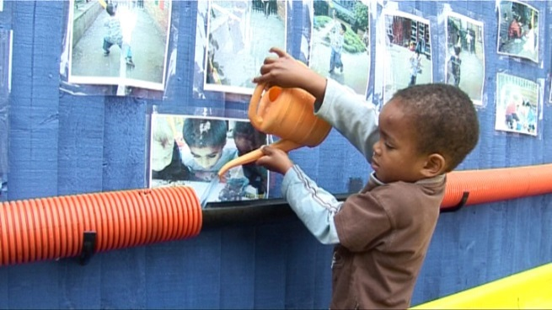
It is vital that we try not to let our own negative feelings influence children’s explorations. For example, children are often keen to explore mud, however many adults would not choose to engage in this exploration and may unwittingly communicate this message. It is possible to provide for this type of exploration so long as this is handled safely and sensitively.

Children who readily participate develop a much larger store of information and experiences to draw on than more passive children and this supports their continued learning. Children need to develop the confidence to view mistakes as opportunities for learning new things rather than becoming disillusioned by simply getting things wrong.
Implications for provision
- First-hand experiences of changes in seasons i.e. to feel drizzle, the snowflakes falling, the wind and experience natural changes in light and temperature etc.
- Chances to explore natural materials, a range of textures, smells, sounds etc. through hands on real experiences.
- Encourage free exploration of new materials before suggesting that they are used in a particular way.
- Provide a rich, stimulating and irresistible environment with open ended resources.
- Be aware of unintentionally restricting children’s imaginative use of materials and objects – develop an ethos of permission to use resources in different ways.
- Ensure sufficient uninterrupted time when children are fully engaged - develop flexible routines.
- Consider modelling novel uses of materials, for example, for den making.
- Provide a range of resources that match children’s current fascinations and interests.
- Develop the environment to become a flexible space with ample opportunities for free exploration.
Adult role
- Declutter the environment, look with fresh eyes and ensure that each area is interesting, enticing and resources are refreshed and readily accessible.
- Ensure experiences link to children’s fascinations and interests as these will motivate them to try new things and engage positively with risk taking.
- Model and talk about having a go yourself.
- Sensitively support more reticent children to develop their imaginative stories and roles.
- Demonstrate and discuss learning through mistakes.
- Show interest in discovering new things.
- Engage in children’s own interests, allow them to lead and then discover new things together.
- Model pretending an object is something else.
- Encourage children’s enthusiasm and growing confidence.
- Talk about how effort and practice will help with developing further skills.
- Become expert in judging when children need help and when they can be supported to keep trying through sensitive encouragement.
- Develop the sensitivity to judge when to intervene to guard against a child becoming too frustrated and when to allow children to encounter challenges and overcome them themselves.
- Support children to manage appropriate risk and to believe they CAN achieve.
- Support parents, carers and families to fully understand the vital role of play and exploration in children’s learning.

