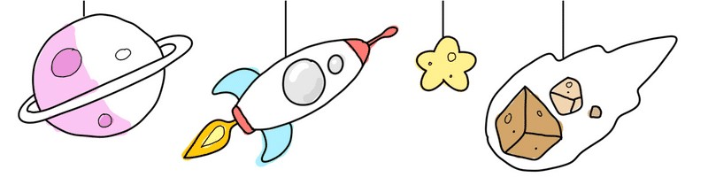
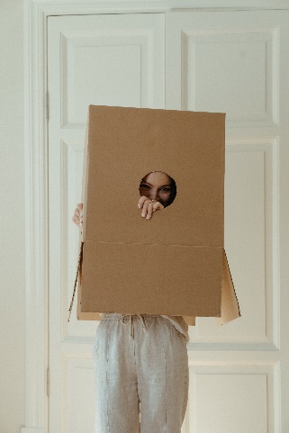
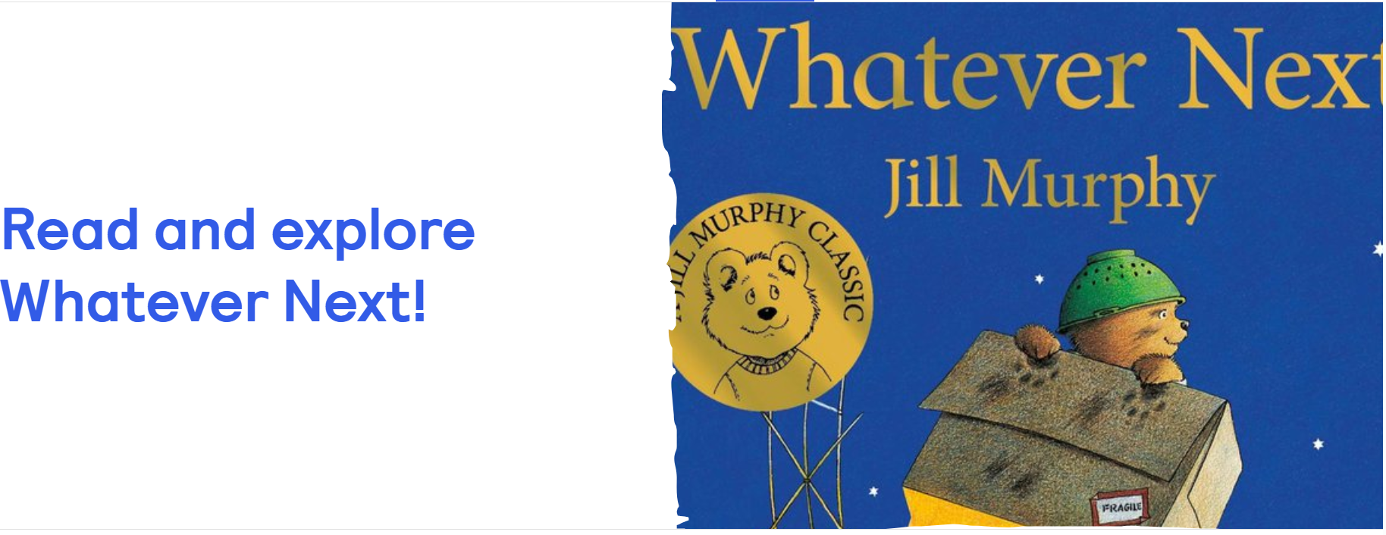 Share this classic children’s story with your child and see if you can recreate a rocket like Baby bear’s. Use a colander for his hat, boots like baby bear’s and a blanket and food for a picnic on the moon. Whatever Next by Jill Murphy
Build your rocket 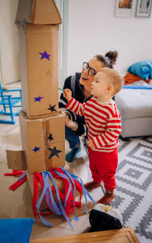

Look around the house for any materials to build your rocket. Here are some suggestions:

Cardboard boxes of different shapes and sizes.

Tape and scissors

Pens, crayons, paints.

The tip of the rocket is the nose cone.
The main section is the body tube.
There are fins on the sides.
Exhaust flames come out of the bottom.
There may be circular windows on your rocket.
Making Models | Words for Life for more ideas

Making friends with aliens

Encourage your child’s imagination by dressing up as aliens, or you could make alien costumes for cuddly toys. Imaginative play helps your child’s language development, social skills and imagination. All skills that will help them when they start school. Make up your own alien language and have fun being silly with your little one.

Build a rocket and get ready to take off!

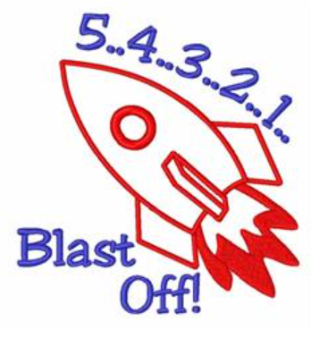

Songs for a space journey
‘Zoom, zoom, zoom’ | Words for Life – we’re going to the moon, we’ll be there very soon.
We're Going On A Rocket Ship - a fun song, easy to learn and sing along with your child.
Counting Fun with 5 Little Men in a Flying Saucer – a lovely song with simple actions that introduce counting backwards from 5, 4, 3, 2 and 1 to blast off!

Top Tips
Sensory play includes any activity that stimulates your child’s senses including touch, smell, taste, sight, hearing, movement and balance. A sensory activity encourages thinking skills as children explore, language development as children talk about their experience and it can also be calming as well as a rich social experience.

Gloop is a mixture of corn flour and water and when combined it creates an unusual texture that is lovely to play with.
To make Gloop, add 2 cups of cornflour with
1 cup of water and mix together (the mixing is all part of the fun). Add a few drops of food colouring if you wish.

The Gloop could be a new alien life form, the surface of a planet or a magical gift from one planet to another!

Chatting Matters
Vocabulary and increasing the number of new words you child hears every day is very important for future learning.

Communication and Language
3 and 4 years old
You might notice that your child can:
• begin to use longer sentences with words like “because” and “and” like “I cried, I did, because I banged my foot”
• ask lots of questions and answer your questions too.
• talk about what we are doing now, and what might happen later or tomorrow.
• use lots of words about things that interest me, like “astronaut” and “Neptune”.
• pretend about things when they are playing, like using my coat on my head “this is my magic flying cape”.

Information for Parents & Carers
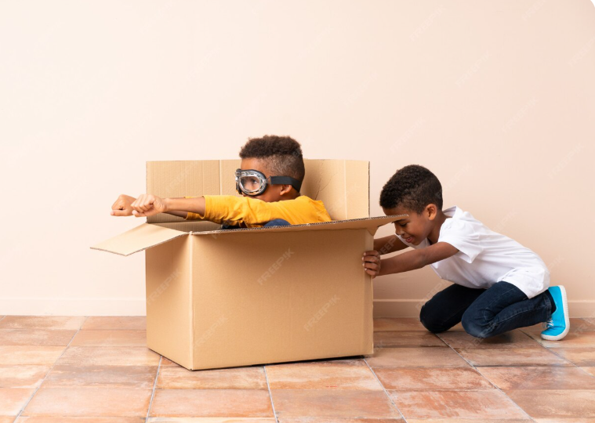
Find out more
Homepage | Best Start in Life

Why do kids play pretend? - BBC Tiny Happy People

Let's get talking - toddlers

Small Talk | National Literacy Trust

Learning to talk - Start for Life - nhs.uk

NASA’s Kids’ Club

Home - Starting Reception 

Writing
3 and 4 years old
You might notice that your child can:
• sometimes tell you about their drawings and paintings and what their writing means.
• tell you what they think your writing means, like the list of destinations says “Earth, Sun, Mercury, Pluto”.
• make the lines and marks that they want with a pencil.
• copy some of the letters in their name on a piece of paper by themselves.

