

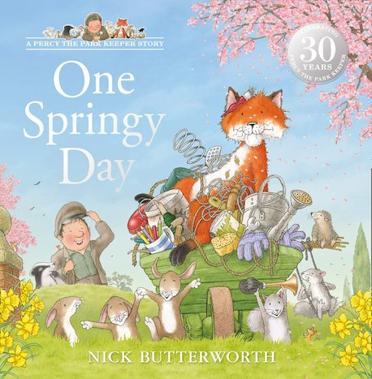
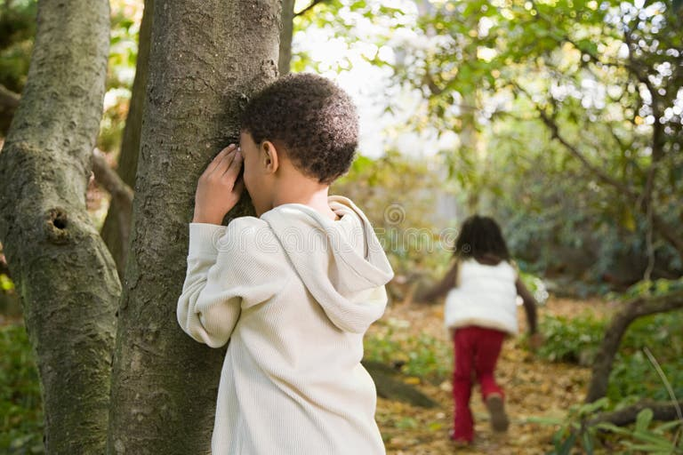
Spring is Here
Teach your children a traditional nursery rhyme “Mary, Mary, Quite Contrary” How does your
Garden grow?
Mary, Mary, Quite Contrary nursery rhyme music and lyrics | Words for Life
Whilst outside explore the feel of
being outside, can you spot any
flowers or bees? Look out for daffodils
and tulips. Note the height, how many hands tall are they – over the weeks do they get taller?

One Springy Day – By Nick Butterworth

Percy the Park Keeper - One Springy Day
To hear the story being read by Nick Butterworth
Perhaps visit your local library and select another Percy book to explore or try Nick’s you tube channel.
‘Lost Acorns’ by Nick Butterworth explores who has dug up all of Percy’s bulbs. Look at other pictures and talk about the park animals like badger, fox, squirrel.
Where do they live, what do they eat?
Visit your local park and look for squirrels and mole hills.

Game of Hide and Seek

Can you play hide and seek like Percy and his friends in the story? This game is a real mood booster, helps children practice following simple instructions and hear you use words for positions such as ‘under’ or ‘behind’.

Shout ‘found you’ when you do. Here is a video to inspire you and your child along with some top tips on how to extend the game. Play hide and seek games with kids - BBC Tiny Happy People



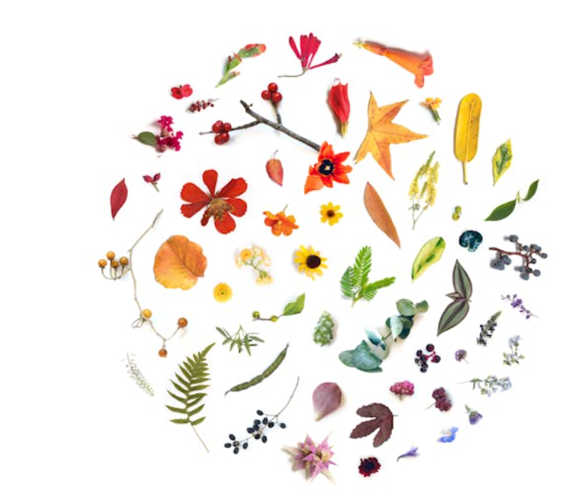 Spring Pictures
Collect items and create a Spring picture or pattern.
Use Natural resources, such as twigs, leaves, stones.
Notice shapes and patterns e.g. twig/leaf/twig/
leaf/ twig. See if your child can add the next one.

Use words to describe the objects…… hard, soft, small, large, bumpy, smooth, shiny, sticky etc?

ISpy Top tips for playing 'I Spy'
Take it in turns to play I Spy on a walk or at home. Change the word you use to match your child’s age, understanding and interests
‘I Spy with my little eye, something the colour of green’. Take it in turns to guess. You could start to provide clues if it proves tricky, such as it grows on the ground… could it be grass? You could make this harder, by introducing something beginning with the letter g. Ensure you can see it, bees, trees, flowers, hedge, leaves, sky.

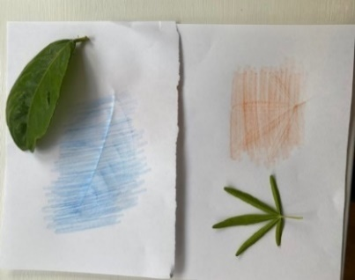

Leaf Rubbing
Collect some leaves and using white
paper and a wax crayon on its side if you
have one or crayons, pencils, felt pens?
Lay the leaf under the paper and crayon
over it and see if you can spot a pattern.
Have a go at different size / shapes.
Are leaves the same size / shape? You
could cut out the leaf shapes and create a collage picture.

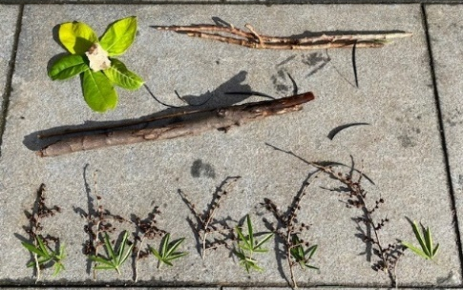
Information for Parents & Carers
Communication and Language
3 and 4 year olds
You might notice that your child can:
- I can use long sentences of four to six words.
- Use lots of different words. I like to learn new words.
- When I am playing I talk to pretend: “Let’s go on a bus... you sit there... I’ll be the driver.”

Top Tips
- Allow children to enjoy the game of Hide and Seek, encourage the language and counting skills, ‘coming to find you ready or not’. Talk about the hiding places children have found and discuss were they good places to hide. Talk about where the Fox hid in the story.
- You may have some ideas about how children could create their own artwork, however, try to encourage the children to tell you about what they have made, and comment on any patterns you may see.
- Support children by understanding how the fox would feel, about being covered in the items and running off. What can we do to make the fox feel better? What do you do when you are upset? Have you been stuck?

Chatting Matters
Vocabulary and increasing the number of new words you child hears every day is very important for future learning. Use words like hard, soft, big, small, large, biggest, smallest, stuck, boingy, hollow, pruning, trail, stuck, teamwork, tugged.

Chatting Matters
Vocabulary and increasing the number of new words you child hears every day is very important for future learning. Use bold for suggested words


Expressive Arts and Design
3 and 4 year olds
You might notice that your child can:
- Remember and sing entire songs.
- Sing the pitch of a tone sung by another person (‘pitch match’)
- Listen to sounds with increased attention.
- Respond to what I hear and express my thoughts and feelings.

Find out More

Teddington Teaches Nature

CBeebies Parenting

Health for Under 5s

Small Talk | National Literacy Trust

Learning to talk - Start for Life - nhs.uk

Home - Starting Reception

Homepage | Best Start in Life



Personal, Social and Emotional Development
3 and 4 year olds
You might notice that your child can:
- becoming more and more independent and enjoy being given resources and activities that I can use by myself.
- I can use different words to explain how I am feeling.

Find out more about your child’s development

What to expect in the Early Years: A guide for parents

If you have any concerns about your child’s development the first thing you can do is chat to your child’s key person Nursery, Pre-school or Childminder.

