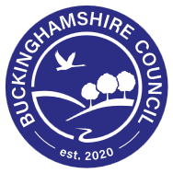

Buckinghamshire – Measuring the Impact of the Neuroinclusive Education Network
using the NEN Standards Framework
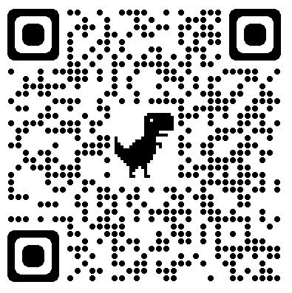

Name:
Setting:

Key: E = Emerging – An area where there is room for development, or we haven’t yet considered
D = Developing – We’re on our way
S = Secure – We know we do this well and can explain and demonstrate how

Early Years Service November 2025
Buckinghamshire – Measuring AET Impact Audit
A Unique Child
Principle One: Understanding the strengths, interests, and needs of each autistic child.
S1. We are committed to developing knowledge about autism, and we gather information from a range of sources to fully understand the individual autistic child.
S2. We take into account how each child’s co-occurring conditions and differences, including anxiety and stress, can affect behaviour and cause barriers to learning. We are committed to understanding the causes and functions of a child’s behaviour.
Principle Two: Enabling the autistic child to contribute to and influence decisions.
S3. We use child-centred approaches to consult and involve children in any decisions being made.
S4. We provide play and learning opportunities that are planned around the needs and interests of each individual child and that take into account their autism. We involve children as partners in their learning goals.
A Unique Child: | Focus Standard Numbers | Current Status: | Next Steps |  | Review
Positive Relationships:
Principle Three: Collaboration with parents/carers and other professionals and services Relationships
S5. We actively listen to and involve parents/carers in contributing to decisions about their child’s education and future aspirations.
S6. We work collaboratively with health, social care, and other professionals to improve educational experiences and outcomes for autistic children.
Principle Four: Workforce development related to good autism practice.
S7. We show a commitment to continuing professional development on autism across our staff and ensure they receive ongoing training that is appropriate to their role.
S8. We audit staff confidence levels, understanding and knowledge of autism, and the changes staff make to their practice as a result of undertaking professional development.
Positive Relationships | Focus Standard Numbers | Current Status: | Next Steps | Review
Enabling Environments
Principle Five: Leadership and management that promotes and embeds good autism practice.
S9. We promote a supportive environment where leaders and managers are knowledgeable about autism and cascade information to their staff. We encourage our staff to reflect upon, discuss, and evaluate their practice.
S10. We develop mutual understanding, communication, and support between autistic children and staff, between autistic children and their peers, and between parents/carers and staff.
Principle Six: An ethos and environment that fosters social inclusion for autistic children.
S11. Our enabling approaches foster a calm, low-arousal learning environment and we promote a sense of wellbeing, security, and belonging for our autistic children.
S12. Our learning environments are structured, understandable, and predictable. We adapt learning environments to enable children to participate fully in learning and play.
Enabling Environments | Focus Standard Numbers | Current Status: | Next Steps | Review
Learning and Development
Principle Seven: Targeted support and measuring the progress of autistic children.
S13. We use a holistic approach to assessment that includes a child’s sensory needs, emotional wellbeing, and preferred way of communicating, interacting, playing, and learning.
S14. We develop and implement targeted child-centred support plans in partnership with the child and parents. These are regularly reviewed to monitor progress.
Principle Eight: Adapting the curriculum, teaching, and learning to promote wellbeing and success for autistic children.
S15. We provide a broad, flexible, and balanced EYFS curriculum that addresses the learning needs of autistic children and their social and emotional well-being, communication needs, and life skills.
S16. We always promote positive attitudes towards autism and have high expectations for all of our children and staff
Learning and Development | Focus Standard Numbers | Current Status: | Next Steps | Review

