


Dress for the weather

Here is a link to a fun way to encourage your child to dress as well as thinking about the weather and their plans for the day -
Getting toddlers to dress for the weather - CBeebies Parenting
Also includes a video for inspiration

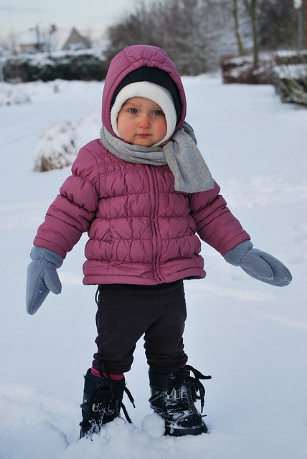

Tracks in the Snow
When there is a snowy day why not go outside and make different prints in the snow.
Jump up and down and look at your footprints … how many are there, what shape are they, whose is biggest, smallest, bigger or smaller …? 2,4,6,8
Shuffle your feet along and look at the double tracks you’ve made. Is it a straight line ….? or curved? What does walking on tip toes look like – are the prints different?
Spot other tracks in the snow – can you see pawprints or bird prints?
Lie flat on your backs in the snow and move your arms up and down above your head, your legs out and in, stand up and look at the pattern – it’s a snow angel!


The Snowy Ball
By Sue Hendra and Paul Linnet CBeebies Bedtime story: Jodie Whittaker - Snowball
On a very snowy mountain top a snow begins an exciting adventure. Listen to the story here and you could follow up by visiting your local library to find a copy to borrow. Catch the bus or walk there and remember to chat to your child about what you can see on the way.


Snow Dough
Why not make some super soft white playdough?
You will need:
½ cup hair conditioner (white is best for snow)
1 cup cornflour (you can get this in the supermarket for 99p)
- Put the conditioner in a bowl
- Add the cornflour
- Little hands to mix the ingredients together into a smooth ball, it smells delicious but remind your child not to put it in their mouth

You can now use this to make a snowy day - can you show your child how to roll a big ball and a smaller ball to make a snow man?
Pretend you are Peter from the story and use your fingers to make prints in the snow.
Use a toy to retell the story using the snow dough to make pictures from the story?






Leave ice cubes on a plate and guess how long it will take for them to melt – what happens if you sprinkle them with salt?


Information for Parents/ Carers
Understanding the World
3 and 4 year olds
You might notice that your child can:
- enjoy exploring natural materials using all of my senses.
- explore and investigate collections of natural materials with similar and/or different properties.
- talk about the differences between materials and changes I notice, e.g. when cooking.

Communication and Language
3 and 4 year olds
You might notice that your child can:
- understand questions and instructions that are more complicated and have two parts, like: “Please get your coat and wait at the door.”
- When you ask me questions about why something happened, I understand, e.g. “Why do you think the caterpillar got so big?”

Top Tips
Even though it’s cold taking children to play outside is a good thing for everyone’s health. Playing outdoors in the fresh, chilly, open air can boost children’s immune systems, developing their ability to fight off infections and build resistance to allergies All you need to do is wrap them up warm in a coat and gloves.

Snow, water and ice play provides children with an exciting sensory experience, and the opportunity to observe how they behave when exposed to different temperatures and substances (i.e. water, salt etc.)
Chatter Matters

Chatting to your child helps them learn to speak.
Vocabulary and increasing the number of new words you child hears every day is very important for future learning. Use these words as you chat about these Snowy Day ideas.
Frozen, freeze, below zero, melt, warm, blizzard, blustery, chilly, frosty, gloves, mittens, icicle, icy, nippy, sledge, snowflake, crystal, slush, sniffle, Winter.

Chatting Matters
Vocabulary and increasing the number of new words you child hears every day is very important for future learning. Use bold for suggested words

Find out more

CBeebies Cold Adventure

CBeebies Parenting

Health for Under 5s

Small Talk | National Literacy Trust

Learning to talk - Start for Life - nhs.uk

Home - Starting Reception

Homepage | Best Start in Life



Physical Development
3 and 4 year olds
You might notice that your child can:
- walk up steps and stairs and climbing equipment using alternate feet.
- skip, hop, stand on one leg and hold a pose for a game like musical statues.
- wave flags and streamers using large muscle movements and paint and make marks on a big scale.

Find out more about your Child’s development
What to expect in the Early Years: A guide for parents

If you have any concerns about your child’s development the first thing you can do is chat to your Child’s Key Person at their Setting

