Go for a walk with your child, and see what plants and flowers you can find – but do not pick or eat any of them
Spring Spotter Sheet 1

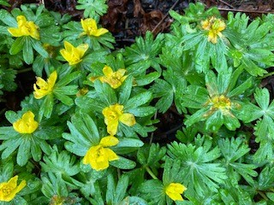
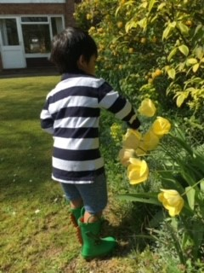
Fresh green leaves start to appear on the bushes and trees in Spring, and flowers begin to appear in the hedges, gardens and parks, like these yellow tulips. Pop on your wellies and see what is flowering near you.

Seeds will still be on some bushes and twigs, waiting for the wind to blow them to the ground below. Can you find any?
What are the first flowers you may see in Spring? Lesser Celandine (above) have small yellow flowers and can be seen growing in shady places in February to April.

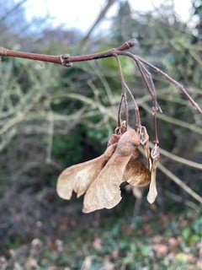
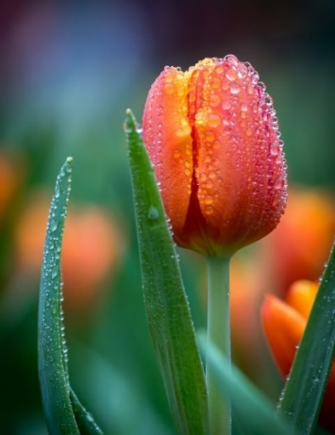
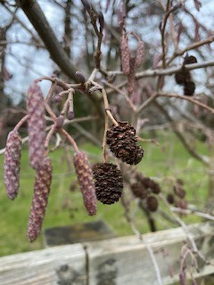
Tulips can be seen in lots of different colours, red, yellow, orange or even dark purple – how many different coloured tulips can you find?

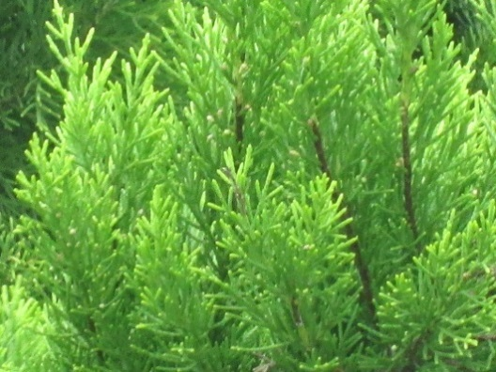
Catkins and cones
Helicopter wings on a sycamore tree

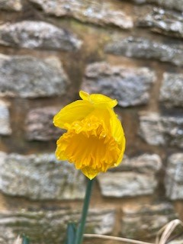
Did you know - Bulbs live under the ground for most of the year, they start to push through the soil in Spring – daffodils, bluebells and tulips are all bulbs. They make food in the leaves from sunlight. The plant eventually dies back, and it happens all over again the next year!

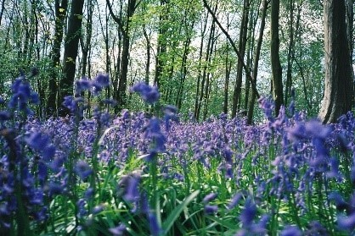
Daffodil

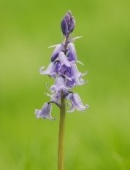
A single bluebell, showing the bell shape flower

A carpet of bluebells in woodland – you may also see them like this in a park.

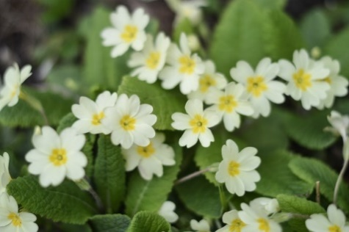
You can see primroses in hedgerows, woods and fields throughout April and May. New plants grow each year from seeds which are moved around and spread by ants. A single primrose plant may live for 15-25 years. This is one of the first plants to bloom in spring. Its name comes from the word ‘primus’ which means ‘first’ or ‘early’.

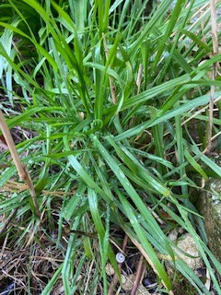
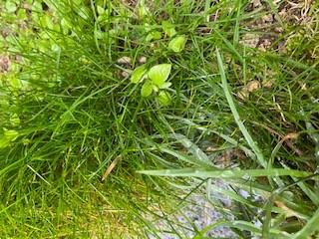
Grass can be fuzzy and hairy or glossy and green. Some grass leaves are wide and floppy, others are narrow and stiff. They can grow together, or separately, sometimes in amongst other plants. How many different colours and shapes of grasses can you find?

A horse hoof print in mud – can you see it is a similar shape to the shape on the tree?
On the Horse Chestnut tree, you may see the shape of a horse’s hoof in the bark – this is why the tree has its name. Its fruit are conkers that you will see in Autumn

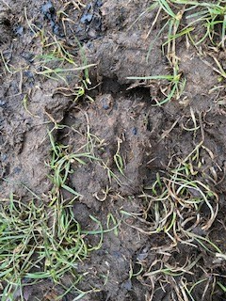
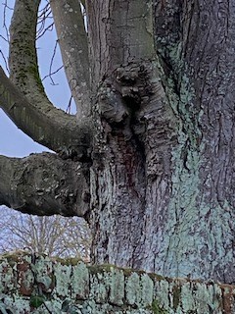
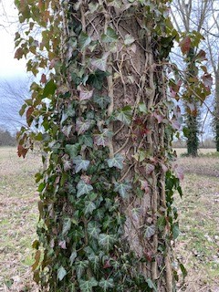
Thistle prickly

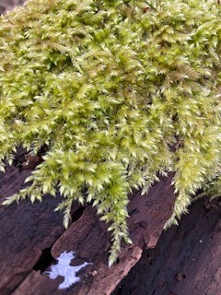
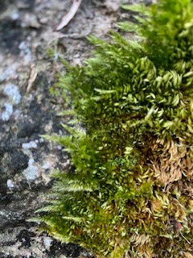
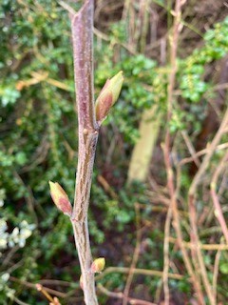
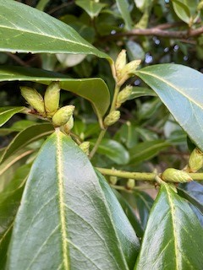
Can you find moss on a wall, a log or even on stones along the path? Swan's-neck thyme-moss is one of our most common mosses. Lush green with bright green new growth in the spring. Mosses are simple, rootless evergreen plants that don’t have flowers or seeds but have spores that move in the air. The spores are so tiny you cannot see them, but they land and grow into new moss.
In spring buds appear on bushes and twigs, these grow into new leaves or branches – can you find any?
Have a look in the trees or on walls – ivy grows up this tree, and where it is old it has made thick stems that wind themselves around the tree trunk. In spring you will see fresh green ivy leaves.

