

So Cold
Everyday routines – laundry time
There will always be laundry to do even in the coldest of months, and these everyday tasks are a lovely time to talk to your toddler and develop their language as you describe what you are doing and involve them in the task. This web page includes tips and a video showing how to make laundry day a fun day.
Laundry time - CBeebies Parenting
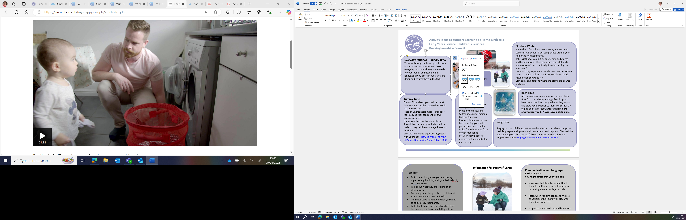

Outdoor Winter
Even when it’s cold and wet outside, you and your baby can still benefit from being active around your home and neighbourhood.
Talk together as you put on coats, hats and gloves and head outside. ‘It’s a chilly day, cosy clothes to keep us warm’. Yes, that’s right, we’re putting on your coat.’
Let your baby experience the elements and introduce them to things such as rain, frost, sunshine, cloud, maybe even snow and ice!
Visit parks and gardens where the plants are all wet and glossy.

Bath Time

After a cold day, create a warm, sensory bath time for your baby by adding a few drops of lavender or bubbles that you know they enjoy and blow some bubbles to them whilst they try to pop and catch them. Ensure children are always supervised. Never leave a child alone.


Winter in a Bag
(indoor activity)
Place some cheap hair gel in a Ziplock bag and add some of the following:
Glitter or sequins (optional)
Buttons (optional)
Ensure it is safe and secure before letting your baby play with it. Put it in the fridge for a short time for a colder experience.
Let your baby’s senses explore on their hands, feet and tummy.

Tummy Time
Tummy Time allows your baby to work different muscles than those they would use on their back.
Place an unbreakable mirror in front of your baby so they can see their own fascinating face.
Tempt your baby with enticing toys. Spread them around your little one in a circle so they will be encouraged to reach for them.
Visit the library and enjoy sharing books with your baby - How To Make The Most of Picture Books with Young Babies - CBeebies Parenting

Song Time

Singing to your child is a great way to bond with your baby and support their language development with new sounds and rhythms. This website has some top tips for a successful song time and a video of a carer singing to her baby Singing Bouncing Baby | Words for Life


Information for Parents/ Carers
Find out more
Cbeebies Bedtime songs

Talking to your baby
CBeebies Parenting

Health for Under 5s

Small Talk | National Literacy Trust

Learning to talk - Start for Life - nhs.uk

Home - Starting Reception

Homepage | Best Start in Life



Physical Development
Birth to 3years
You might notice that your child can:

- use their arms to help lift their head and chest when laying on their tummy.

- reach out and touch things that are near to them.

Personal, Social and Emotional Development
Birth to 3 years
You might notice that your child can:

- show that they like you to hold or cuddle them by snuggling up to you, smiling, looking at your face or stroking you.

Communication and Language
Birth to 3 years
You might notice that your child can:

- show you that they like you talking to them by smiling at you, looking at you or moving their arms, legs or body.

- listen when you sing songs and rhymes as you tickle their tummy or play with their fingers and toes.

- stop what they are doing and listen to a new voice or sound when they hear it.

Top Tips
- Talk to your baby when you are playing together e.g. babbling with your baby ch, ch, ch… . it’s chilly!
- Talk about what they are looking at or playing with.
- Encourage your baby to listen to different sounds such as cars and animals.
- Gain your baby’s attention when you want to talk e.g. say their name.
- Talk about things to your baby when they happen e.g. the leaves are falling off the trees, the snowing is floating from the sky.
- Respond to your child when they try to gain your attention e.g. babbling, first words, facial expressions and gestures. Copy their communication and add one or two words.
- Try and have special time each day with your baby to play with toys and picture books.

Find out more about your child’s development
What to expect in the Early Years: A guide for parents

If you have any concerns about your child’s development the first thing you can do is chat to your Child’s Key Person at their Setting

