Oak tree leaves and acorns


**5 Little Apples Rhyme**

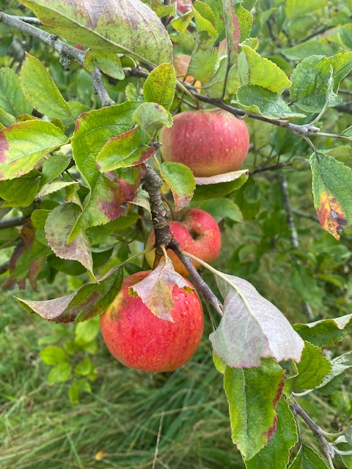

5 little apples bouncing on the tree

1 fell off and bumped his head

Mother called the doctor and the doctor said

no more apples bouncing on the tree

4 little apples bouncing on the tree

1 fell off and bumped his head

Mother called the doctor and the doctor said no more apples bouncing on the tree

(keep going until you get to 0)

**Story Time**

Watch [Ten Apples Up On Top](https://www.youtube.com/watch?v=0rA4zt_boIg) by Dr Seuss

**Autumn walk**

Give your child a bucket or a box. How many natural objects can they fit inside e.g. conkers, acorns, pinecones, seed pods?

Use the collection to sort them in different ways by size, shape, colour or pattern.

**Making an Autumn tree**

Collect sticks of different lengths and lay them out.

Can you describe how long they are? Short, shorter, long, longer and longest.

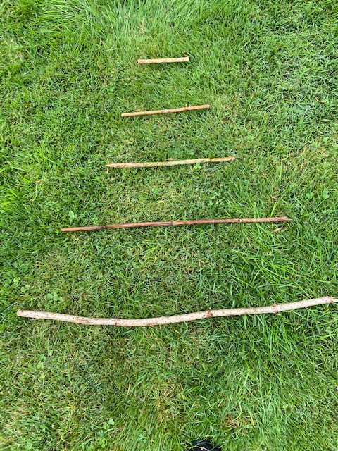

Add leaves, conkers or acorns how many can you get on each twig? Count and compare. Which has the most and which has the least?

**long**

**Autumn Maths**

**Counting**

Help your child to count small collections of objects

e.g. conkers, acorns or leaves.

Get 5 conkers, line them up, count them together

then move them around do they know there are still 5?

If you have 2 conkers, do they know there are 2 just by looking or do they count each time?

**Sharing**

Try some problem solving with your child e.g.

* I wonder how we can share an apple between the two of us.
* I wonder if we could share it between four of us, how big would the pieces be?

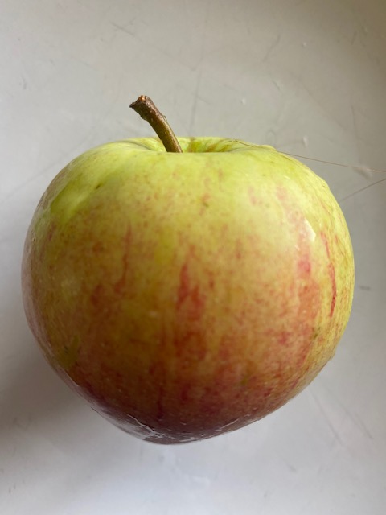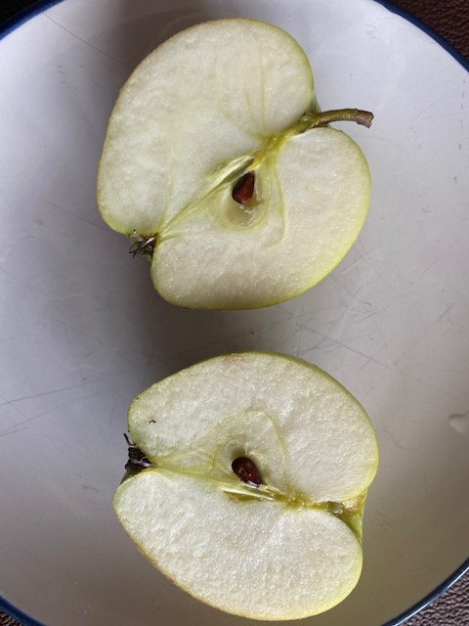 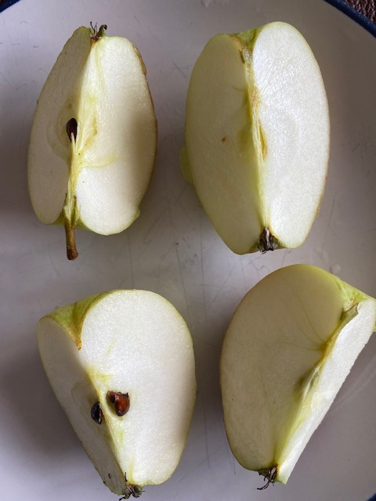

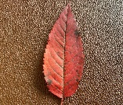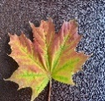

**SHARING**

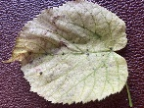

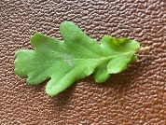

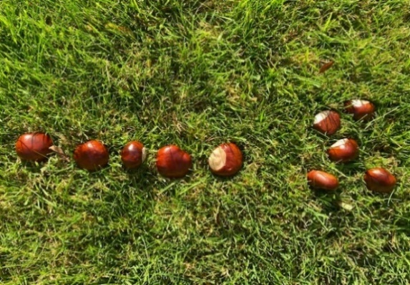

**Communication and Language**

**3 and 4 year olds**

**You might notice that your child can:**

* Understand when you ask questions about why something happened, e.g. “Why do you think the caterpillar got so big?”
* Understand questions and instructions that are more complicated and have two parts, like: “Please get your coat and wait at the door.”

**Top Tips**

* Make it fun for you and your child.
* Investigate and talk about patterns, colours and shapes e.g. shapes of trees, leaves and clouds.
* When counting to begin with touch each object to help children recognise that an object is matched to a number. (It’s called 1 to 1 correspondence)
* Play with shapes, do they join up together or roll down a slope.
* Sing nursery rhymes that have numbers in. Use pictures or objects to help like 5 little frogs.

**Chatting Matters**

Vocabulary and increasing the number of new words that your child hears every day is very important for future learning.

* **Maths words** are all around us e.g. **big, small, shorter, taller, less than, behind, above, under and over, more, heavy.**
* Play guessing games wherever you go; which is the tallest tree, which is the heaviest pumpkin. If you see two dogs which is the smallest, which has the longest tail.
* Try using the words: **I wonder how, I wonder what …**

**Information for Parents/ Carers**

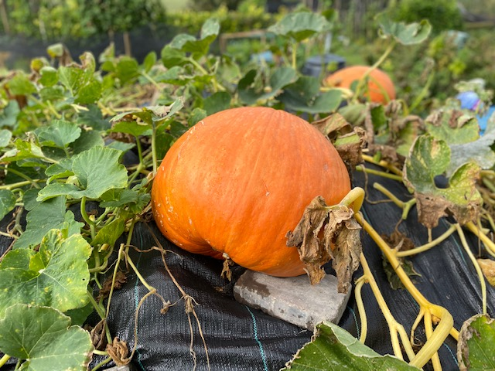

**Find out More**

[Cbeebies - Help your child with maths](https://www.bbc.co.uk/cbeebies/grownups/help-your-child-with-maths)

* Is a real pumpkin as big as you?
* Can you get your arms all the way around?

**Maths**

**3 and 4 year olds**

**You might notice that your child:**

* match the correct numeral (number symbol) to the right amount, up to 5, e.g. point to the number 3 when I count 3 snails.
* use mathematical words to compare amounts ‘more than’, ‘fewer than’.

**Find out more**

[Cbeebies/help your child with maths](https://www.bbc.co.uk/cbeebies/grownups/help-your-child-with-maths)

<https://wordsforlife.org.uk/>

[Learning to talk - Start for Life - nhs.uk](https://www.nhs.uk/start4life/baby/learning-to-talk/2-to-3-years/#anchor-tabs)

[Let's get talking - Health for Under 5s](https://healthforunder5s.co.uk/sections/toddler/lets-get-talking/)

[Home - Starting Reception](https://startingreception.co.uk/?es_c=308CAA55AD47458C53A7854E8022C490&es_cl=31CAEEFA6CD7BB5DA1A8D907712C1260&es_id=ph7%C2%A322)

**Understanding the World**

**3 and 4 year olds**

**You might notice that your child:**

* Talks about plants and animals that interest them.
* Begins to notice changes in things e.g. when bananas turn black when they stay in the bowl too long, leaves turning colour.

**Find out more about your child’s development**

[What to expect in the Early Years: A guide for parents](https://foundationyears.org.uk/files/2021/09/What-to-expect-in-the-EYFS-complete-FINAL-16.09-compressed.pdf)

If you have any concerns about your child’s development the first thing you can do is chat to your child’s Key Person at their setting.