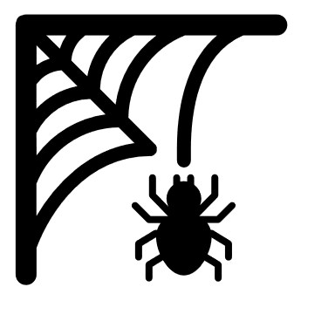Book called The Very Busy Spider

Trees and bench with string between like a spiders web


## Story Time [Listen to the story here](https://www.youtube.com/watch?v=p6s1vs3LzM0)

In the story, the spider keeps on working at the task of spinning a web and is not distracted by the other animals. This is a useful model for encouraging children to keep going even when things don’t always work out. Using positive words help here. Try encouraging your child to keep going on some simple tasks and praise the effort e.g.

* I can see you have built a tower of 4 bricks so far.
* You have nearly finished the jigsaw, only a few pieces left.
* We’ve walked most of the way, almost home now.
* One sock on, now the other.

## Making a web outside

Find a group of trees.

Using some wool or string, wander between the trees, linking them together with the string. If you don’t have local trees, you can use chair legs or poles. You can wrap the string around the tree trunk as high as you can reach or low down. Soon you will have created your criss-cross spider’s web. Let your child travel across the web, crawling **under** some strings or going **over** others or **around** the trees.

**The Very Busy Spider**

**By Eric Carle**

**Find a cosy spot or bench in the garden or park to share the story together**

**Spider Web Hunt**

When out and about on a damp day, look out for webs in trees, hedges, park benches, at the park. Encourage your child to look closely at the pattern and detail of the web.

## Incy Wincy Spider

[Listen to the rhyme](https://wordsforlife.org.uk/activities/incy-wincy-spider/)

Incy wincy spider climbed up the water spout,

Down came the rain and washed the spider out,

Out came the shine and dried up all the rain,

So Incy wincy spider climbed up the spout again.

Leave a plate of water or draw a chalk line around a puddle in the sunshine and the shade. Wonder with your child what happens to the water and why it is different in the two places.

Card with holes in it and string woven across like a spider's web


## Weaving your web

Cut a circle of card, then

use a hole punch to put holes around the edge - your child may be able to do this with your support. Thread a length of wool or string through and across to make a spider’s web. (A piece of sticky tape on the end makes threading easier.)

Talk to your child about the position and direction they are threading in – **up, down, across** and **pull** and **push**.

## Animal noises and Sequencing in order

* Draw or cut out printed or magazine pictures of the animals in the story. If you have small world toy animals, you could use these. Make the noise of an animal and ask your child to point to that animal and possibly name it. Swap over and you name the animal and the child makes the noise.
* How many animals from the story can your child remember?
* Can they put them in the order they appear in the book, starting with the sun and ending with the moon?

****horse

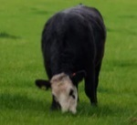sheep
pig
duck
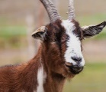****

**Information for Parents & Carers**

## Top Tips

Learning and Development in Early Years and beyond includes **Characteristics of Effective Learning** - these are ways of learning, rather than what is learnt.

**Playing and Exploring:** includes children being curious about objects, events and people.

**Active Learning:** involves persisting when challenges occur and maintaining focus on an activity- although this takes several years to develop.

**Creating and Thinking Critically**: involves thinking of ideas, noticing patterns, links and sequences.

Encouraging your child to “have a go” and “keep going” helps to build up this determination and resilience.

Try modelling a deliberate mistake and then saying you will try it again or try another way.

**Chatting Matters**

**Vocabulary** and **increasing** the number of new words you child hears every day is very important for future learning. Talk about the position of objects or how your child moves – **up, down, sideways, under, over, next to, beginning, end.** Getting the correct order sequence is crucial for reading and comprehension.

**Communication and Language**

**You might notice that your child can:**

**2 and 3 year olds**

* Listen to simple stories. Understand what is happening, with the help of the pictures.
* Identify familiar objects when you describe them. Point to the big boat in a book you’re sharing. Get an apple when you ask me to.

**3 and 4 year olds**

* Understand when you ask me questions about why something happened e.g. “Why do you think the caterpillar got so big?”

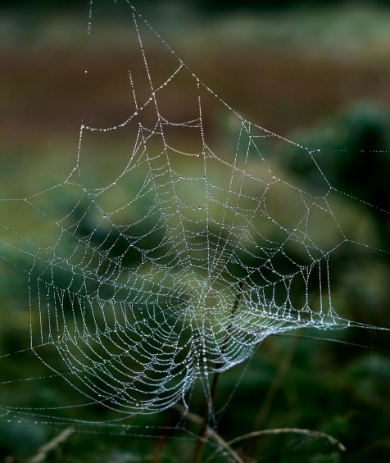

**Find out more about your Child’s development**

[What to expect in the Early Years: A guide for parents](https://foundationyears.org.uk/files/2021/09/What-to-expect-in-the-EYFS-complete-FINAL-16.09-compressed.pdf)

If you have any concerns about your child’s development the first thing you can do is chat to your Child’s Key Person at their Setting.

**Find out more**

[cbeebies Come Outside Spiders](https://www.youtube.com/watch?v=UQ2RzDl0vvM)

[CBeebies Parenting](https://www.bbc.co.uk/tiny-happy-people)

[https://wordsforlife.org.uk/](https://eur03.safelinks.protection.outlook.com/?url=https%3A%2F%2Fwordsforlife.org.uk%2F&data=05%7C01%7Chelen.smith%40buckinghamshire.gov.uk%7C885368289adf4bc4d82208da278f077d%7C7fb976b99e2848e180861ddabecf82a0%7C0%7C0%7C637865792499198220%7CUnknown%7CTWFpbGZsb3d8eyJWIjoiMC4wLjAwMDAiLCJQIjoiV2luMzIiLCJBTiI6Ik1haWwiLCJXVCI6Mn0%3D%7C3000%7C%7C%7C&sdata=DUrHmRJb95b7upTRnBUxTsgIu7sqoEpGETenQp%2Bss2A%3D&reserved=0)

[Learning to talk - Start for Life - nhs.uk](https://www.nhs.uk/start4life/baby/learning-to-talk/2-to-3-years/#anchor-tabs)

[Let's get talking - Health for Under 5s](https://healthforunder5s.co.uk/sections/toddler/lets-get-talking/)

[Home - Starting Reception](https://startingreception.co.uk/?es_c=308CAA55AD47458C53A7854E8022C490&es_cl=31CAEEFA6CD7BB5DA1A8D907712C1260&es_id=ph7%C2%A322)

**Physical Development**

**You might notice your child can:**

**3 and 4 year olds**

* Wave flags and streamers using large muscle movements and paint and make marks on a big scale.
* Use one handed tools such as scissors.
* Continue to develop a range of physical skills - balancing, riding and ball skills.

**Personal, Social & Emotional Development**

**3 and 4 year olds**

**You might notice your child can:**

* Talk to friends to solve problems that might happen when they are playing.
* Use my fine motor skills to do up buttons, zips and to pour myself a drink.