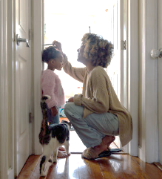

Photographs
Share family photographs with your child if you have them showing them at different ages from when they were babies, toddlers, teenagers and grandparents. This helps them learn about the past and how we change over time. Click on the link to see the children having fun talking with their Nany as she shows them old family photos Sharing photo albums with children -- BBC Tiny Happy People.
Alternatively, cut out pictures from magazines, leaflets from days out and special pictures to create a memory book How to make a memory keepsake | Words for Life

How tall am I?
Start by measuring your child’s height and show them where they sit on the height chart or measure against a wall inside or outdoors.
Then compare your height to theirs.
Ask your child ‘do you think you are taller or shorter’ and if so why’?
Can they find a soft toy that is shorter than them to measure?
Talk about the similarities and differences, size and shape.
Use language such as taller than and shorter than.

Growing -
All about me

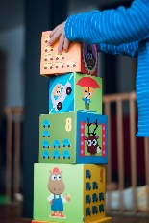
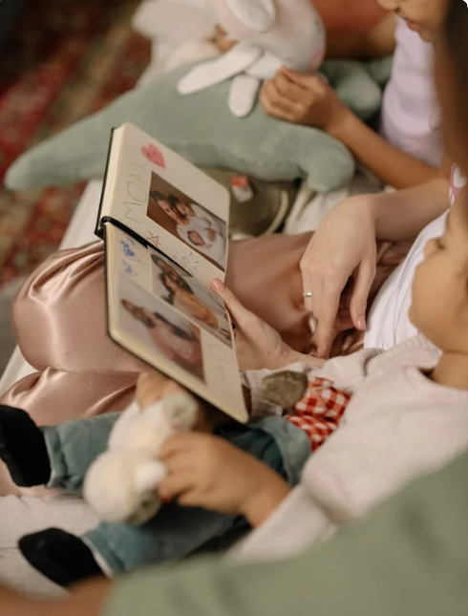

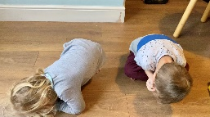

How big are my hands and feet?
Measure your child’s hand and feet with them and ask them how big they think they were when they were a baby? How have they changed and grown?
Let your child either paint or draw around their hand.
This is my handprint – what can you do with your hands? I can catch, throw, colour, wave, clap, snap, hug, paint, feel and pat with my hands.
This is my footprint, I can; stomp, run, hop, tiptoe.
Here are some top tips for a fun painting session at home-
Benefits of finger paints - BBC Tiny Happy People
Painting at home | Words for Life

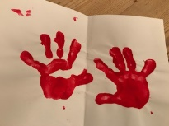
I’m a little bean song

I’m a little bean small and round
(curl up on the floor)
Bury me deep into the ground
(sung in a very low deep voice)
Sprinkle on some water
(act out watering can)
Some sunshine too
(hands out wide)
Watch me grow as tall as you
(stretch to the sky)
I'm a little bean - YouTube

Story Time

Snuggle up with your loved ones and share a picture book, there are so many that help to talk about our families and how we grow as unique and special people. Click on the link to find a wide range of picture books for all ages Book lists for children and young people | Words for Life.

Enjoy this CBeebies bedtime story Love Makes a Family,

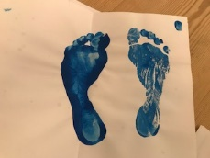
Information for Parents & Carers

Top Tips
All living things are constantly changing. As we grow, we are continually changing in our appearance, activities, likes, dislikes, relationships and experiences.
Ask your child how they think they have changed since they were a baby?
Encourage your child to investigate their early growth and development by talking to you, Grandparents, friends etc.
Where was I born?
What day of the week was it?
What month and season was it?
What did I weigh when I was born?
What did I eat and drink when I was a baby?
What was my favourite food when I was a baby and how has it changed now?
What was my favourite toy and is it still my favourite toy?
Would you like to be a baby forever? Why? Why not? What is good about growing up?
Chatting Matters
Vocabulary and increasing the number of new words you child hears every day is very important for future learning. Introduce words such as grow, growing, small, tall, big, bigger, height and measure.

Communication and Language
3 and 4 year olds
You might notice that your child can:

Listen to what you tell them to do and then they can do it.

When singing rhymes or songs or sharing a story with a grown up can listen carefully to what is happening.

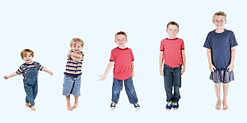
Find out more

All about me BBC Bitesize

Mr Tumble All About Me, Myself and I
Youtube.com
Out and about on the Farm

CBeebies Parenting

Health for Under 5s

Small Talk | National Literacy Trust

Learning to talk - Start for Life - nhs.uk

Home - Starting Reception

Homepage | Best Start in Life



Understanding the world
3 and 4 year olds
You might notice that your child can:

Talk about things like how flowers or buildings look the same or look different.

Talk about how things change, like the seeds growing into sunflowers or the block of ice melting into water.

Physical Development
3 and 4 year olds
You might notice that your child can:

Stand on just one foot (for a second) if you show them how without falling over.

Run, walk, hop, jump, skip and move around in lots of different ways.

Find out more about your child’s development

What to expect in the Early Years: A guide for parents

If you have any concerns about your child’s development the first thing you can do is chat to your Child’s Key Person at their Setting.

