**Water play**

**

Pouring from A to B is a skill that develops over time and is one that helps develop the fine motor skills needed for mark making. Find ways to encourage pouring and as children master pouring from one pot to another, increase the challenge by changing the pots or jugs to make it harder.

**Sink or float?**

One of the questions that comes up when playing with water is about which objects **sink** or **float**. While this can be explored through play, you can also turn it into an **experiment**.

Collect a range of items from around your home. Then **predict** whether you think the item will float or sink. You may want to draw or write your **predictions**. **Investigate** the items by placing them on the water and see what happens. Discuss whether there is a **pattern** as to why certain items float or sink.

Discuss what the objects are made of - is there a link?

One of the scientific concepts at play here is buoyancy, items with a larger surface area will float. [Sinking and Floating Song - CBeebies](https://www.bbc.co.uk/cbeebies/watch/do-you-know-sinking-and-floating-song) ‘sing along with Maddie and learn how and why things sink and float’.

[Have a look at this CBeebies video.](https://www.bbc.co.uk/cbeebies/watch/messy-goes-to-okido-why-do-things-sink-and-float)

Can you make some boats out of materials that will float?

How much weight can they carry?

Can you have timed races and keep a tally of who wins?

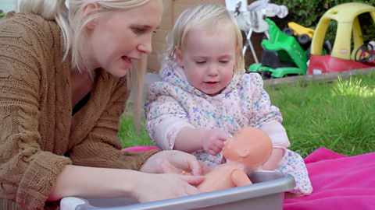**Give Dolly a Bath**

Scan the QR code for the benefits of bath time with your little one’s favourite toys and how this simple water activity can help teach them about their daily routines**.**

Two toddlers playing with a bowl of water.


**Water play**

**Bath time for Babies**

[Bath time fun for babies | Words for Life](https://wordsforlife.org.uk/activities/bath-time-fun/) try some of these activities to encourage more chatter.



**What can you play with?**

The size of your water play area will indicate what resources you play with. Pots, **containers** and buckets of different sizes will allow for filling. **Funnels** and **pipes** could be added to direct water flow while sieves and nets allow children to experiment with flow.

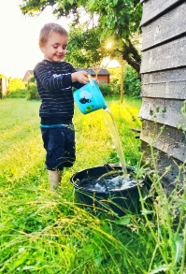 **Information for Parents & Carers**

**Health and safety**

Ensure that children are always supervised when playing with water.

Depending on the child’s development, teach them to manage their own safety by clearly setting rules for them to follow.

Ensure that anything you add to the water is risk assessed and ensure that allergies are considered.

Empty the water away after playing.

**Communication and Language**

**3 and 4 year olds**

**You might notice that your child can:**

* stop what they are doing when they hear you talk to them.
* carry out simple instructions “can you put this there?” if not engrossed in play.
* show you that they understand “who”, “what” and “where” when you use short questions as you play with the water.
* use simple sentences with 3-4 words to talk about what they are doing.
* understand your questions “What can you see in the paddling pool?” so they know what you mean.
* use longer sentences with words like “because” and “and”.
* ask lots of questions and answer your questions too.
* talk about different things they might want to experiment with next time.

**Top Tips**

There are lots of things you can talk about while playing with water.

Here are some ideas:

* how does the water feel?
* what is the temperature of the water?
* how is the water moving, if at all?
* what has been added to it?

If your child doesn’t want to talk, then a running commentary of what they are doing is a great way to develop their language and takes the pressure off the child about answering a string of questions.

Talk about the ***capacity*** of containers. Can you fill the container, so it is ***full****,* ***half full****,* ***empty***? Are the containers ***heavy*** or ***light***? Use cups to fill a larger container and count how many it takes. Empty the container and count backwards as you do so.

**Vocabulary** and **increasing** the number of new words your child hears every day is very important for future learning.

**Find out more**

[Make a water squirter with CBeebies](https://www.bbc.co.uk/cbeebies/makes/my-story-water-squirter)

[BBC Tiny Happy People](https://www.bbc.co.uk/tiny-happy-people)

[https://wordsforlife.org.uk/](https://eur03.safelinks.protection.outlook.com/?url=https%3A%2F%2Fwordsforlife.org.uk%2F&data=05%7C01%7Chelen.smith%40buckinghamshire.gov.uk%7C885368289adf4bc4d82208da278f077d%7C7fb976b99e2848e180861ddabecf82a0%7C0%7C0%7C637865792499198220%7CUnknown%7CTWFpbGZsb3d8eyJWIjoiMC4wLjAwMDAiLCJQIjoiV2luMzIiLCJBTiI6Ik1haWwiLCJXVCI6Mn0%3D%7C3000%7C%7C%7C&sdata=DUrHmRJb95b7upTRnBUxTsgIu7sqoEpGETenQp%2Bss2A%3D&reserved=0)

[Learning to talk - Start for Life - nhs.uk](https://www.nhs.uk/start4life/baby/learning-to-talk/2-to-3-years/#anchor-tabs)

[Let's get talking - Health for Under 5s](https://healthforunder5s.co.uk/sections/toddler/lets-get-talking/)

[Home - Starting Reception](https://startingreception.co.uk/?es_c=308CAA55AD47458C53A7854E8022C490&es_cl=31CAEEFA6CD7BB5DA1A8D907712C1260&es_id=ph7%C2%A322)

**Physical development**

**3 and 4 year olds**

**You might notice that your child can:**

* show control in holding and using jugs to pour liquids from one container to another.
* show control over a variety of pots and containers when transferring liquids between them.
* show the need to be safe when playing with new toys.

**Find out more about your child’s development**

[What to expect in the Early Years: A guide for parents](https://foundationyears.org.uk/files/2021/09/What-to-expect-in-the-EYFS-complete-FINAL-16.09-compressed.pdf)

If you have any concerns about your child’s development the first thing you can do is chat to your Child’s Key Person at their setting.