**Get outside**

Take your child to the park or a local green space to explore and watch the season changing. Talk about what you see happening now. Talk about how it is different to what you saw in Summer and Spring. Watch this time lapse video with your child [time lapse tree](https://www.bing.com/videos/riverview/relatedvideo?q=you%20tube%20autumn%20changes%20time%20lapse&mid=E72ABCC2E0A6E0B406C2E72ABCC2E0A6E0B406C2&ajaxhist=0), how do the trees near you look now? What has happened to their leaves? Is there anything else growing on the trees now?

Can you act out the Autumn Days poem?

Use lots of movement with your body, arms and legs. Pick up leaves, throw them in the air and watch them fall.

**Poetry time**

Read the poem to your child. Read it slow, read it fast, read it at a normal steady pace.

Think about all the words – does your child know what they all mean?

Take time to explore each new word.

**Autumn Days**

**by Brenda Williams ©**

Swirling,  
Twirling  
Autumn leaves  
Whooshing,  
Whirling  
From the trees.  
  
Snapping,  
Cracking  
Conkers fall.  
Dropping,  
Popping  
Near the wall.  
  
Grouping,  
Swooping  
Birds up high.  
Crying,  
Flying  
Round the sky.  
  
Curling,  
Furling  
Smokey fires.  
Flowing,  
Blowing  
Higher, higher.

A close up of a tree's golden leaves

AAutum

**ACTION TEDDY**

**Autumn Poems and Stories**

**Autumn Stories**

Can you find some stories that take place in Autumn? Maybe you could go to your local library, charity book shop or local book shop to find some. Why not look out for:

* [Autumn by Ailie Busby](https://www.youtube.com/watch?v=fa2DjzgU9S8)
* [Wakey Wakey Big Brown Bear by Tracey Corderoy](https://www.youtube.com/watch?v=Zd09eoSFVn0) Or click the link for more ideas [Our autumn-themed book list! | Words for Life](https://wordsforlife.org.uk/activities/autumn-themed-booklist/)

Or watch on CBeebies:

* [JoJo and Gran Gran Its Time for Autumn Leaves](https://www.bbc.co.uk/iplayer/episode/m000nqtw/jojo-gran-gran-series-1-autumn-1-its-time-for-autumn-leaves)
* [Cbeebies Nella and Nora Autumn](https://www.bbc.co.uk/cbeebies/watch/nelly-and-nora-autumn)

**Create a poem**

Can you create your own poem based on the one shown here? What other words could you use to describe Autumn? Can you add these words in, crinkly, crackly, whizzing, bursting, puffing?

You can write the poem for your child as you chat about Autumn words.

**Top Tips**

**BookTrust** is the UK’s largest reading charity that helps get children and families reading. There’s a section on the website called Home Time for children under 5. Here you can access some fun stories and activities to do with your child.  [Parents, Carers and Families | BookTrust](https://www.booktrust.org.uk/how-we-help/parents-families/)

**CBeebies** has a range of stories you can share with your child featuring their favourite characters. [Go to CBeebies Stories](https://www.bbc.co.uk/cbeebies/stories).

There are several libraries across Buckinghamshire. Information about your local library and the services they provide, including ebooks, can be found online.

Go to [Buckinghamshire Council Libraries](https://www.buckinghamshire.gov.uk/libraries/)

**Chatting Matters**

Vocabulary and increasing the number of new words you child hears every day is very important for future learning. **Autumn, change, season, leaves, conkers, colours, hibernation- this is when some animals go into a deep sleep like state until it gets warmer.**

**Information for Parents & Carers**

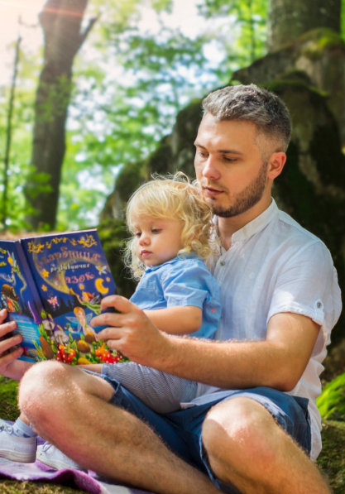

**Literacy**

**3 and 4 year olds**

**You might notice your child is learning:**

* print has meaning
* we read pages in story books one at a time.
* to tune into the different sounds in English.
* spot and suggest rhymes
* count or clap syllables in a word
* to recognise words with the same initial sound, such as money and mother.
* enjoys having long conversations about stories and learning new words.

**Find out more**

[Let's get talking - Health for Under 5s](https://healthforunder5s.co.uk/sections/toddler/lets-get-talking/)

[https://wordsforlife.org.uk/](https://eur03.safelinks.protection.outlook.com/?url=https%3A%2F%2Fwordsforlife.org.uk%2F&data=05%7C01%7Chelen.smith%40buckinghamshire.gov.uk%7C885368289adf4bc4d82208da278f077d%7C7fb976b99e2848e180861ddabecf82a0%7C0%7C0%7C637865792499198220%7CUnknown%7CTWFpbGZsb3d8eyJWIjoiMC4wLjAwMDAiLCJQIjoiV2luMzIiLCJBTiI6Ik1haWwiLCJXVCI6Mn0%3D%7C3000%7C%7C%7C&sdata=DUrHmRJb95b7upTRnBUxTsgIu7sqoEpGETenQp%2Bss2A%3D&reserved=0)

[Poetry for very young children | Words for Life](https://wordsforlife.org.uk/parent-support/poetry-for-very-young-children/)

[CBeebies Parenting](https://www.bbc.co.uk/tiny-happy-people)

[Learning to talk - Start for Life - nhs.uk](https://www.nhs.uk/start4life/baby/learning-to-talk/2-to-3-years/#anchor-tabs)

[Home - Starting Reception](https://startingreception.co.uk/?es_c=308CAA55AD47458C53A7854E8022C490&es_cl=31CAEEFA6CD7BB5DA1A8D907712C1260&es_id=ph7%C2%A322)

**Find out More**

**Find out more about your child’s development**

[What to expect in the Early Years: A guide for parents](https://foundationyears.org.uk/files/2021/09/What-to-expect-in-the-EYFS-complete-FINAL-16.09-compressed.pdf)

If you have any concerns about your child’s development the first thing you can do is chat to your child’s Key Person at their setting.