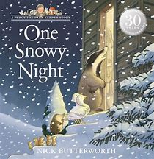

Matching pairs

“Percy wears two pairs of woolly socks inside his wellington boots” Can you match the pairs of socks at home? This page from the Tiny Happy People website has top tips on how to make this a fun learning activity Pairing socks - BBC Tiny Happy People
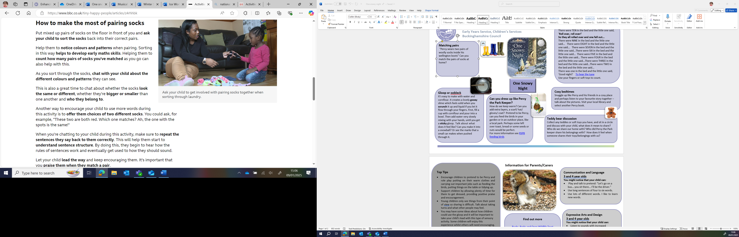

Nursery Rhyme – Ten in the Bed
There were TEN in the bed and the little one said,
'Roll over, roll over!'
So they all rolled over and one fell out...
There were NINE in the bed and the little one said... There were EIGHT in the bed and the little one said... There were SEVEN in the bed and the little one said...There were SIX in the bed and the little one said... There were FIVE in the bed and the little one said... There were FOUR in the bed and the little one said...There were THREE in the bed and the little one said...There were TWO in the bed and the little one said...
There was one in the bed and the little one said,
'Good night!' To hear the tune
Use your fingers or soft toys to count.

One Snowy Night

Gloop or oobleck

It’s easy to make with water and cornflour. It creates a lovely gooey slime which feels solid when you scrunch it up and liquid if you let it flow through your fingers. First, fill a cup with cornflour and pour into a bowl. Then add water very slowly mixing with your hands, until you get a sticky gloop. Talk about what does it feel like? Can you make it into a snowball? Or see the marks that a small car makes when pushed through it.

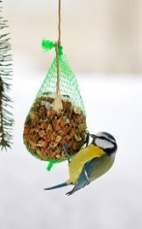

Cosy bedtimes

Snuggle up like Percy and his friends in a cosy place and perhaps listen to your favourite story together – talk about the pictures. Visit your local library and select another Percy book.
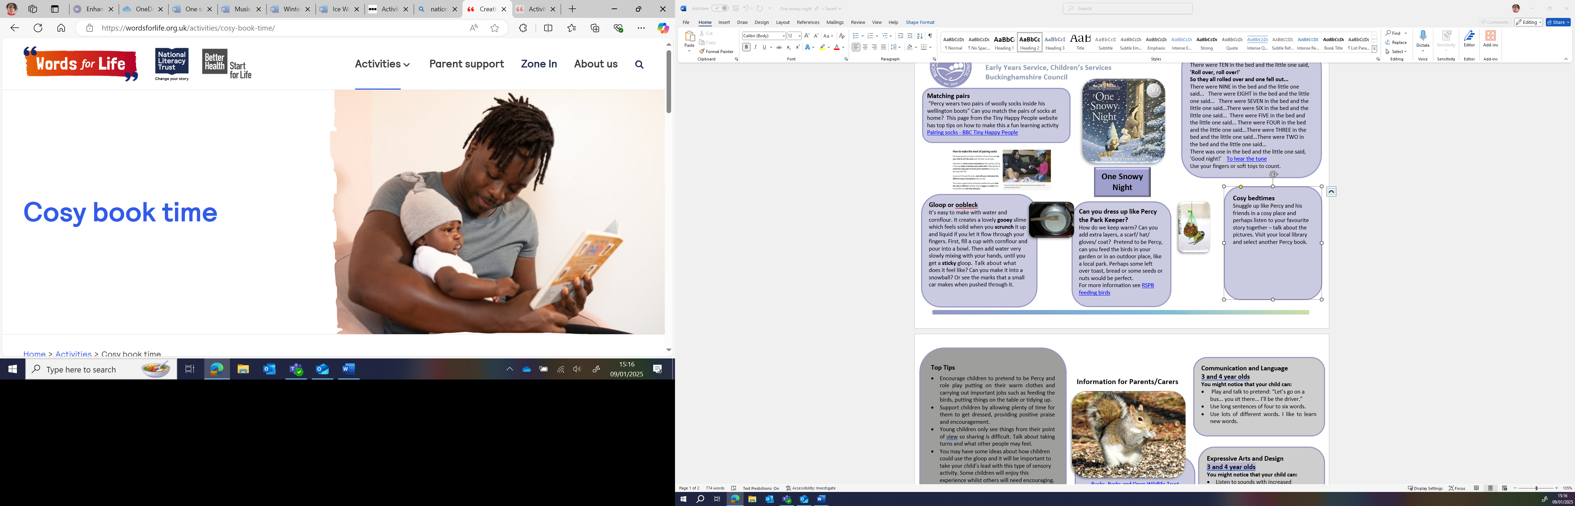
Creating a cosy book time with your baby | Words for Life with top tips and a video example.

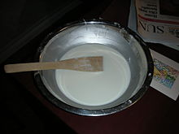
Feed the birds….
How do we keep warm? Can you add extra layers, a scarf/ hat/ gloves/ coat? Pretend to be Percy, can you feed the birds in your garden or in an outdoor place, like a local park. Perhaps some left over toast, bread or some seeds or nuts would be perfect.
For more information see RSPB feeding birds


Information for Parents/Carers

Top Tips
- Encourage children to pretend to be Percy and role play putting on their warm clothes and carrying out important jobs such as feeding the birds, putting things on the table or tidying up.
- Support children by allowing plenty of time for them to get dressed, providing positive praise and encouragement.
- Young children only see things from their point of view, so sharing is difficult. Talk about taking turns and what other people may feel.
- You may have some ideas about how children could use the gloop and it will be important to take your child’s lead with this type of sensory activity. Some children will enjoy this experience whilst others will need encouraging.
Chatting Matters
Vocabulary and increasing the number of new words you child hears every day is very important for future learning. Use words like snow, ice, cold, slimy, hard, soft, big, small, large, biggest, smallest

Chatting Matters
Vocabulary and increasing the number of new words you child hears every day is very important for future learning. Use bold for suggested words

Find out more

Bucks, Berks and Oxon Wildlife Trust

CBeebies Parenting

Health for Under 5s

Small Talk | National Literacy Trust

Learning to talk - Start for Life - nhs.uk

Home - Starting Reception

Homepage | Best Start in Life



Expressive Arts and Design
3 and 4 year olds
You might notice that your child can:
- Listen to sounds with increased attention.
- Respond to what I hear and express my thoughts and feelings.
- Remember and sing entire songs.
- Sing the pitch of a tune sung by another person (‘pitch match’).

Communication and Language
3 and 4 year olds
You might notice that your child can:
- Play and talk to pretend: “Let’s go on a bus... you sit there... I’ll be the driver.”
- Use long sentences of four to six words.
- Use lots of different words. I like to learn new words.

Find out more about your Child’s development

What to expect in the Early Years: A guide for parents

If you have any concerns about your child’s development the first thing you can do is chat to your Child’s Key Person at their Setting
Physical Development
3 and 4 year olds
You might notice that your child can:
- Use a range of tools such as pencils for drawing and writing, paintbrushes, scissors, knives, forks, and spoons.

