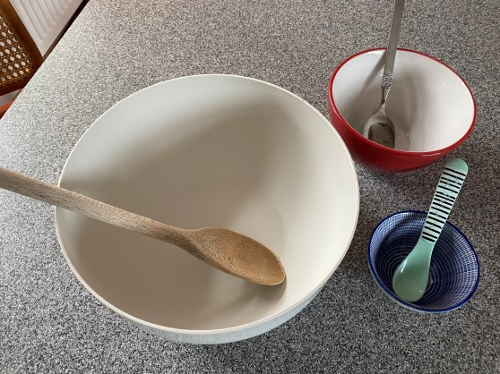

**Goldilocks and the three Bears**

Set up a pretend cottage with three bowls, spoons, chairs and beds one small, one medium sized and one large. Read or tell the story encouraging your child to act it out. Use different voices if you can.

[BBC Traditional Tales](https://www.bbc.co.uk/teach/school-radio/eyfs-listen-and-play-traditional-tales/zjjkbdm)

Sing the rhyme **‘**When Goldilocks crept through the house of the bears,  
Oh, what did her blue eyes see?  
A bowl that was big,  
A bowl that was small,  
A bowl that was teeny, and that was all,  
She counted them: one, two, three.’

<https://www.bussongs.com/songs/goldilocks>

**Story Time**

Tell other traditional tales that involve maths words: Jack and the Beanstalk – size

The Three Little Pigs – 1st, 2nd, 3rd

Three Billy Goats Gruff - size

The Gingerbread Man – ordering.

[BBC Traditional Tales](https://www.bbc.co.uk/teach/school-radio/eyfs-listen-and-play-traditional-tales/zjjkbdm)

**Comparing Size**

How many words can you use to describe the size of the three bears, the bowls or the spoons?

**Big, bigger, biggest, huge, gigantic, large.**

**Small, smallest, tiny, little.**

**Fun with Maths**

**Number Rhymes**

**Counting up and down**

Sing the rhyme together and use your fingers to help count

*1, 2, 3,4, 5*

*Once I caught a fish alive*

*6, 7, 8, 9, 10*

*then I let it go again.*

*Why did you let it go? Because it bit my finger so*

*Which finger did it bite?*

*This little finger on the right.*

10 Green bottles for counting down.

[One, Two, Three, Four, Five nursery rhyme music and lyrics | Words for Life](https://wordsforlife.org.uk/activities/one-two-three-four-five/)

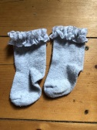

**Getting dressed**

Help children to understand the order things come in e.g. First, second, third in the queue. Try this when getting dressed. Start by laying out all their clothes and then talk about the order first we put on our pants, second we put on our t shirt, third we put on our jeans and after that we put on our socks.

For slightly older children use a timer to see how quickly they can do it.

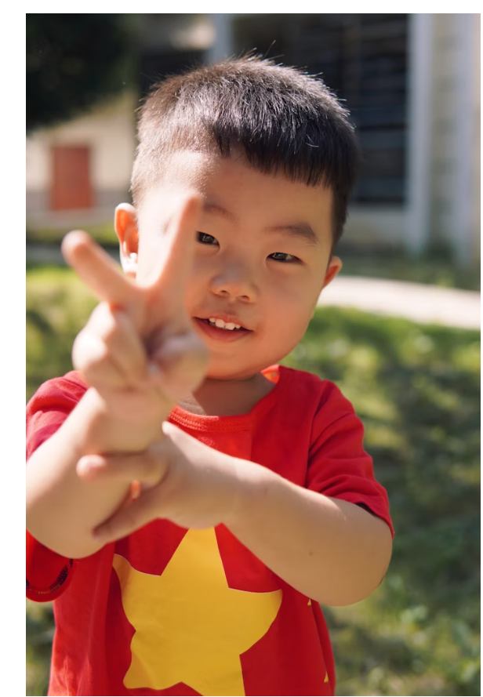

**Sorting**

Let your child sort the fruit in the bowl, cars into colours or sort the socks into colours, **pairs, big, small**?

**Communication and Language**

**2 and 3 year olds**

**You might notice that your child can:**

* join in with singing songs and rhymes.
* point to the right picture or object to show that I understand describing words such as “big” or “small”.

**Top Tips for Maths**

* Make it fun for you and your children.
* Build maths into everyday life e.g. getting dressed, cooking.
* See the maths all around you e.g. count steps; notice what is heavy, light, big or small.
* When counting to begin with touch each object to help children recognise that an object is matched to a number. (It’s called 1 to 1 correspondence)
* Recognise and spot numbers everywhere.
* Sing nursery rhymes that have numbers in. Use pictures or objects to help like 5 little ducks.
* Play games like cards, snakes and ladders, dominoes or skittles.
* Play guessing games e.g. I wonder who can build the **highest** tower, I wonder who has the **most** bricks.
* Use bath time to learn about capacity, talk about **full, half full or empty.**
* **Chatting Matters**
* **Vocabulary** and **increasing** the number of new words you child hears every day is very important for future learning.

**Information for Parents/ Carers**

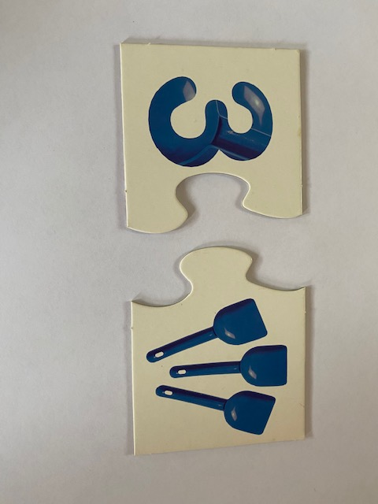

**Physical Development**

**2 and 3 year olds**

**You might notice that your child can:**

* put on my hat, unzip my coat and take off my unfastened shoes/boots and cardigan/shirt by myself.
* Climb up a small ladder on a slide – and count the steps.
* Hold a chunky crayon, pen, pencil or paint brush and make lines that go across, up and down or round or round.

**Find out more**

[Let's get talking - Health for Under fives](https://healthforunder5s.co.uk/sections/toddler/lets-get-talking/)

[CBeebies Parenting](https://www.bbc.co.uk/tiny-happy-people)

[Learning to talk - Start for Life - nhs.uk](https://www.nhs.uk/start4life/baby/learning-to-talk/2-to-3-years/#anchor-tabs)

[Tiny Happy People Teddy Bear Picnic](https://www.bbc.co.uk/tiny-happy-people/teddy-bear-picnic/zhcd8xs)

[Small Talk | National Literacy Trust](https://literacytrust.org.uk/policy-and-campaigns/home-learning-environment/small-talk/)

[Home - Starting Reception](https://startingreception.co.uk/?es_c=308CAA55AD47458C53A7854E8022C490&es_cl=31CAEEFA6CD7BB5DA1A8D907712C1260&es_id=ph7%C2%A322)

**Maths - Numbers**

**2 and 3 year olds**

**You might notice that your child:**

* I use words like “more” and “a lot” to describe amounts of objects.
* give you the right number of objects from a collection when you say “please give me one”, “please give me two”.
* I can say some number names in order.

**Find out more about your child’s development**

[What to expect in the Early Years: A guide for parents](https://dev-foundation-years.pantheonsite.io/wp-content/uploads/2021/09/What-to-expect-in-the-EYFS-complete-FINAL-16.09-compressed.pdf)

If you have any concerns about your child’s development the first thing you can do is chat to your child’s Key Person at their setting.