Whose Baby, am I?
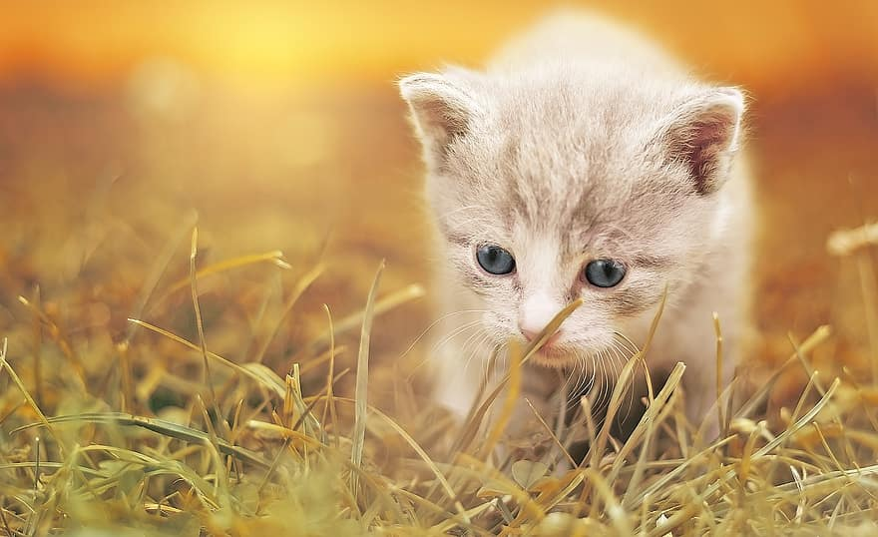

Playing Pretend Animals -
Have a look at this activity on the Tiny Happy People Website.
This is a simple game to play at home that needs no equipment.
- Pretend play is an excellent way to encourage children to use language and take a lead.
- Describe an animal's movement to link words and actions.
- Moving like an animal is a fun way to develop your little one's coordination.
- Repeat words like 'high', 'over' and 'under' when they move around teaches them lots of position words.

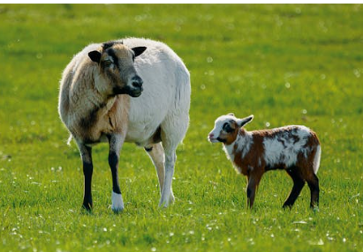

Animals and maths

Match the pairs
Using your play animals talk about size bigger, smaller, longer, shorter, count the legs, ears and tails.
Sort your play animals or pictures of animals in different ways e.g. those that like water and those that don’t, those with 2 legs and those with 4.

Story Time
Read or tell the story of The Three Little Pigs it’s all about piglets growing up and leaving home to start their own lives.
The first little pig makes a house of straw
and the wolf blows it down.
The second little pig makes a house of sticks
and the wolf blows it down.
The third little pig makes a house of bricks,
but the wolf can’t blow it down.
Can you find straw, sticks or bricks to make a house for one of your animal toys?



Song Time

What songs do you and your little one know about baby animals? This traditional rhyme is a lovely one to share and have fun as you they anticipate you tickling them at the end….This Little Piggy nursery rhyme | Words for Life
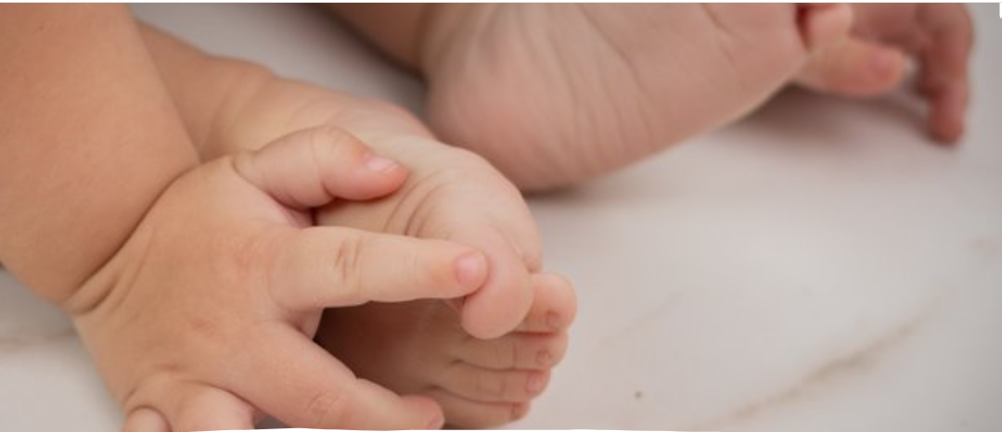
Use props such as toy animals as you sing Old McDonald had a farm Old MacDonald had a Farm - BBC Tiny Happy People

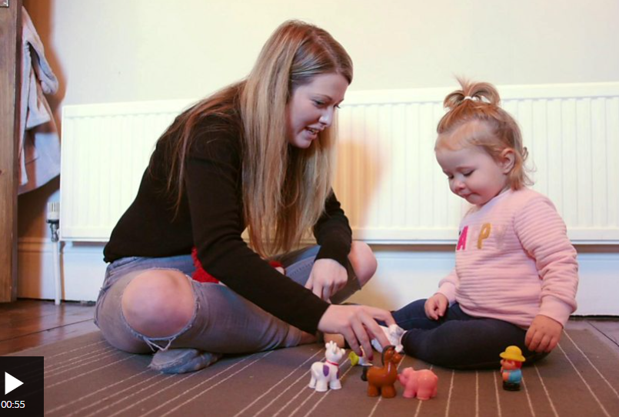

Guess the animal sounds game
Sounds on the Farm quiz - CBeebies - BBC
Go outside, stop and listen, which animals or birds can you hear?
Can you make an animal sound and get your child to guess what it is?

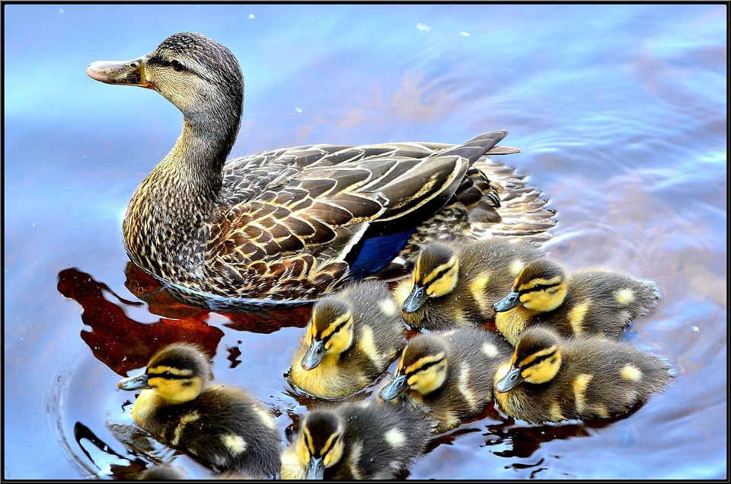

Information for Parents & Carers
Communication and Language
3 and 4 year olds
You might notice your child can:
- Have long conversations with you and their friends.
- When you ask me questions about why something happened, I understand e.g. ‘Why do you think the birds are picking up sticks?’
- Use words and actions to explain their thoughts and ideas. They can give their point of view and disagree.

Top Tips
- Ensure children wash their hands after touching any animals.
- Talk to your children about different types of animals and relate it to their own bodies.
- Mammals are vertebrates which have a backbone, can you feel yours? They give birth to babies which are smaller versions of themselves.
- All other Vertebrates, fish, birds, amphibians and reptiles hatch from eggs.
- All animals eat plants or other animals they use their senses to find food and avoid danger.

Chatting Matters
Vocabulary and increasing the number of new words you child hears every day is very important for future learning.
Talking about and describing babies and parents helps to extend vocabulary as well as helping them to understand the basic life processes common to all living things.

Baby, adult, grow, mother, father, bigger, change, birth, mammal, egg, hatch, small, mammals, vertebrates, amphibians, reptiles, frogspawn, tadpole, froglet

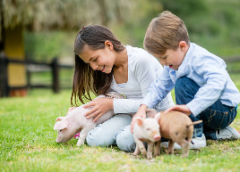

Understanding the World
3 and 4 year olds
You might notice your child can:
- understand the important parts of life cycles of both plants and animals, e.g. a bean, a caterpillar or a chick.
- enjoy exploring natural materials using all their senses
- learning that it is important to respect and care for the natural environment and all living things.
- enjoy planting seeds and caring for growing plants

Find out more

Out and about on the Farm

CBeebies Parenting

Health for Under 5s

Small Talk | National Literacy Trust

Learning to talk - Start for Life - nhs.uk

Home - Starting Reception

Homepage | Best Start in Life



Maths Development:
3 and 4 year olds
You might notice your child can:
- Talk about routes and locations, using words like ‘in front of’ and ‘behind’.
- Say one number for each item in order: 1,2,3,4,5.
- Quickly recognise groups of up to 3 objects, without having to count them individually (this is called ‘subitising’).

Find out more about your child’s development

What to expect in the Early Years: A guide for parents

If you have any concerns about your child’s development the first thing you can do is chat to your child’s Key Person at their setting.

