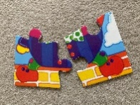
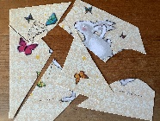
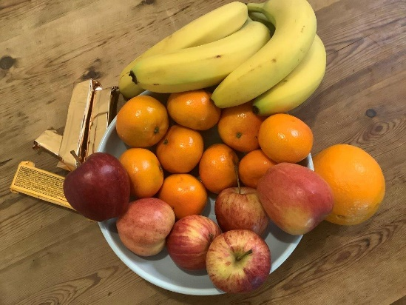
Sharing a snack
Either use the picture or set up a similar group of foods to share out at home. You can share these between members of your family or a few cuddly toys. How would you decide who takes what? There are no right or wrong answers It is more the discussion around the sharing out that is most important.
Encourage children to peel their own fruit.
Ideas that may crop up include:
- I want the red apple, so do I!
- We can have a banana each.
- If we share the satsumas, there is one left.
- I don’t like those yellow biscuits.
- Apples are more healthy than biscuits.
- You have the big orange.
Enjoy your snack together, chatting as you munch. Listen together to the story
The Doorbell Rang about another snack time with friends.

Jigsaw Puzzles

Jigsaws are fantastic for practical spatial awareness and positional language. You can make your own by cutting up old celebration cards or cereal packets - adapting the number and shape of pieces to your child. Sit with your child to talk and encourage them to…..turn it round more, that has a straight edge so goes on the outside, a corner, that matches that bit. Click on the link to see a parent and child work together to complete a homemade puzzle.
How to make your own jigsaw puzzle

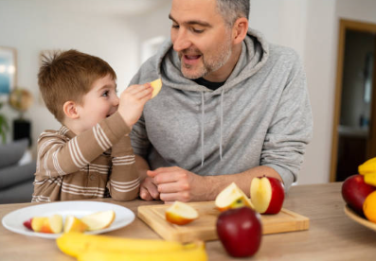

Puzzles


Exploring Maps

- Try drawing a simple map of your route to the local shop, park or the home of a friend or relative. You could also take some photos of key landmarks. Encourage your child to find the way walking there – looking for the landmarks. Talk about what you see.
- Encourage your child to draw a map and let them explain what it is about and maybe try it out together. Or on a dark starlight evening, imagine the route your rocket would take to get to the moon.





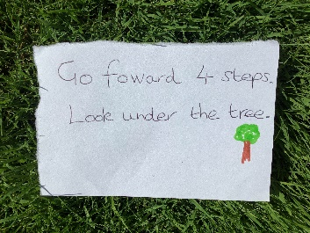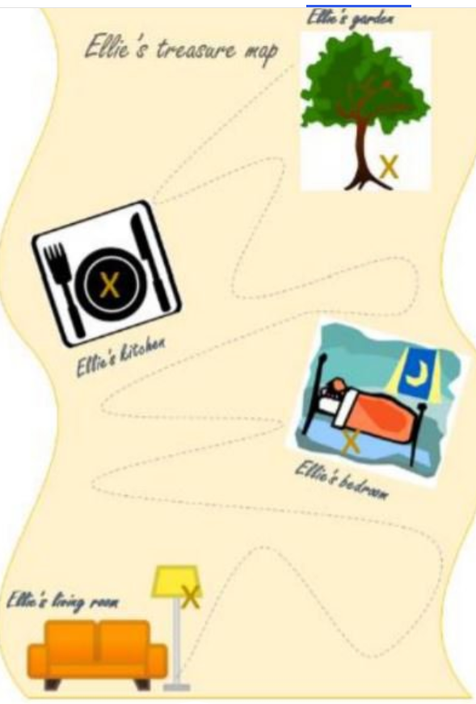
Treasure Hunts
Create a series of clues for your child to find something special – a small gift like a torch or a cuddly toy possibly. Depending on your child, you may need to explain parts and read most or all of the clues - picture symbols help them to guess. Introduce different ideas e.g. number of steps, fairy or giant steps, jumps, direction -forward, backwards, sideways. Pirate treasure hunt | Words for Life for more ideas on how to make a map together. Or Indoor treasure hunt for kids - warmer and colder game - BBC Tiny Happy People for indoor treasure hunts

Communication and Language
You might notice that your child can:
Birth to 3 year olds
- identify familiar objects when you describe them. I can point to the big boat in a book we’re sharing.
- understand longer sentences. I can “Make teddy jump.”
- understand simple questions about ‘who’, ‘what’ and ‘where’ (but generally not ‘why’).
3 and 4 year olds
- Use long sentences of four to six words.
- Likes having long conversations with you and my friends.
4 and 5 year olds
- can talk about how to solve problems and give explanations about how things work and might happen.
- I am using new words that I have learned. I can ask questions to find out more about something I am interested in.

- Ask lots of questions and answer some of yours
- -

Top Tips
- Use real objects, where safe e.g. fruit, spoons, cups. This helps children to understand more about their world e.g. weight, texture, smell.

- Eating a picnic together, indoors or out, to encourage children to try new foods – especially if they have helped to making them.

- Charity shops are a useful source of jigsaw puzzles and books.

- Value your child’s input however insignificant it may appear to you.

- Model when things don’t go right for you and allow your child to get things wrong – workout how to overcome such together – this builds resilience.

Chatting Matters
Vocabulary and increasing the number of new words you child hears every day is very important for future learning.
Information for Parents/Carers
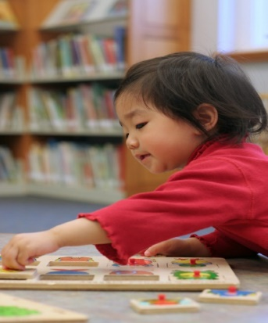
Find out more

CBeebies Parenting
Health for Under 5s

Learning to talk - Start for Life - nhs.uk

Homepage | Best Start in Life

Small Talk | National Literacy Trust

Home - Starting Reception



Find out More

Find out more about your child’s development

What to expect in the Early Years: A guide for parents

If you have any concerns about your child’s development the first thing you can do is chat to your child’s Key Person at their setting.

Personal, Social and Emotional Development
You might notice that your child can:
Birth to 3 year olds
- learn about other feelings through stories and play.
- begin to understand how to wait for my turn and learning to control my feelings when I want something.
3 and 4 year olds
- talk to my friends to solve problems that might happen when we are playing.
- can use different words to explain how they are feeling.

30-50 months

