Go for a wintery walk with your child, wrap up warm and see what you can find?
Winter 1 Spotter Sheet
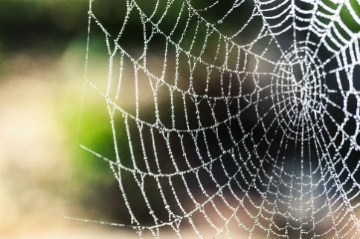
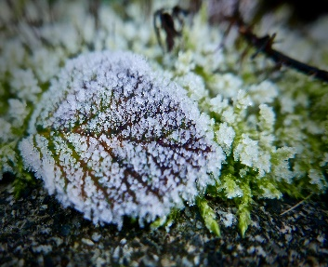

Frost
Frost is a thin layer of ice on a solid surface,
It forms from water coming into contact with a hard surface whose temperature is below freezing,
You will often see it on the grass or pavements after a cold night, or on bushes and trees when the temperature is very cold.
When you walk on it the frost can be slippery or sound crunchy underfoot. If you are walking in the dark the frost shines in the star and moon light.

Look at how the frost makes this leaf crisp and shiny. The beads of frost look like little stars.
Can you see frost on a spider’s web in the bushes or plants, or perhaps on a fence?

Thistle prickly
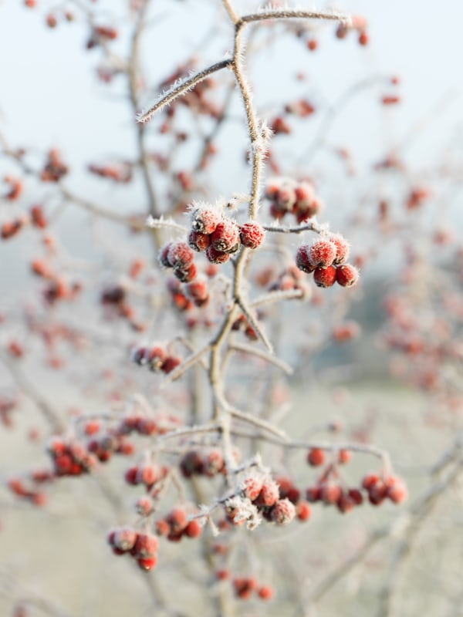

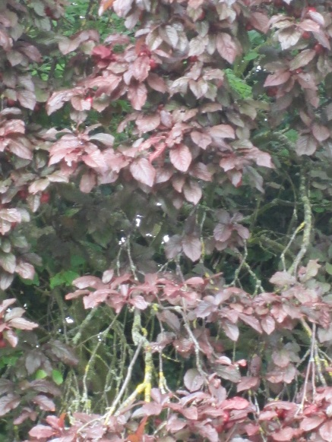
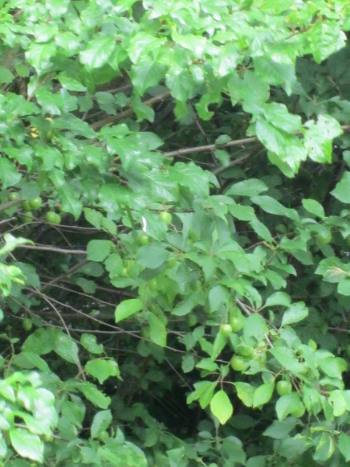
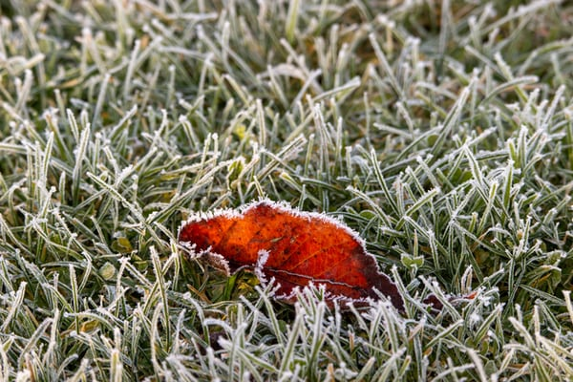
The frost on these red berries looks like sugar coating, but they must not be eaten as berries can be poisonous.
This leaf on the grass stands out with frost round its edges – can you find leaves like this on a frosty morning?

A Hoar Frost
Hoar frost is a type of feathery frost that forms when the hard surface is already very cold. The word ‘hoar’ comes from old English and refers to the way the ice crystals form making it look like white hair or a beard.
The ice in hoar frost continues to grow as more water vapour is added and frozen. On a still night, it can grow well on tree branches, shining in the night like stars.
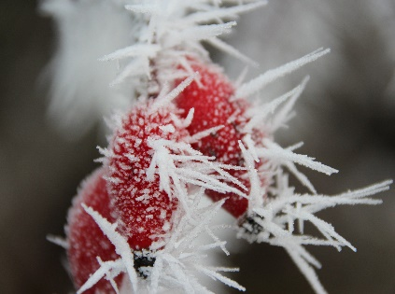
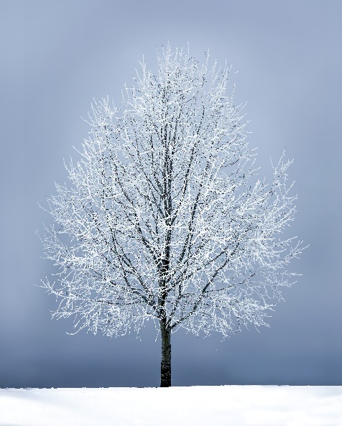

You may see hoar frost forming on plants and berries. On these red berries the frost looks like spikey feathers.

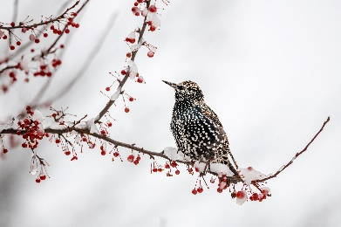

Birds can get hungry in winter when the trees and bushes are covered in frost – remember to put out seeds for them if you see them in your garden.
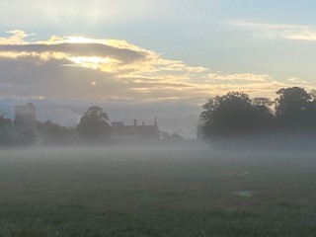
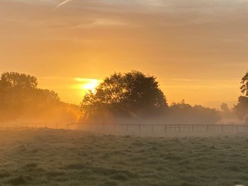

Mist and Fog
Fog is formed when any cloud makes contact with the ground. In low-lying areas, such as valleys and fields, the fog bank (a mass of fog) is essentially a cloud formation. Clouds form when water droplets condense and merge but fail to achieve a size large enough to fall as rain.
Mist is also formed by water droplets but is less dense and quicker to disappear when wind, temperature, or air humidity changes. Mists can form due to sudden temperature changes (such as when breathing out in cold air), or from evaporation or condensation, such as when rain hits sun-warmed street surfaces or evening allows dew to form. It is often seen rising from fields as the sun warms the cold surfaces from overnight.

You may see mist on the ground in parks and fields – but you will have to get up early!

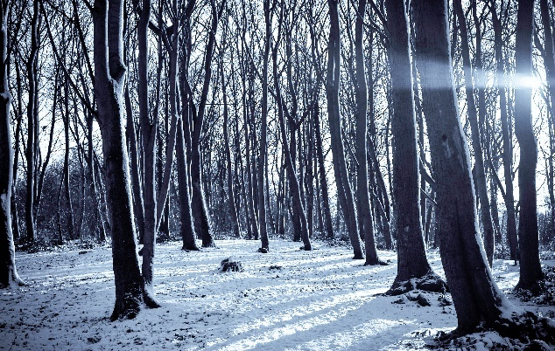
Trees and Bushes
The leaves have now gone from most of the trees and bushes, but you can still see seeds and nuts on some of them. Trees and bushes that lose their leaves are called ‘deciduous’, those that keep their leaves are ‘evergreen’.

Deciduous trees in winter – the leaves have all fallen. In early winter there are lots of leaves on the ground – see how many leaves of different colours you can find.
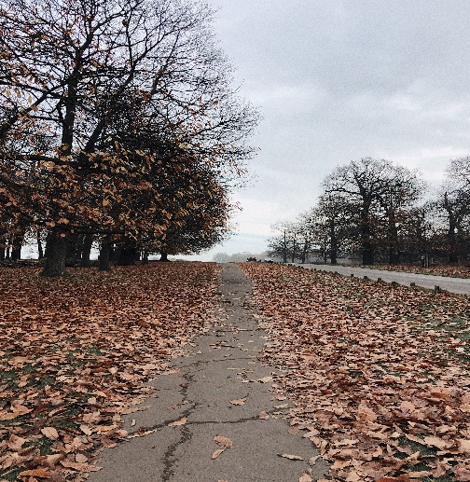
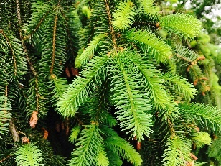

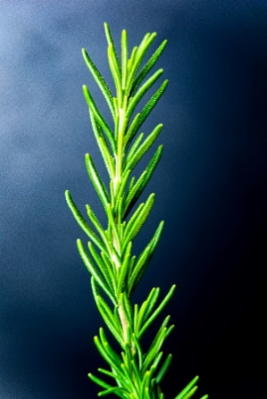
Conifer leaves from a tree that is ‘Evergreen’.
Rosemary is an evergreen herb; it can be used in cooking and has a strong smell. It grows in parks and gardens. You may see big bushes of Rosemary.
The Holly Bush is an evergreen. It has sharp spikey leaves that are often dark green but can be yellowing. The berries are red and shiny.

